[https://sanket-m-kangle.medium.com/mulesoft-certified-developer-level-1-questions-answers-quiz-336e2751e01d#:~:text=According%20to%20mulesoft%2C%20what%20is,the%20line%20of%20business%20developers](https://sanket-m-kangle.medium.com/mulesoft-certified-developer-level-1-questions-answers-quiz-336e2751e01d" \l ":~:text=According%20to%20mulesoft%2C%20what%20is,the%20line%20of%20business%20developers" \t "_blank" \o "https://sanket-m-kangle.medium.com/mulesoft-certified-developer-level-1-questions-answers-quiz-336e2751e01d#:~:text=according%20to%20mulesoft%2c%20what%20is,the%20line%20of%20business%20developers)

$ and $$

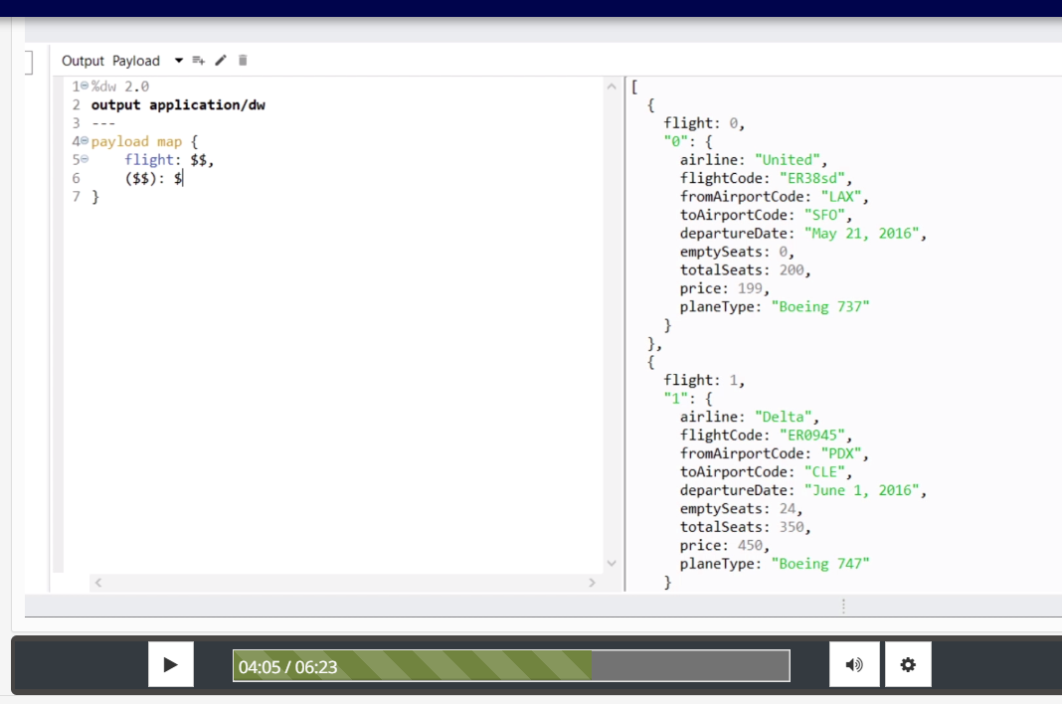

Swap key value

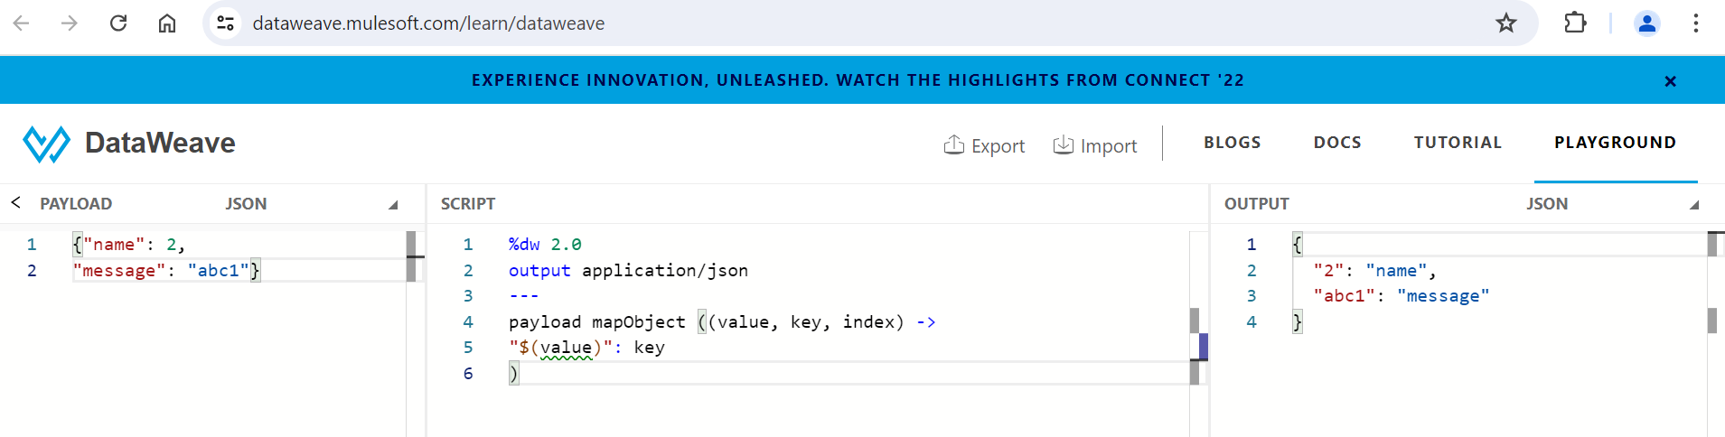

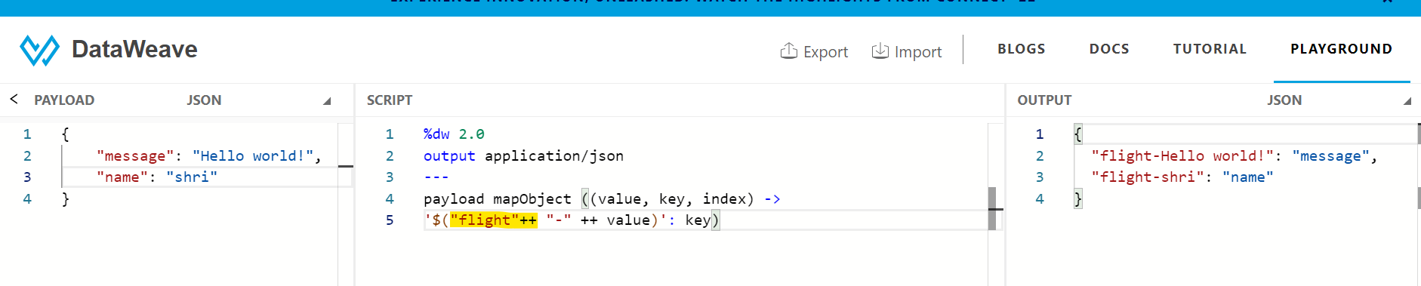

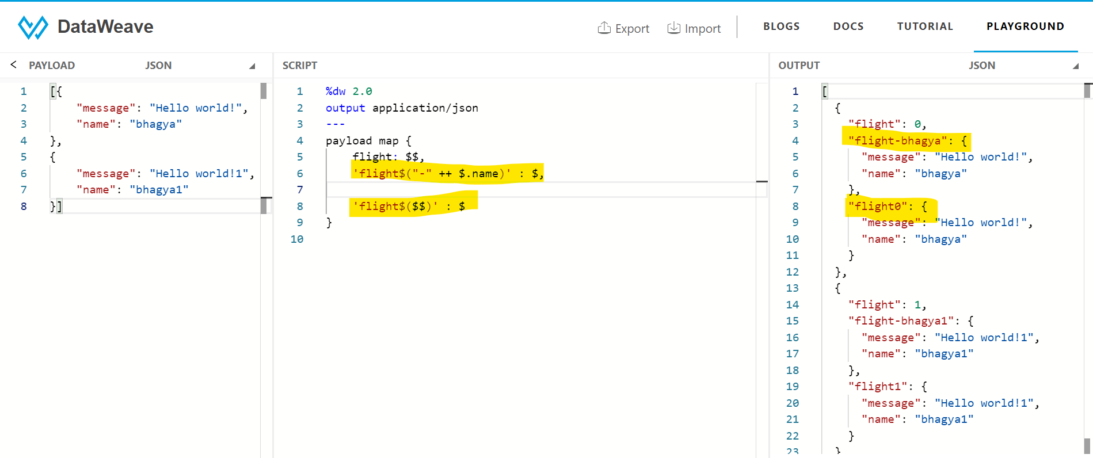

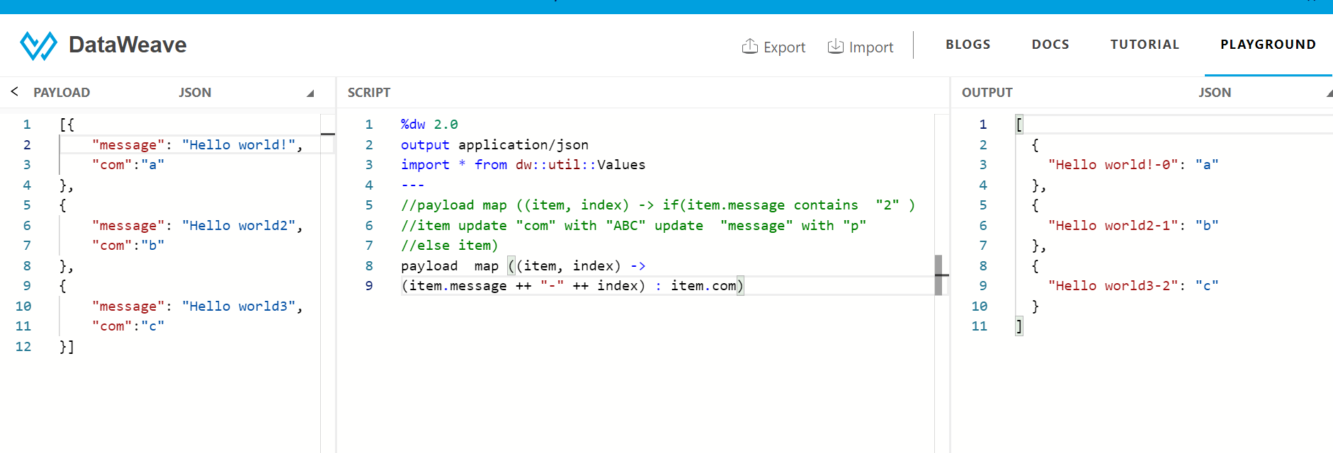

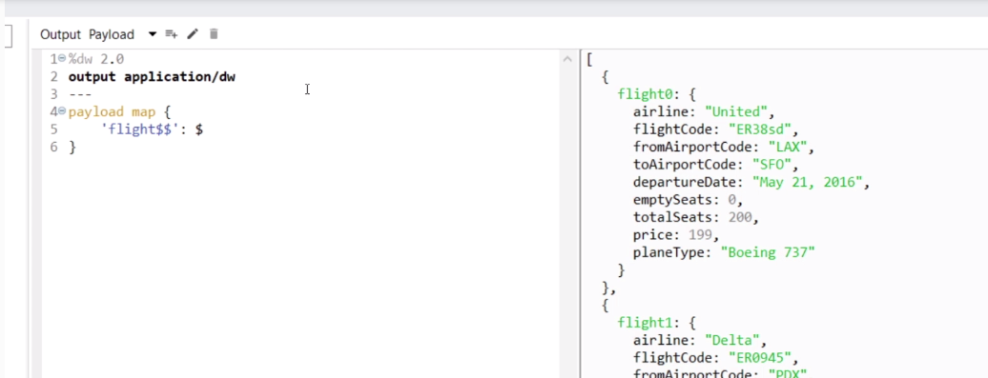

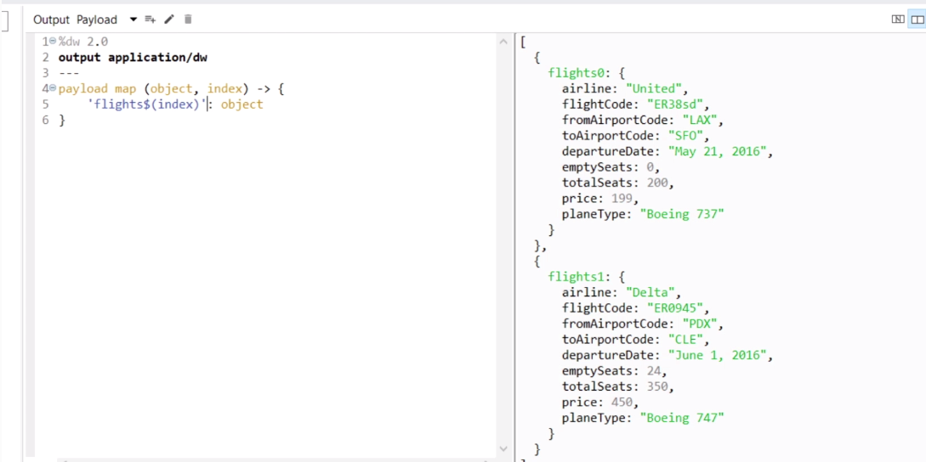

{()} json / java to xml

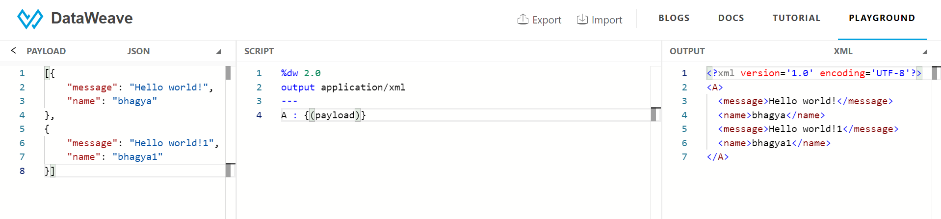

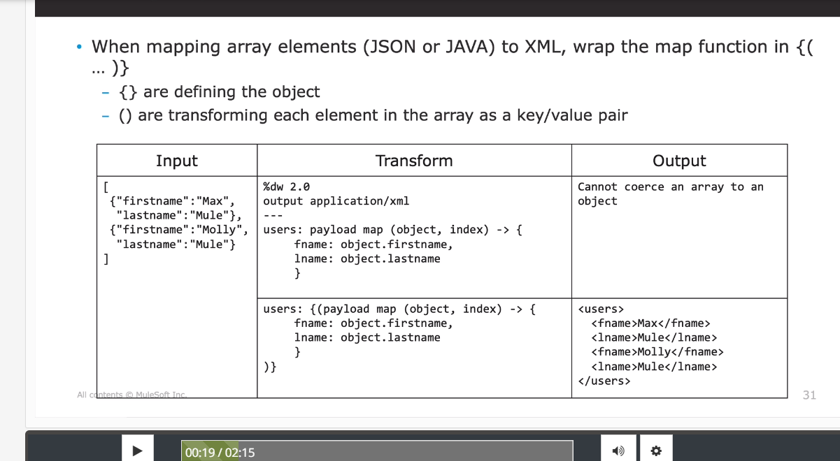

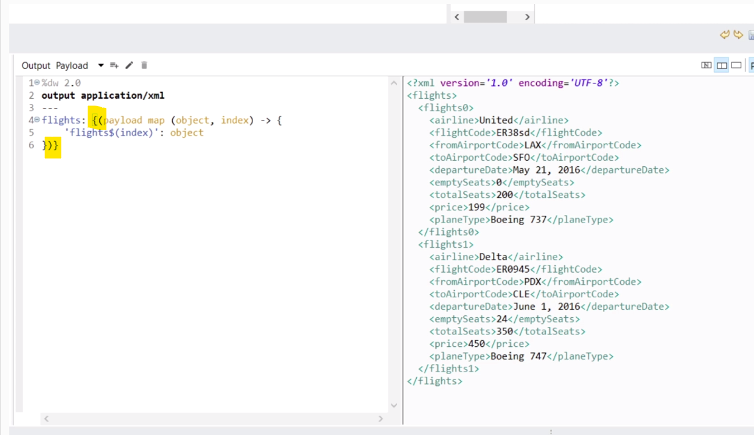

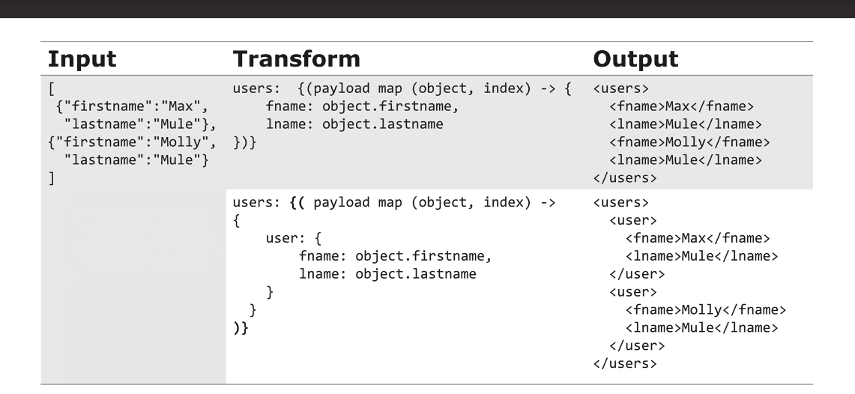

Xml to json

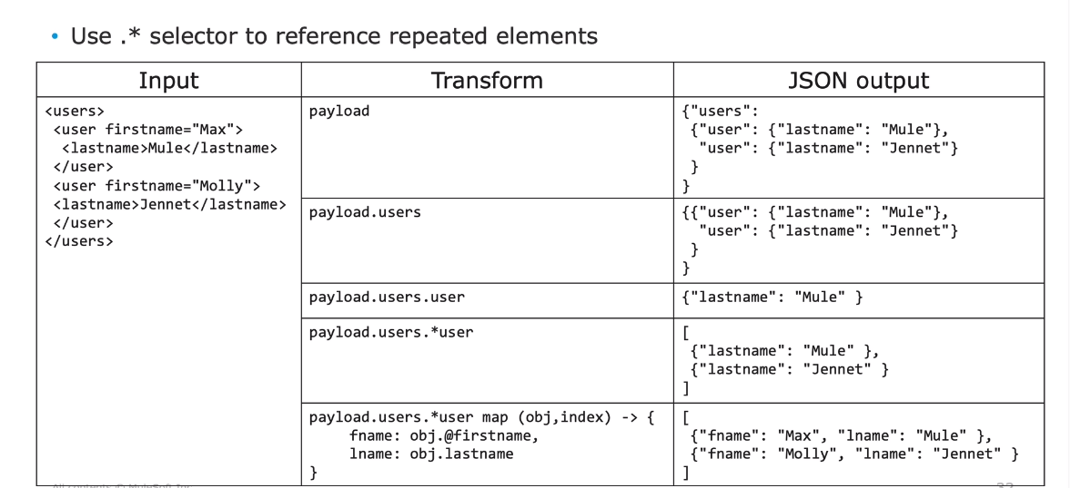

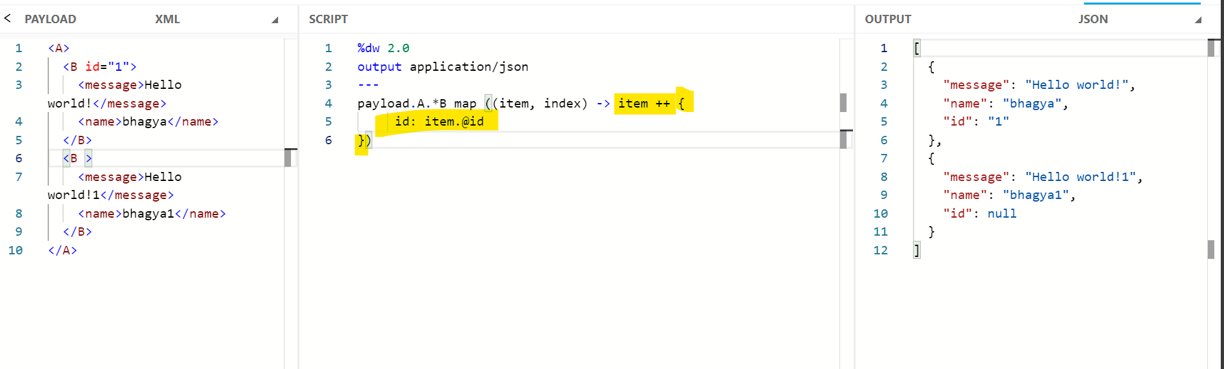

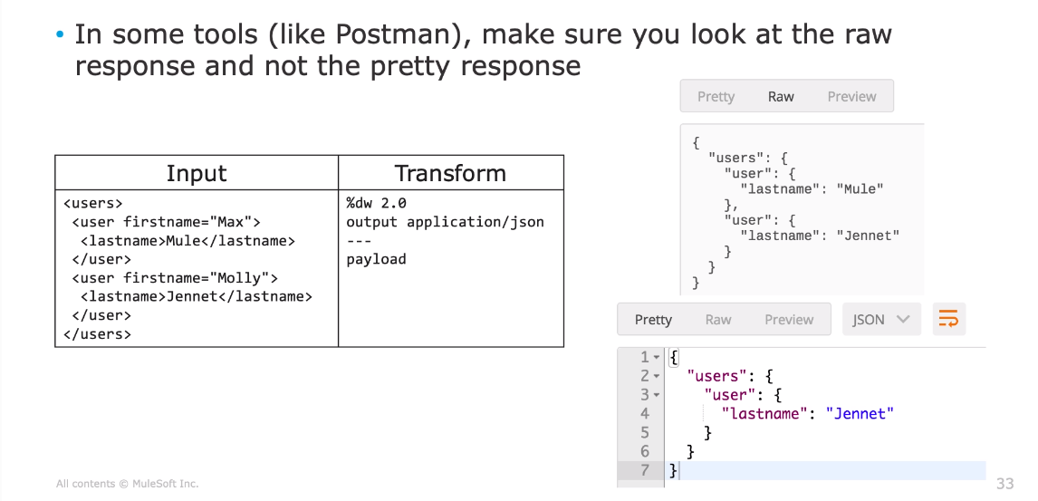

JSON to Java

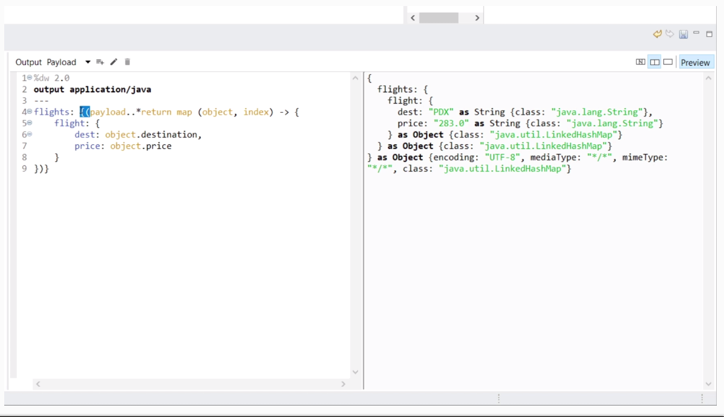

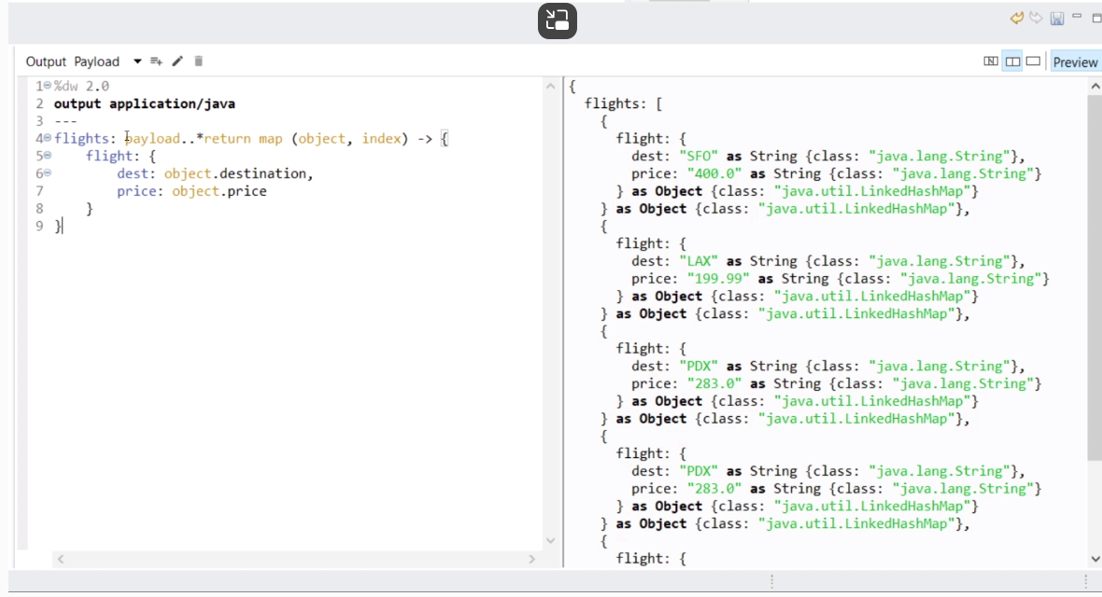

var

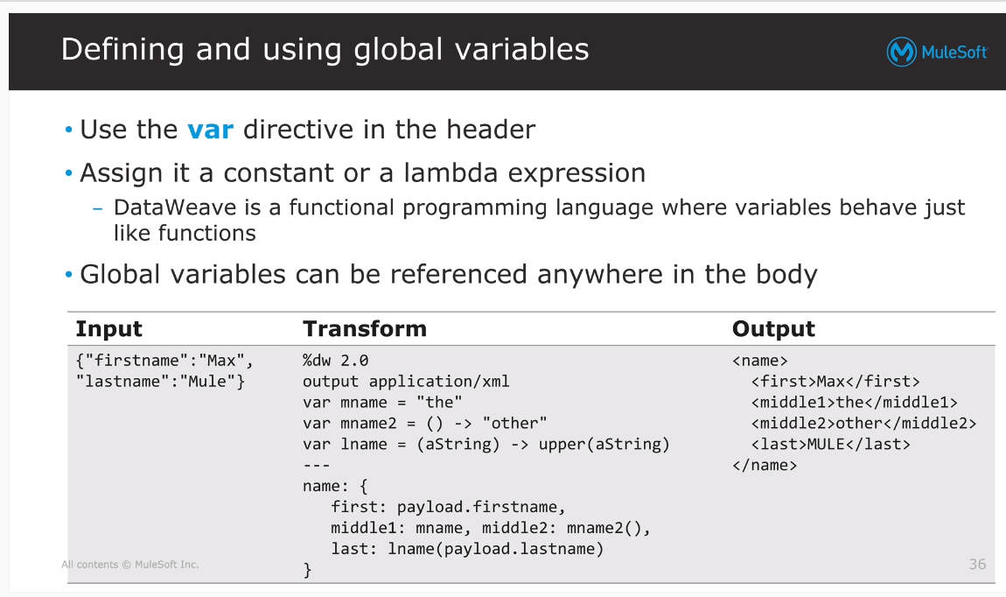

Var VS Fun

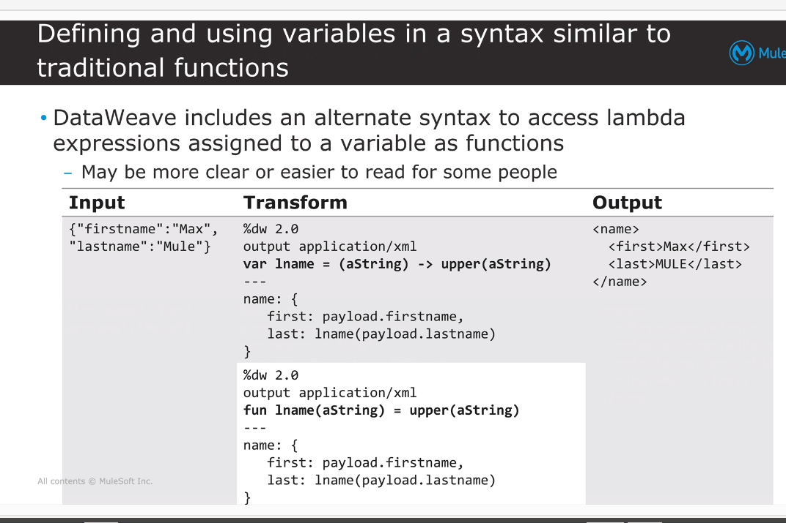

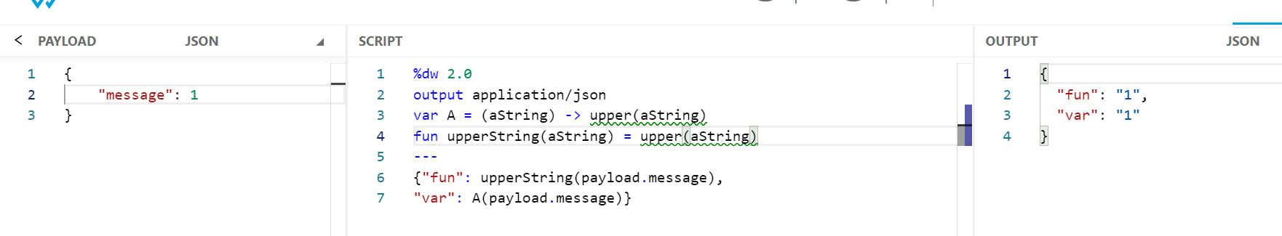

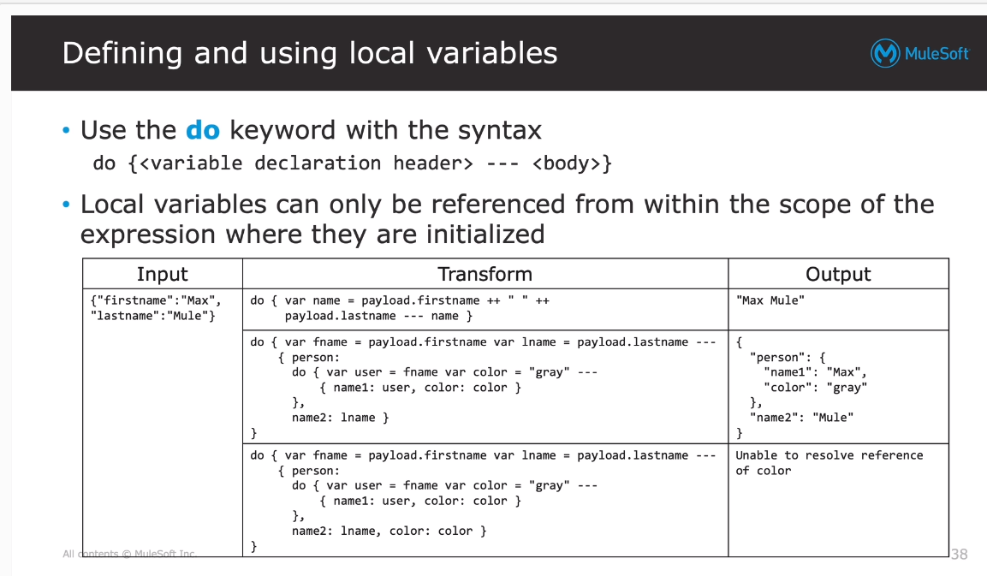

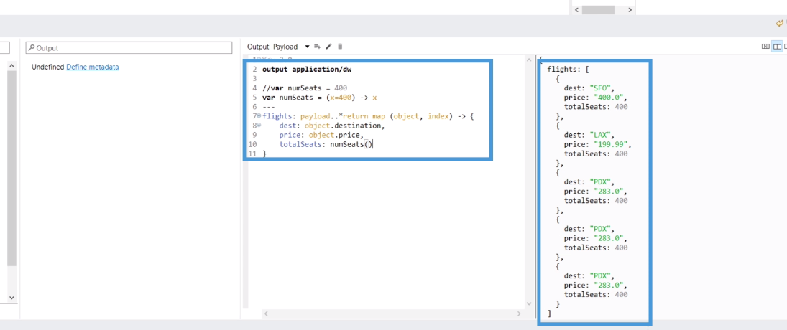

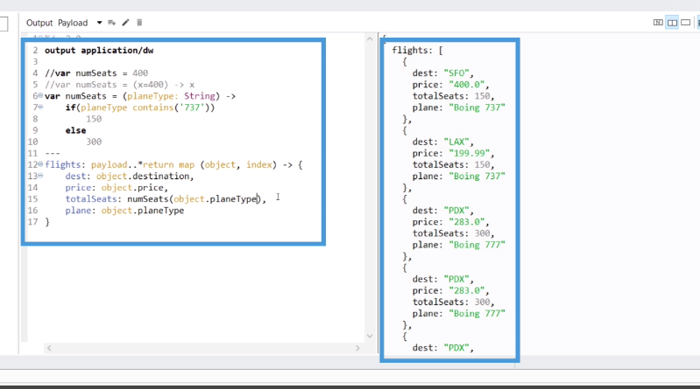

Fun and var = \*\*

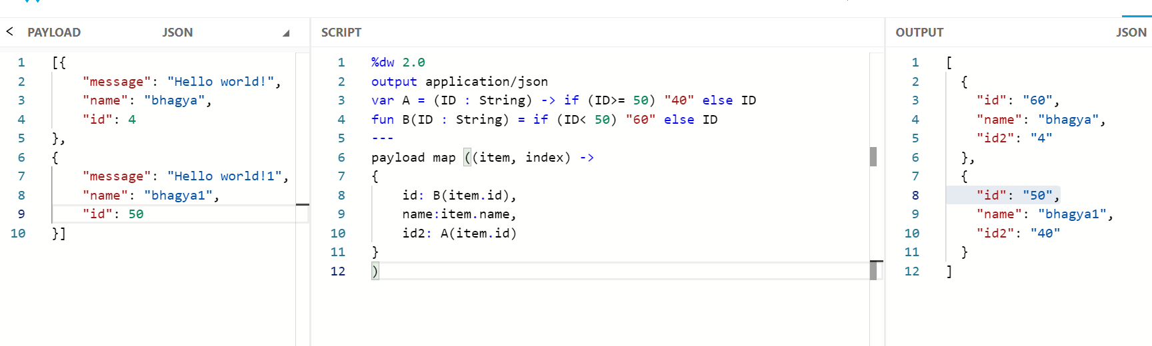

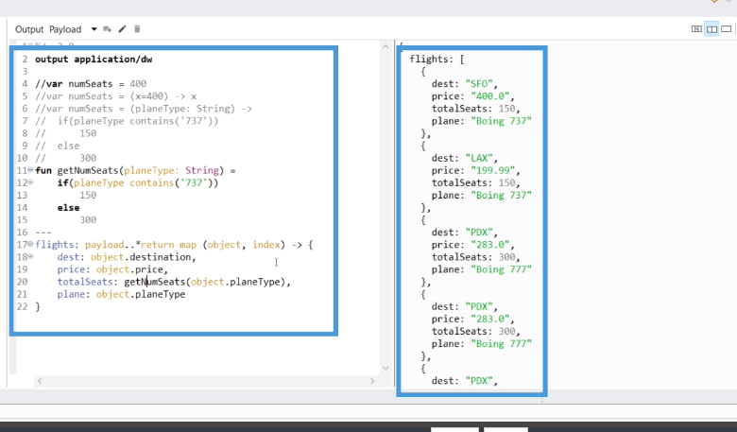

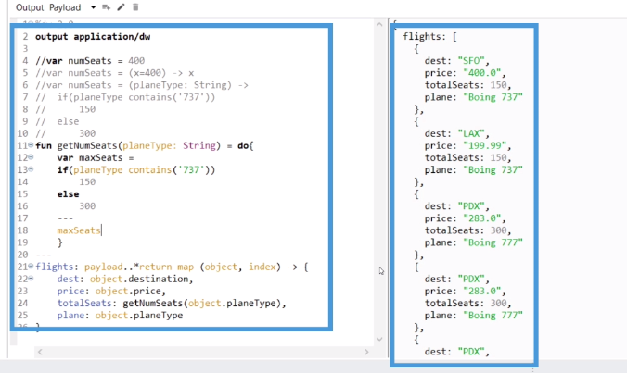

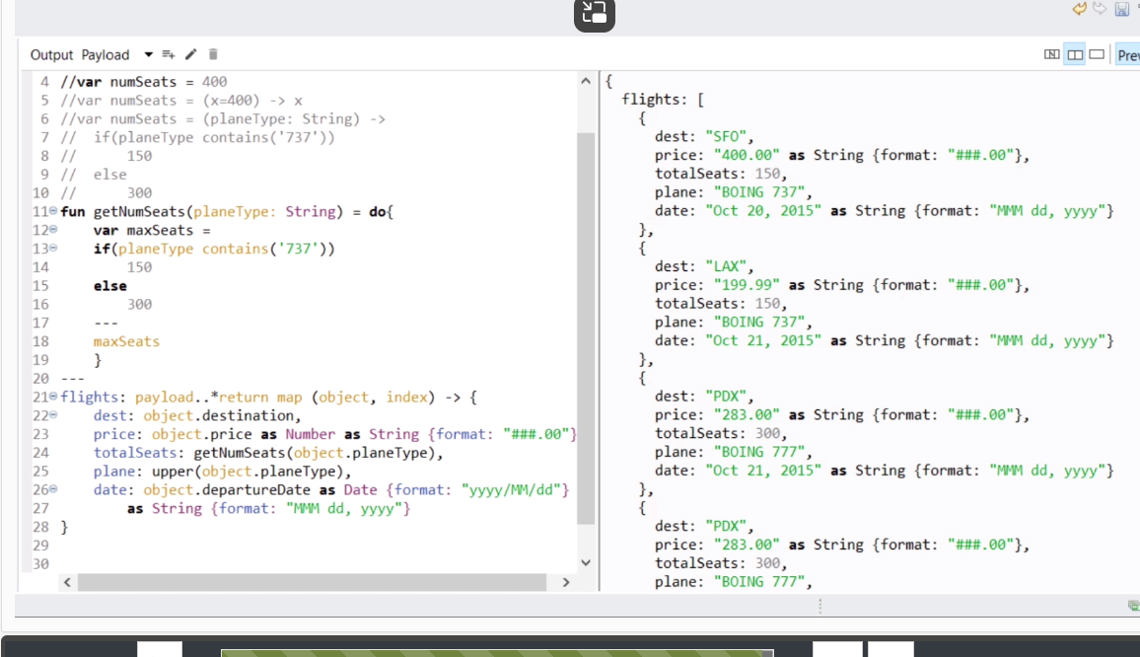

Custom datatype \*\*\*\*\*\*\*\*\*

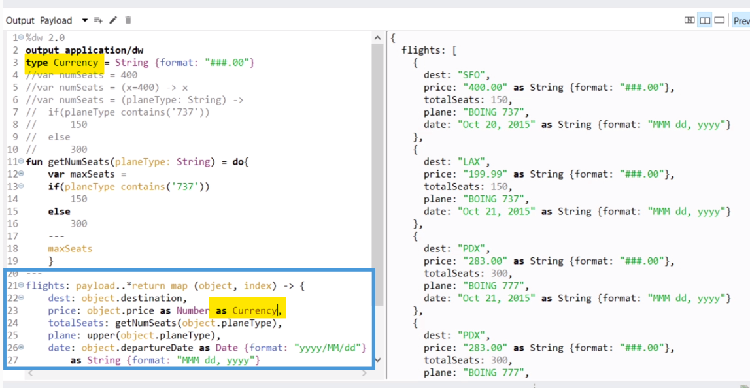

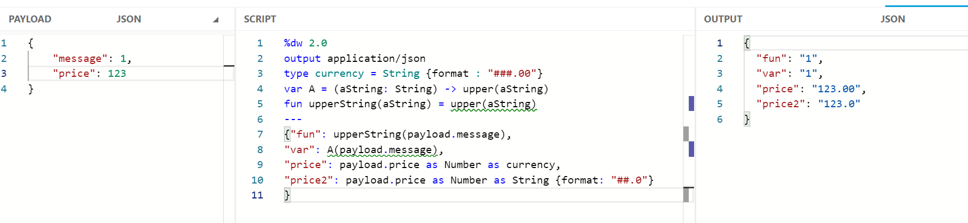



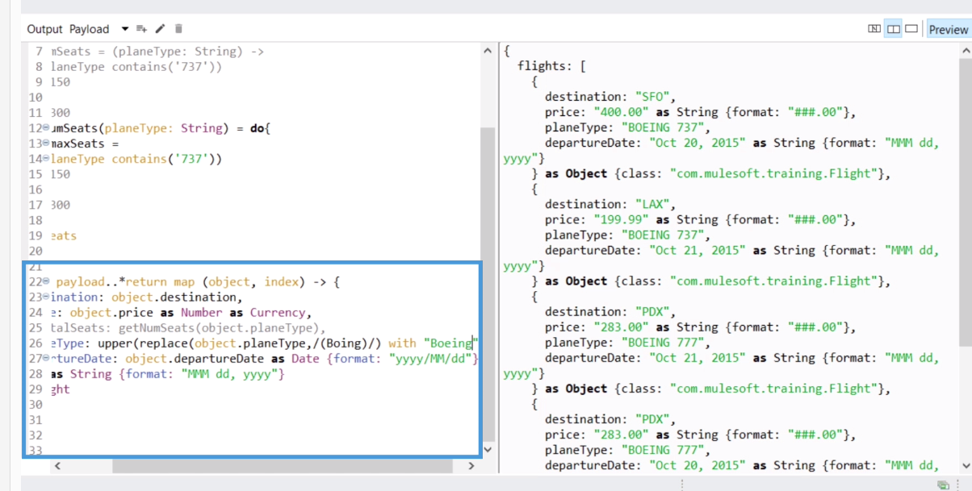Replace \*\*\*\*\*\*\*



upper function  
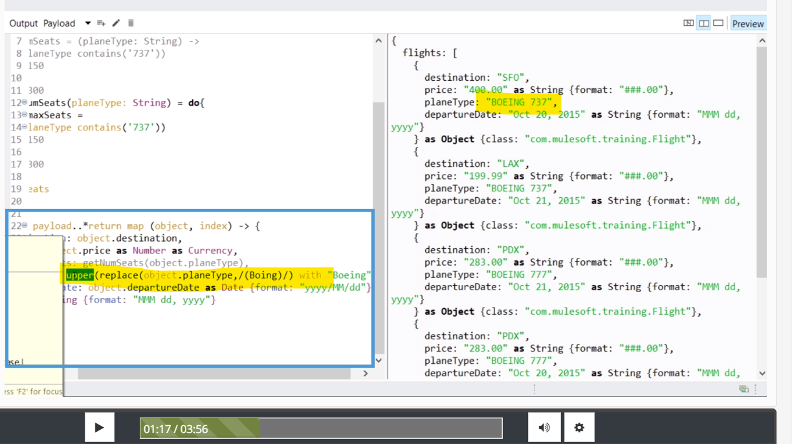

Dasherize (lower case function) \*\*\*\* dw:: String

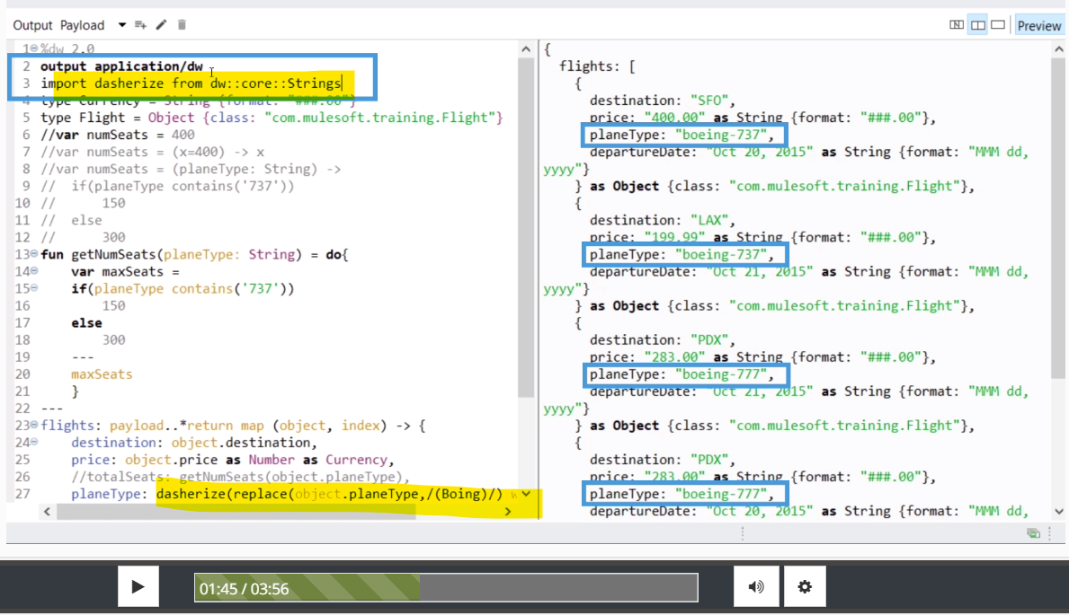

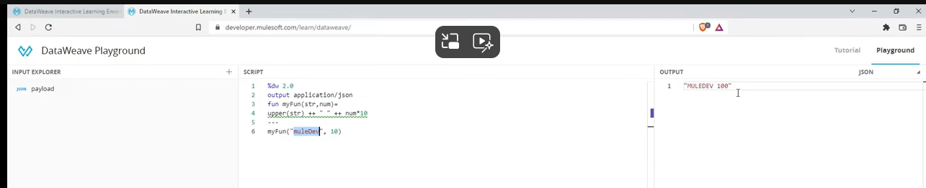

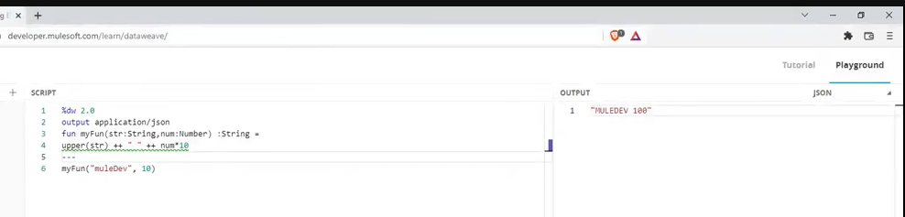

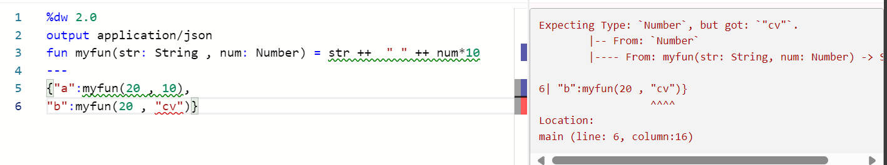

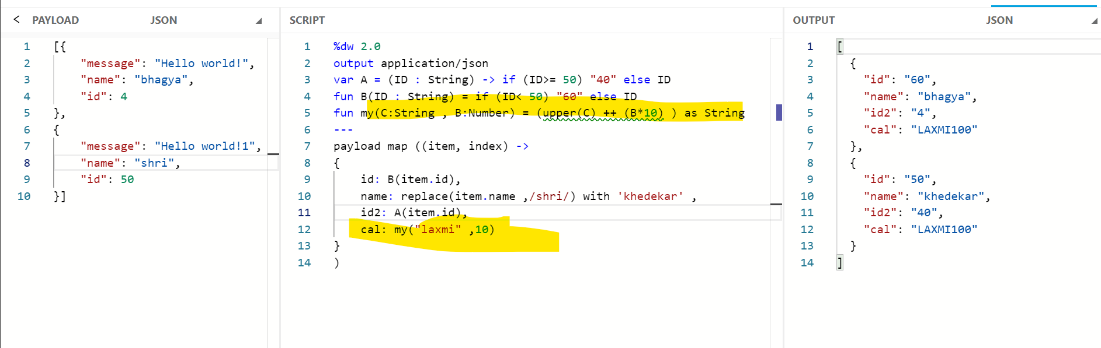

Update and contains

Update will need field name \*\*\*\*\*\* dw

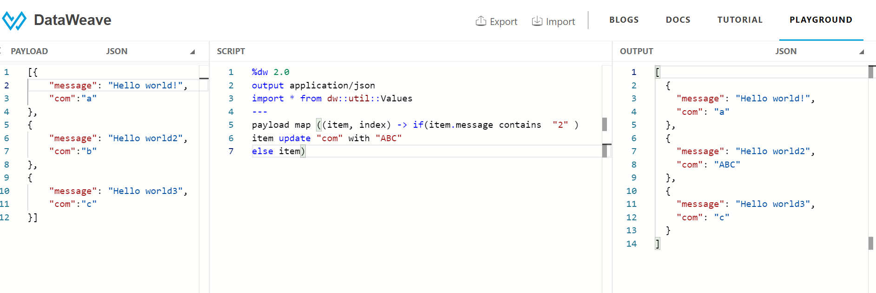



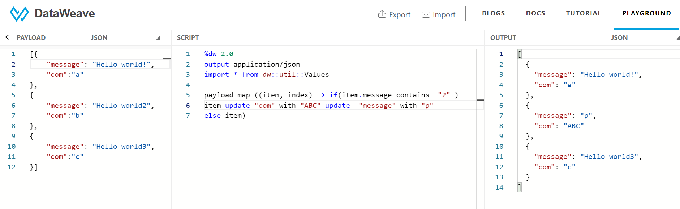



groupBy

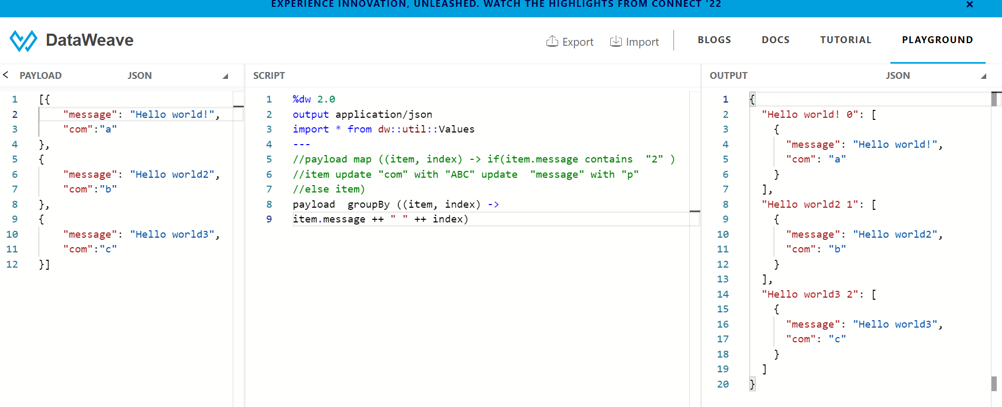

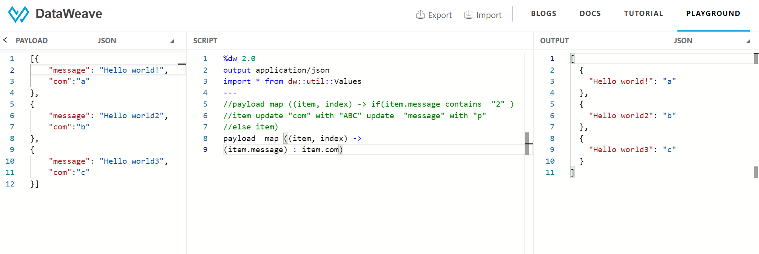



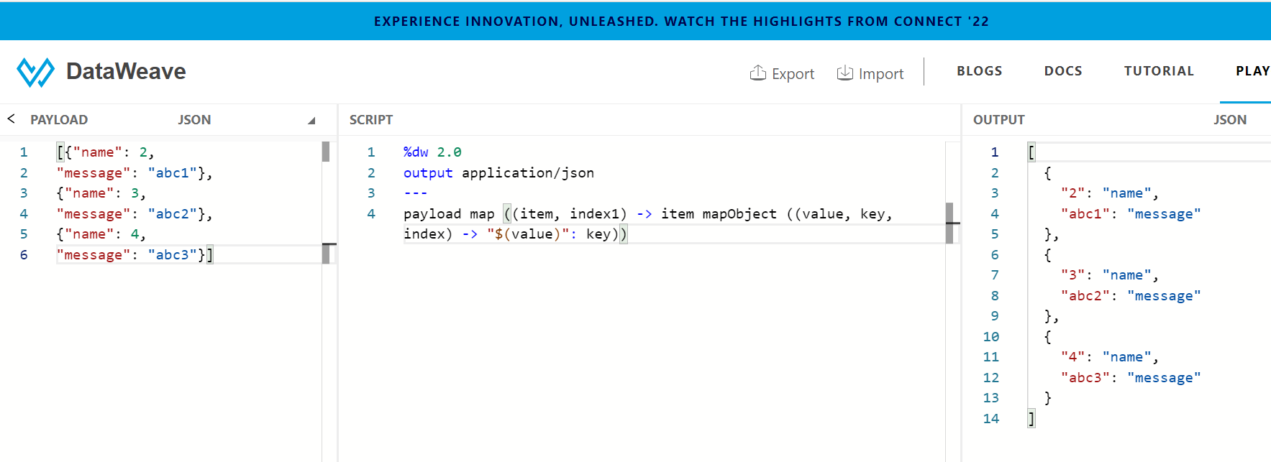

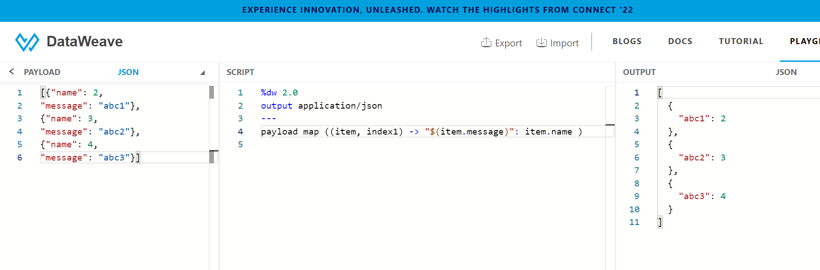

mapobject

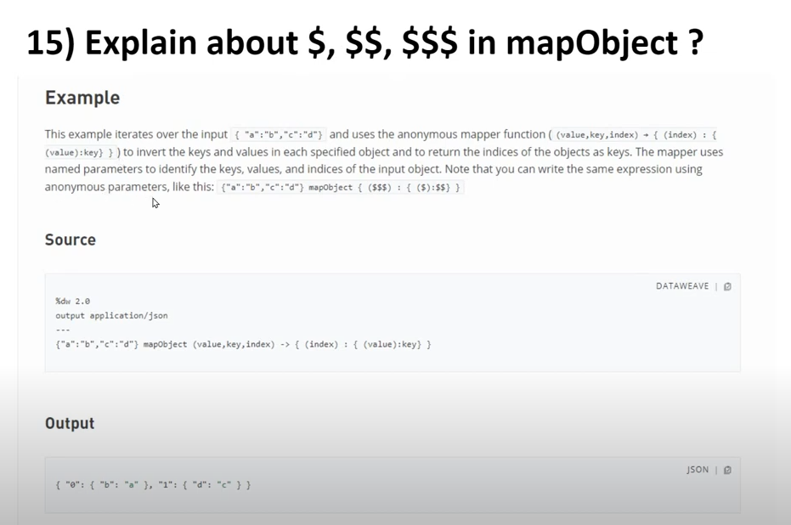

$ $$



valuesOf

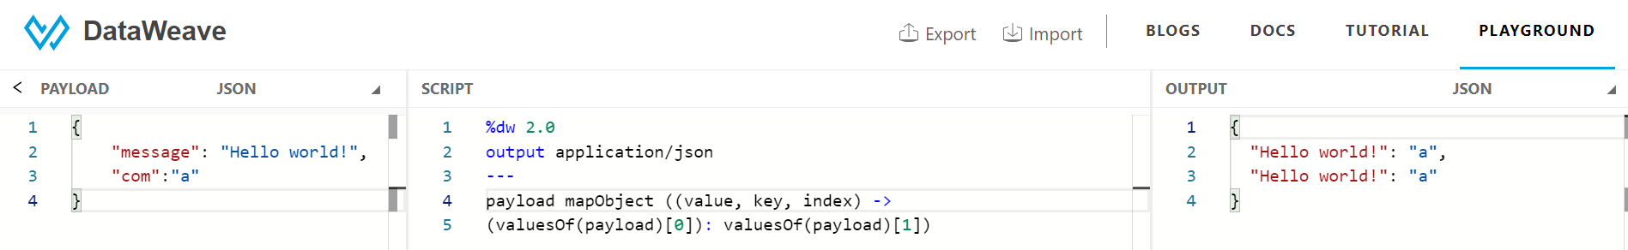

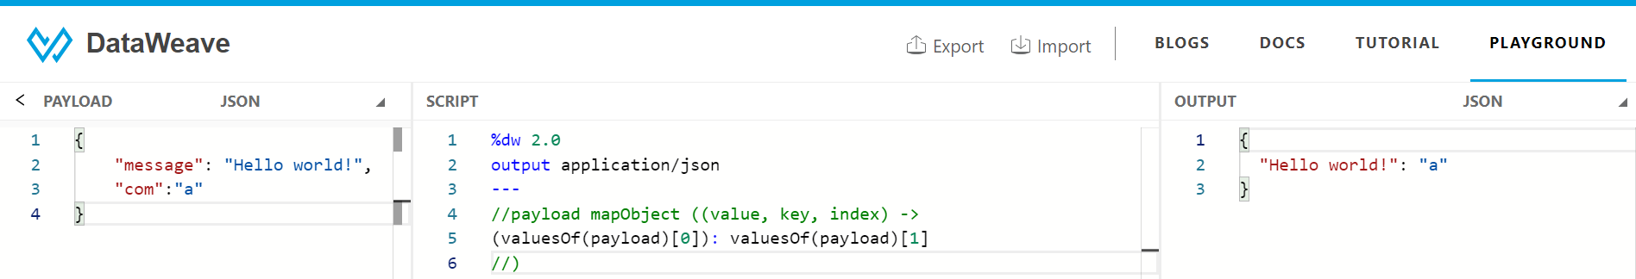

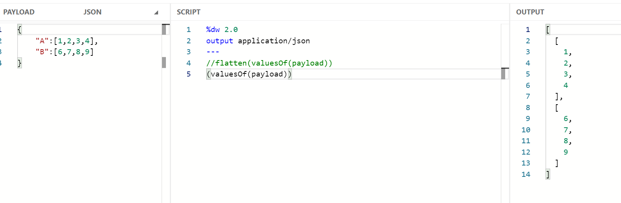

flatten

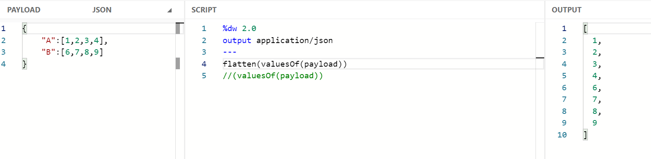

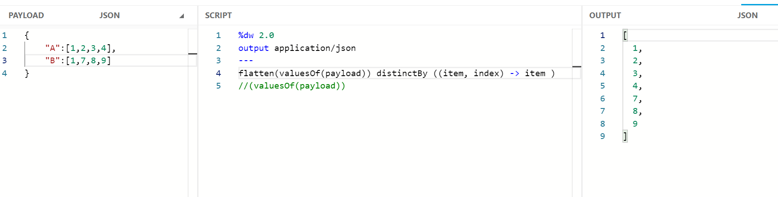

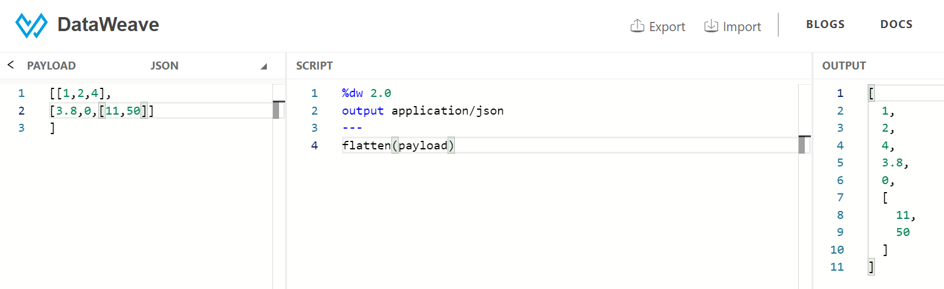

reduce

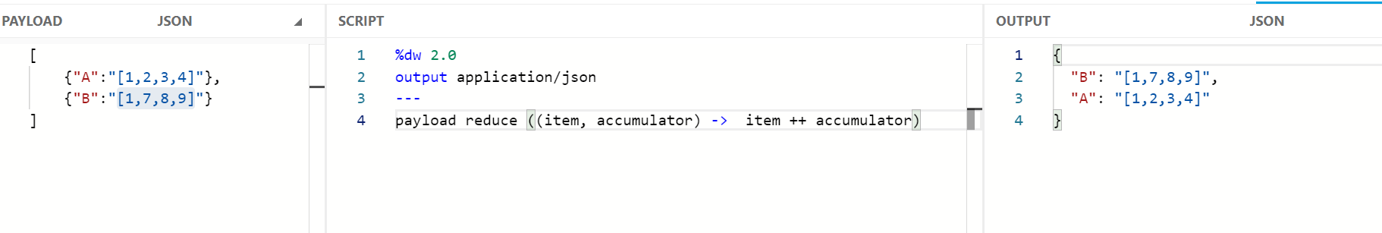

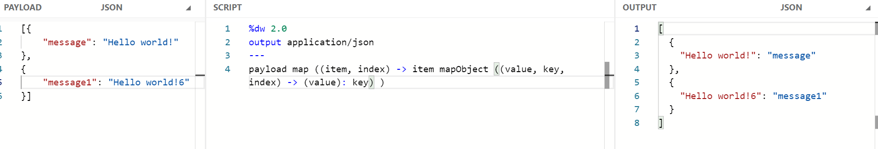

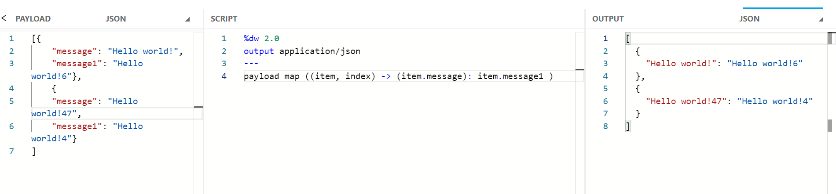

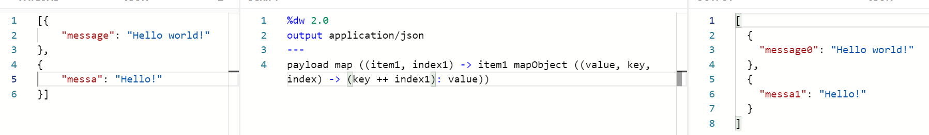

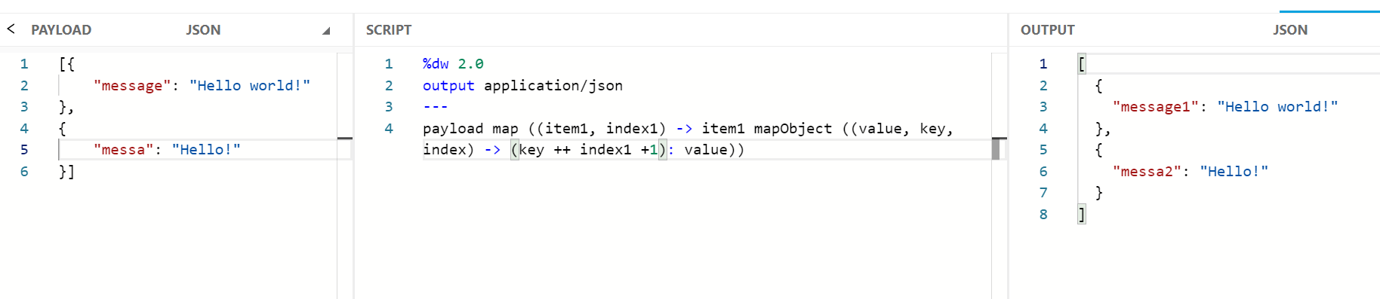

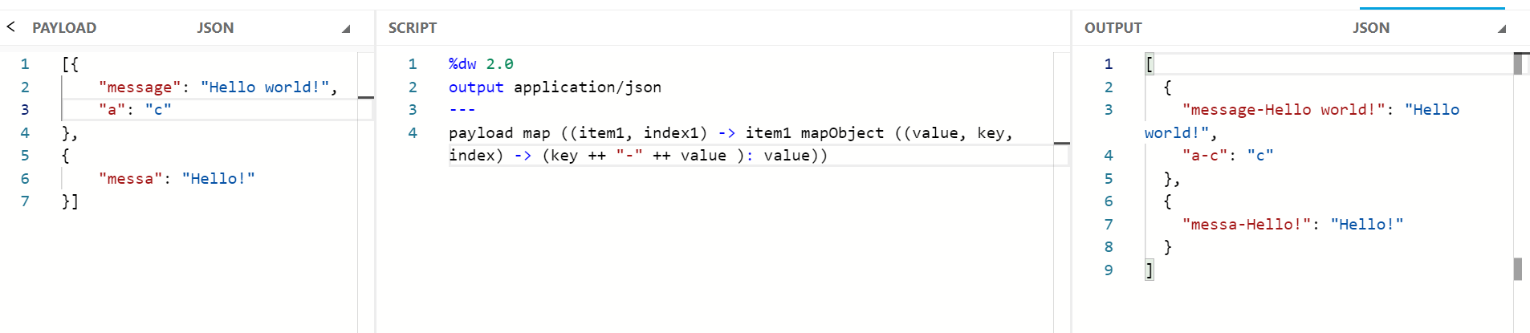

pluck

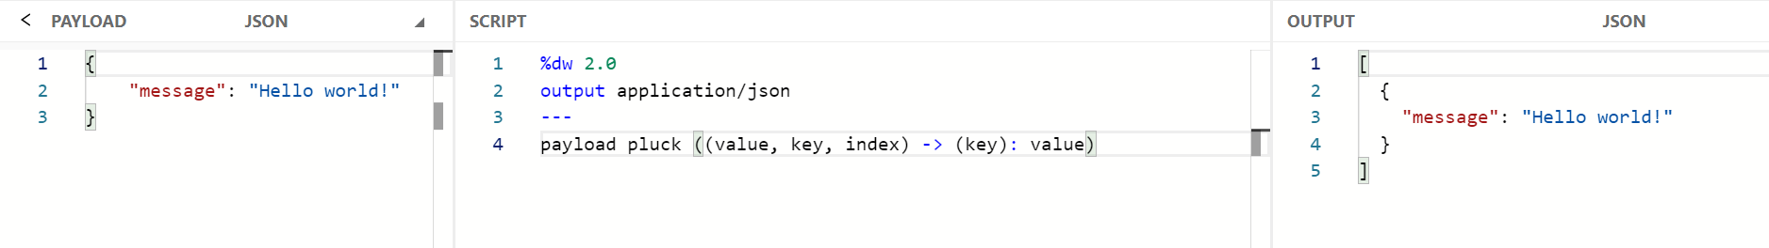

Prime number

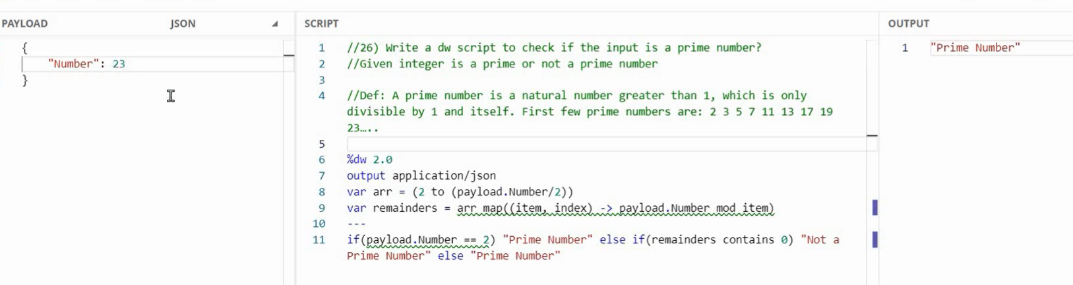

reduce factorial



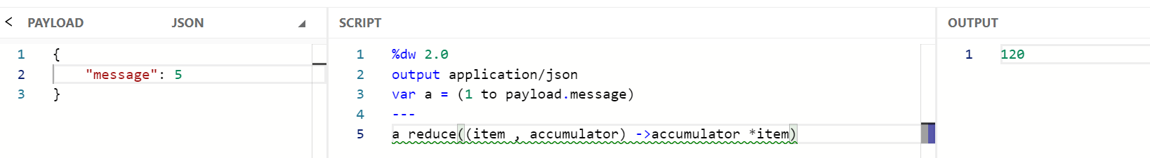

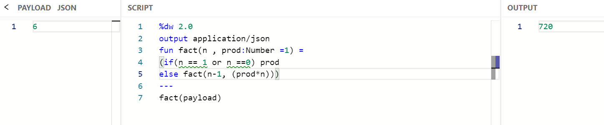

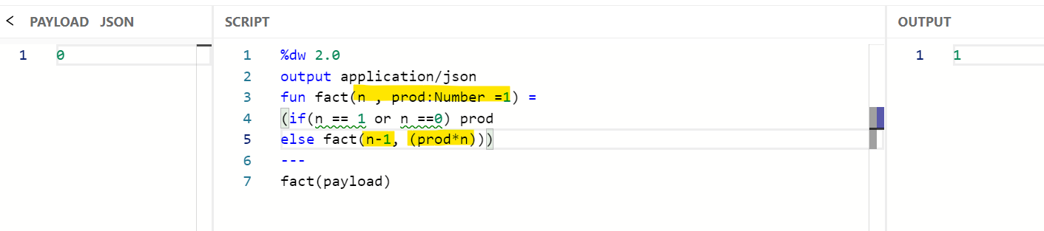

orderBy

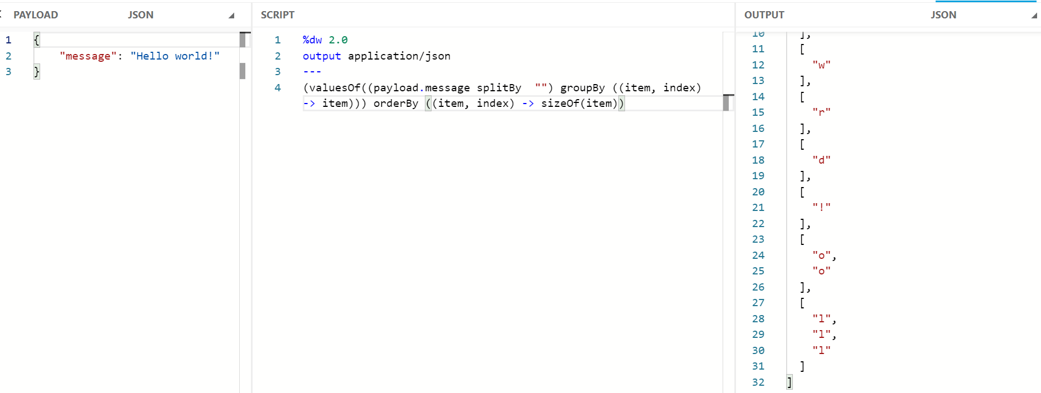

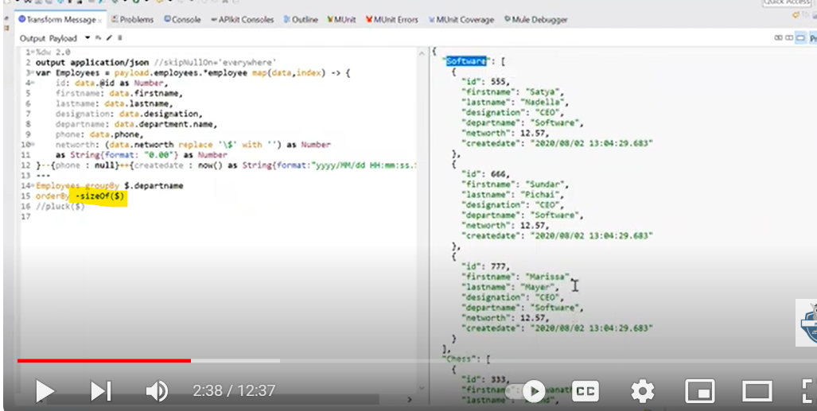

groupBy orderby

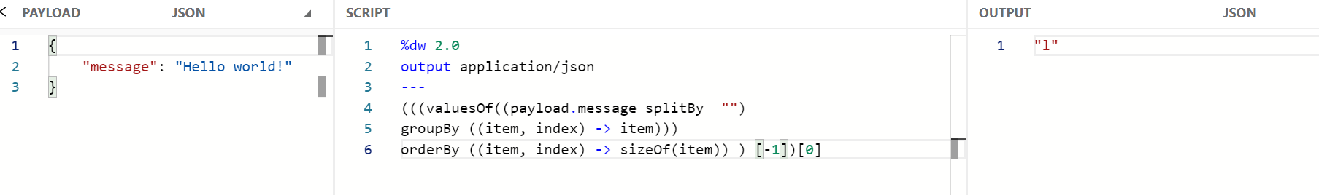

Case-sensitive - palindrome or reverse dw::Strings

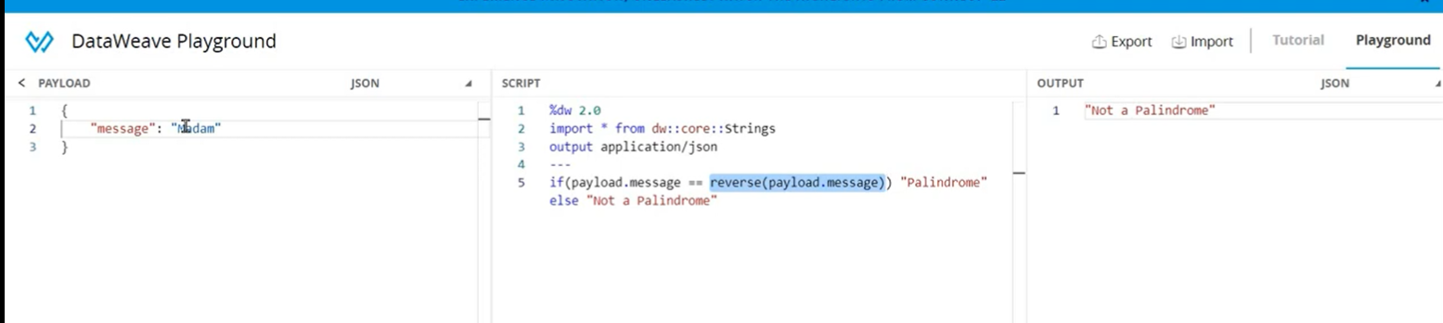

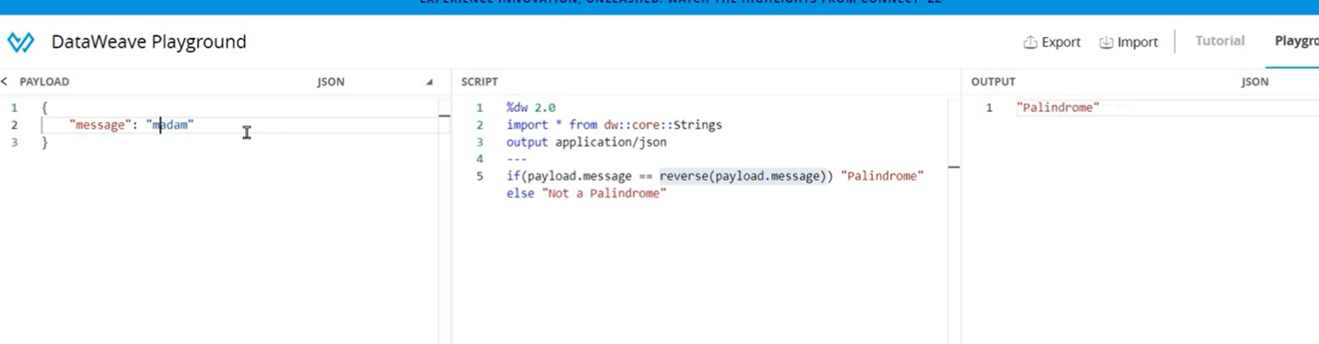

Reverse the whole sentence

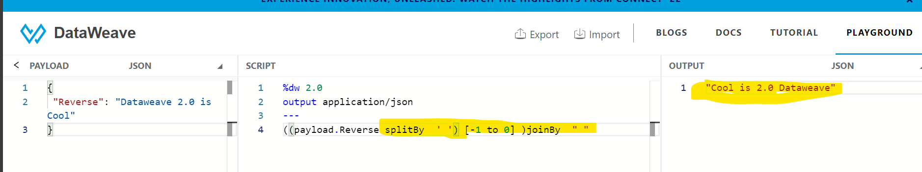

read

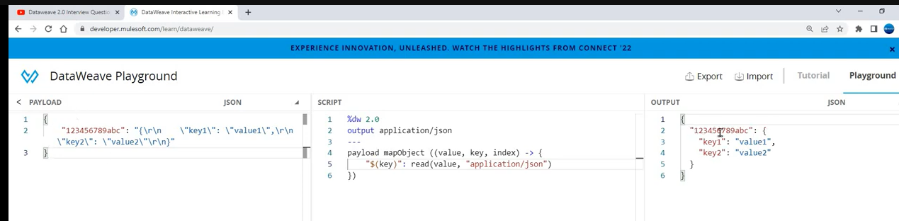

Json to xml

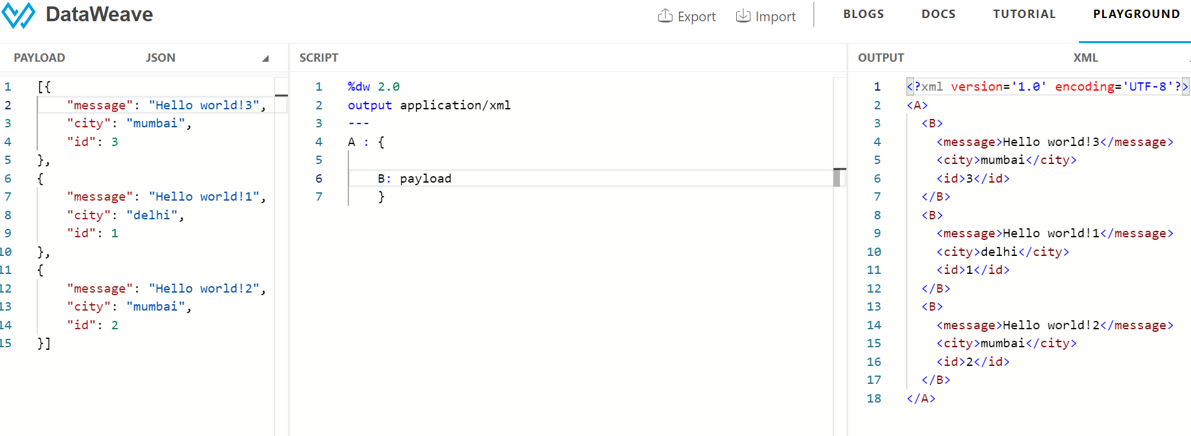

$ $$

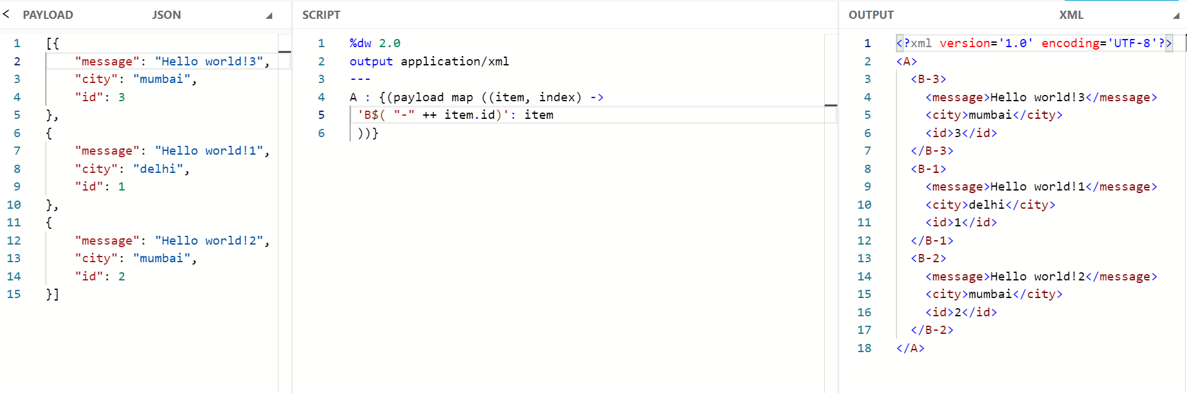

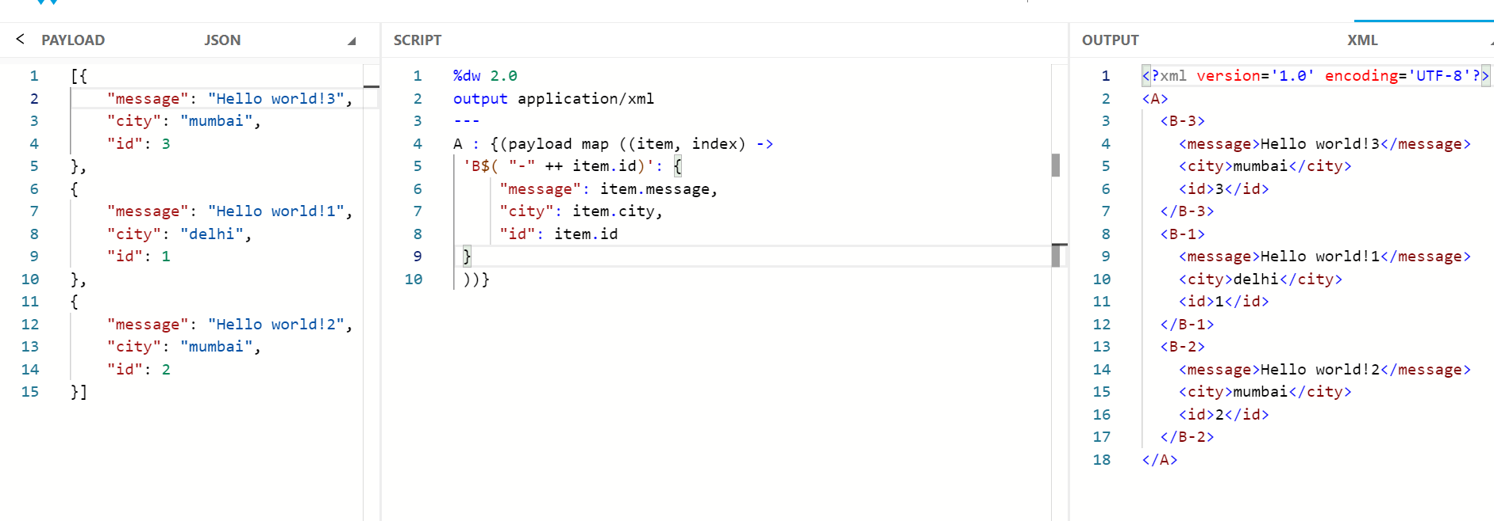

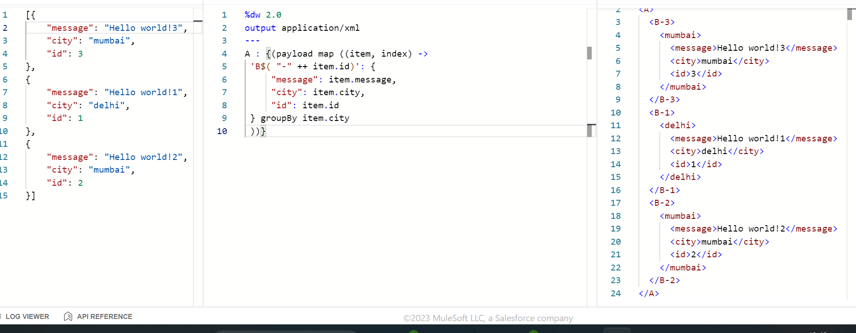

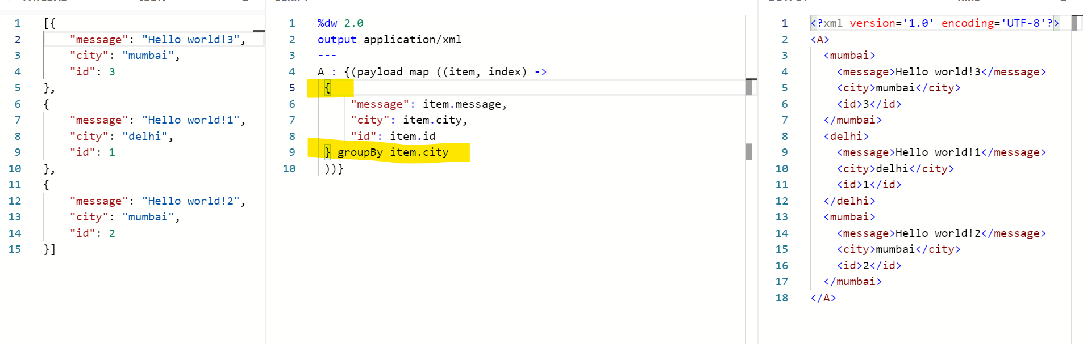

Xml to json

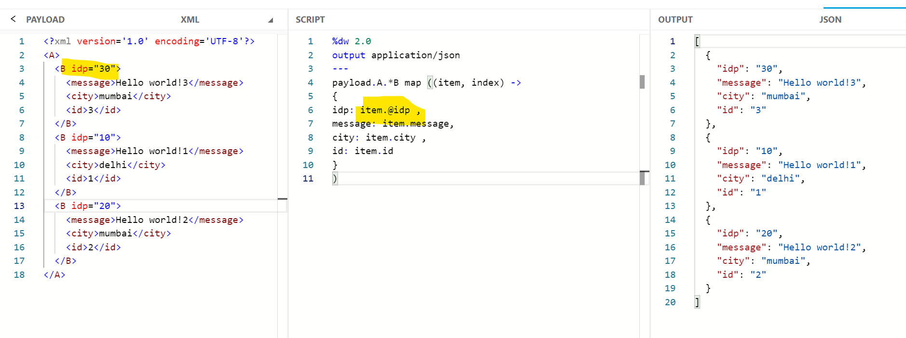

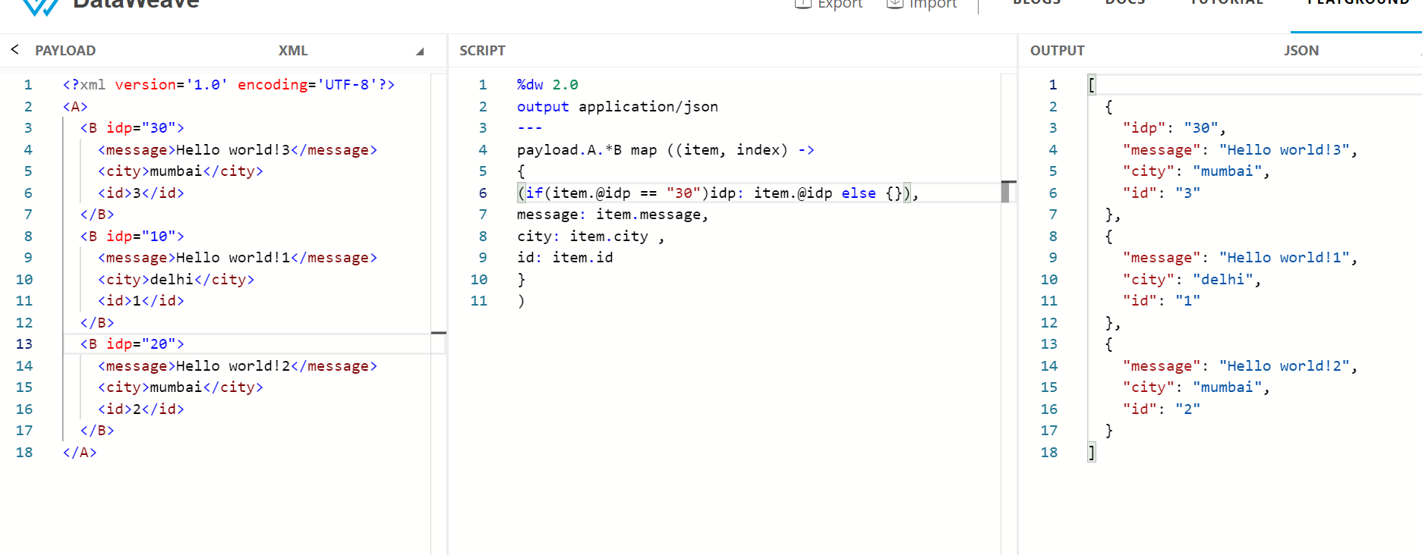



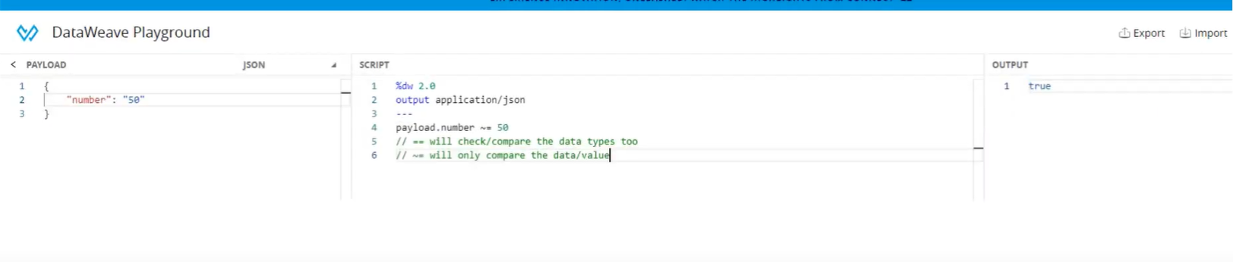

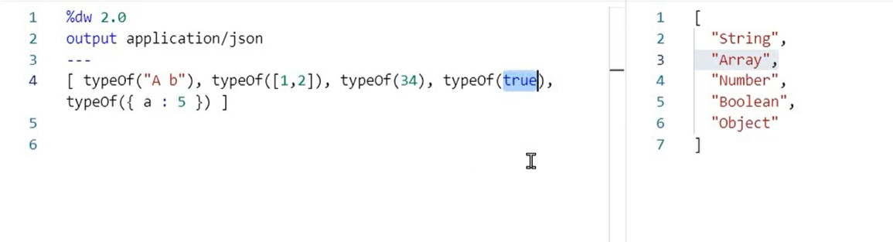

remove

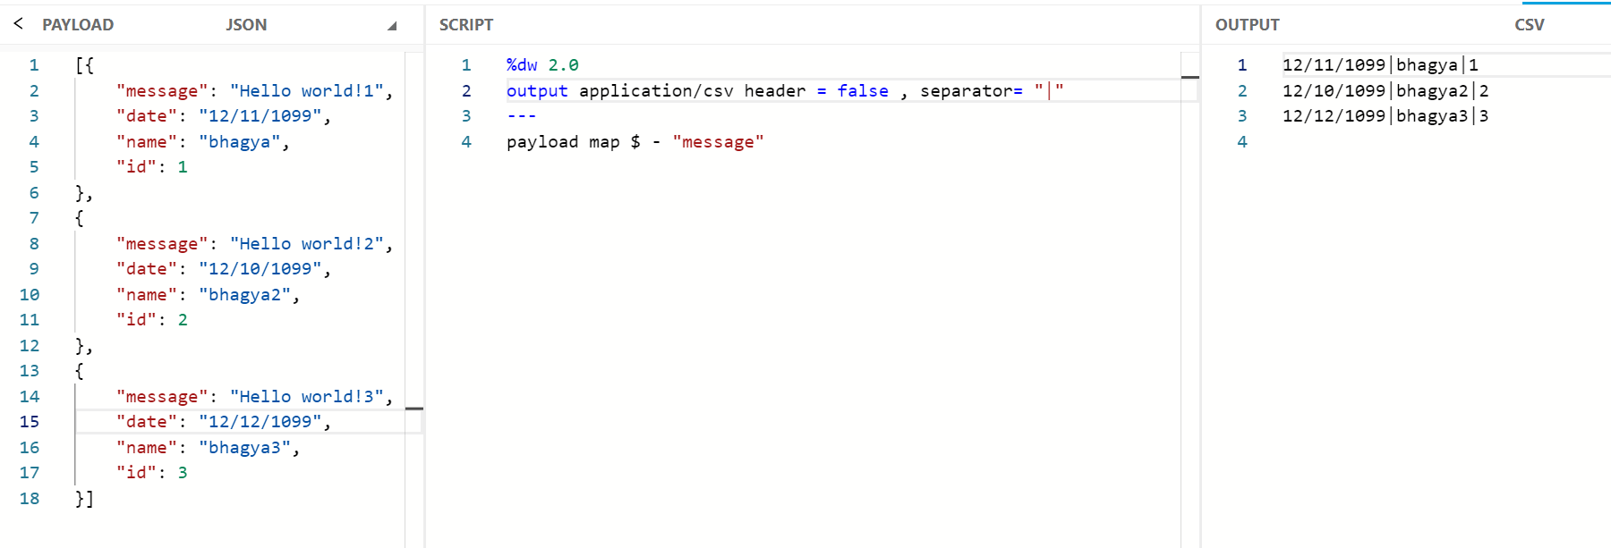

**Remove Count Key from each object**

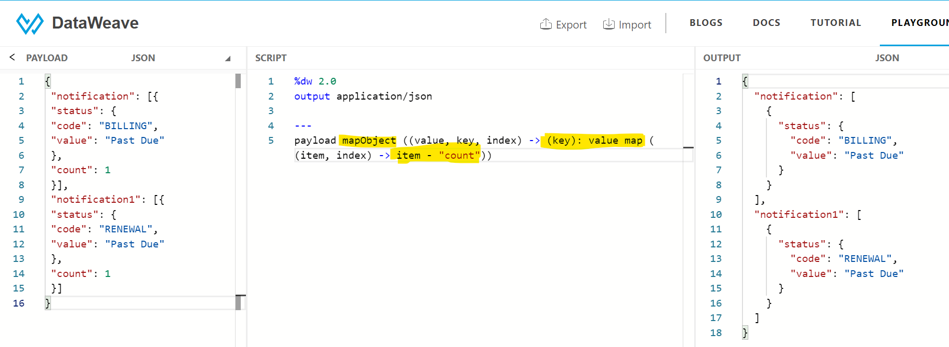

Separator pipeline header csv – dw::Strings

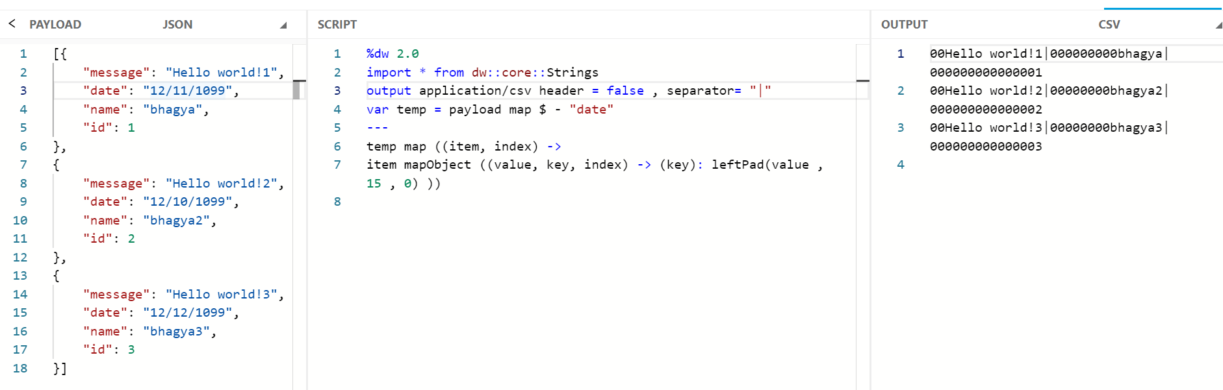



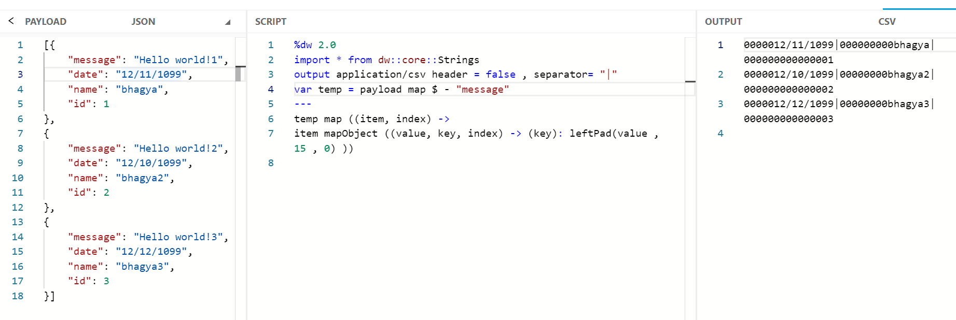

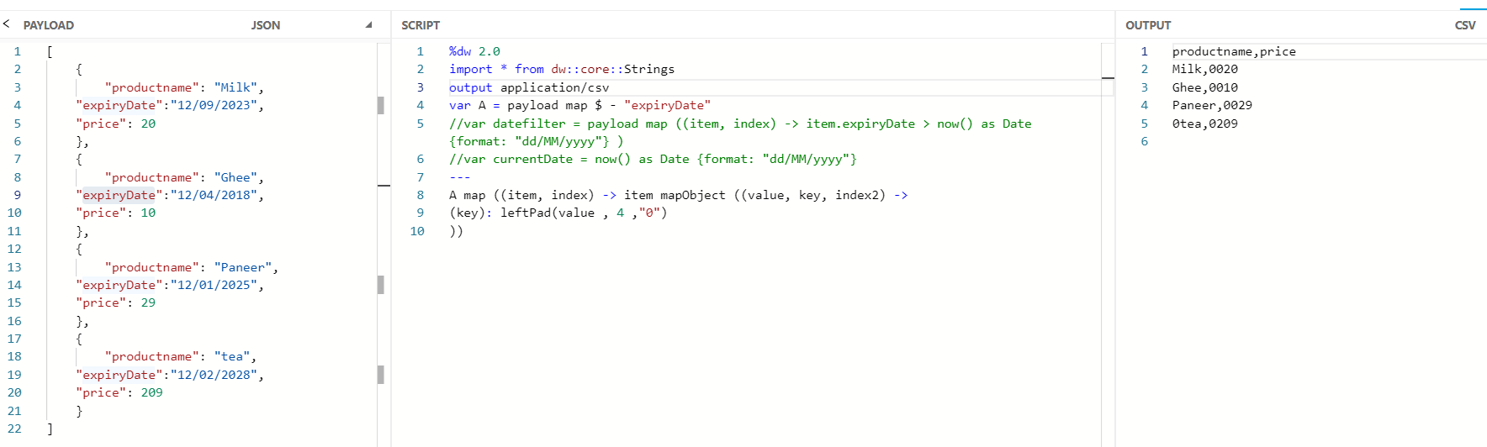

leftpad

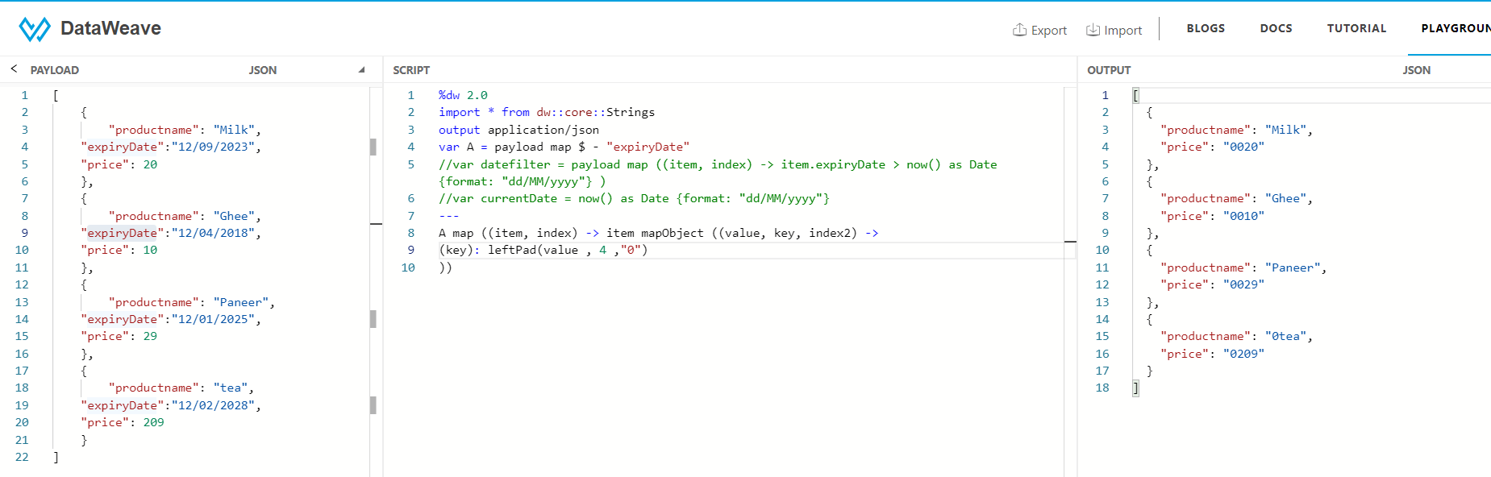

Remove – key value pair \*\*\*\*\*

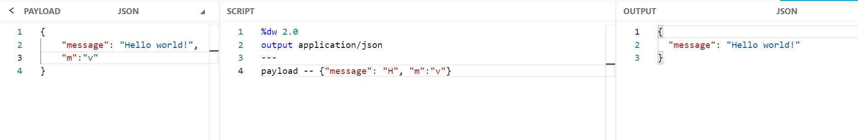



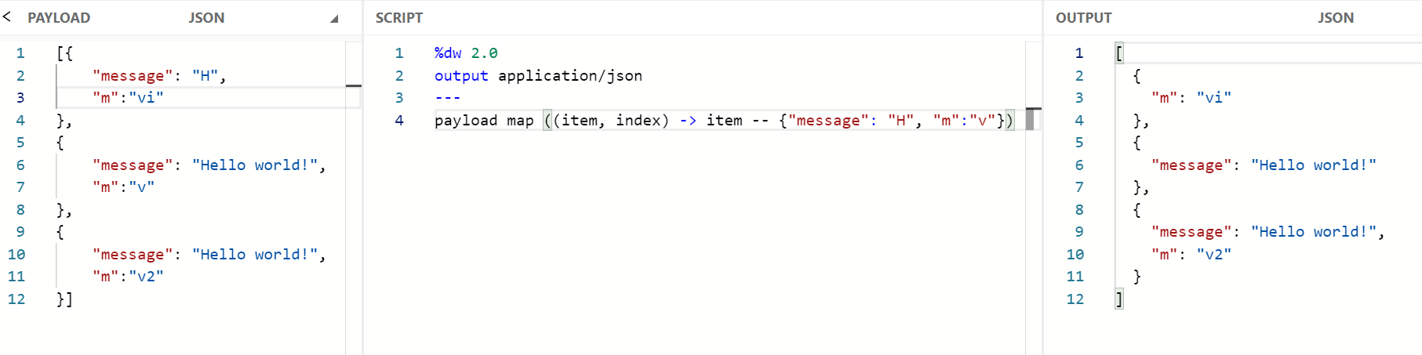

Merge 2 array values \*\*\*\*\*\*\*\*\*\*\*\*\*\*

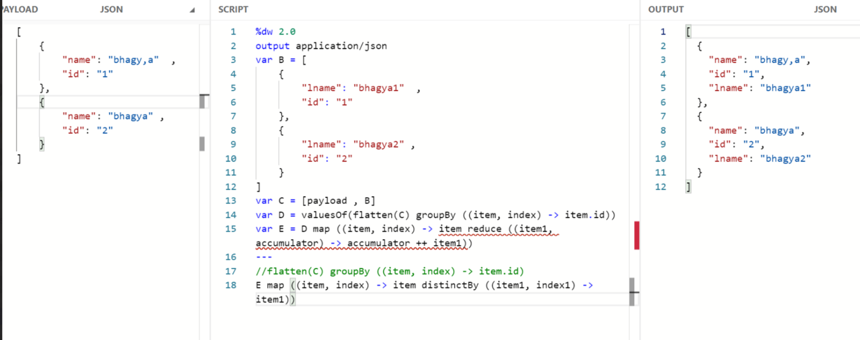

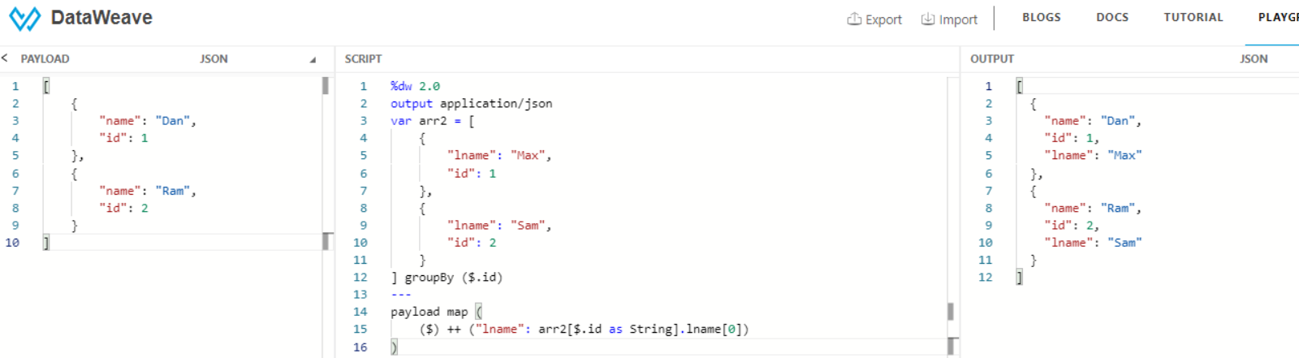



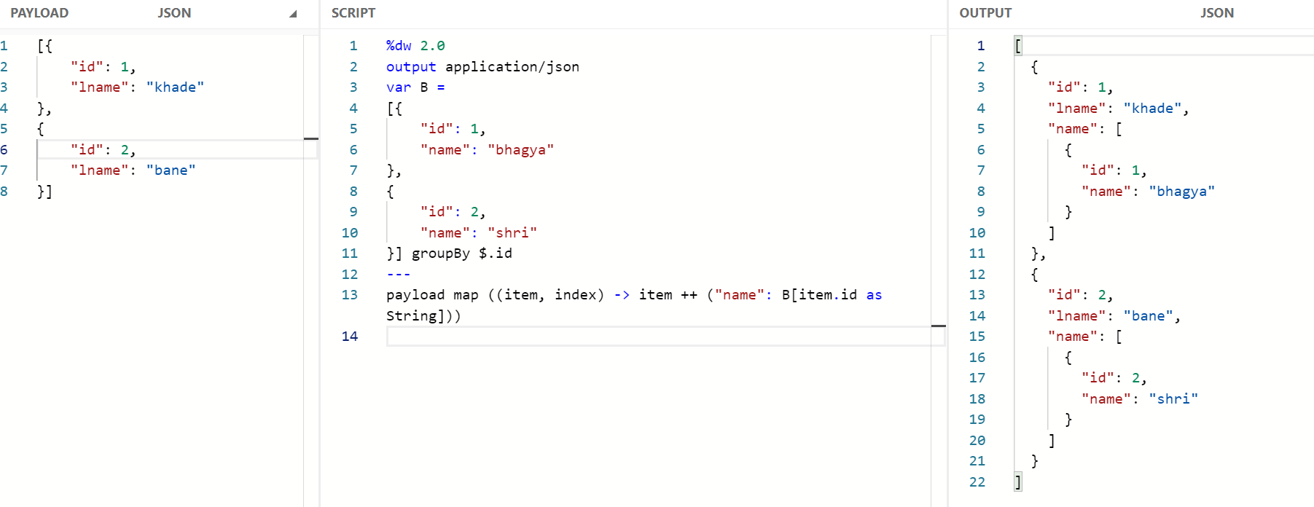

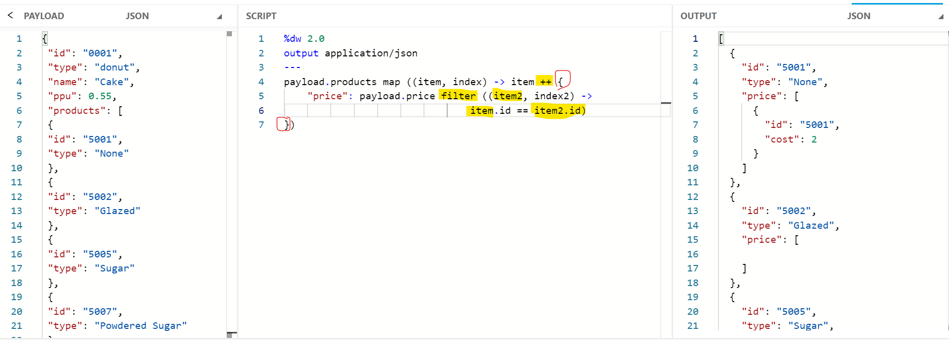

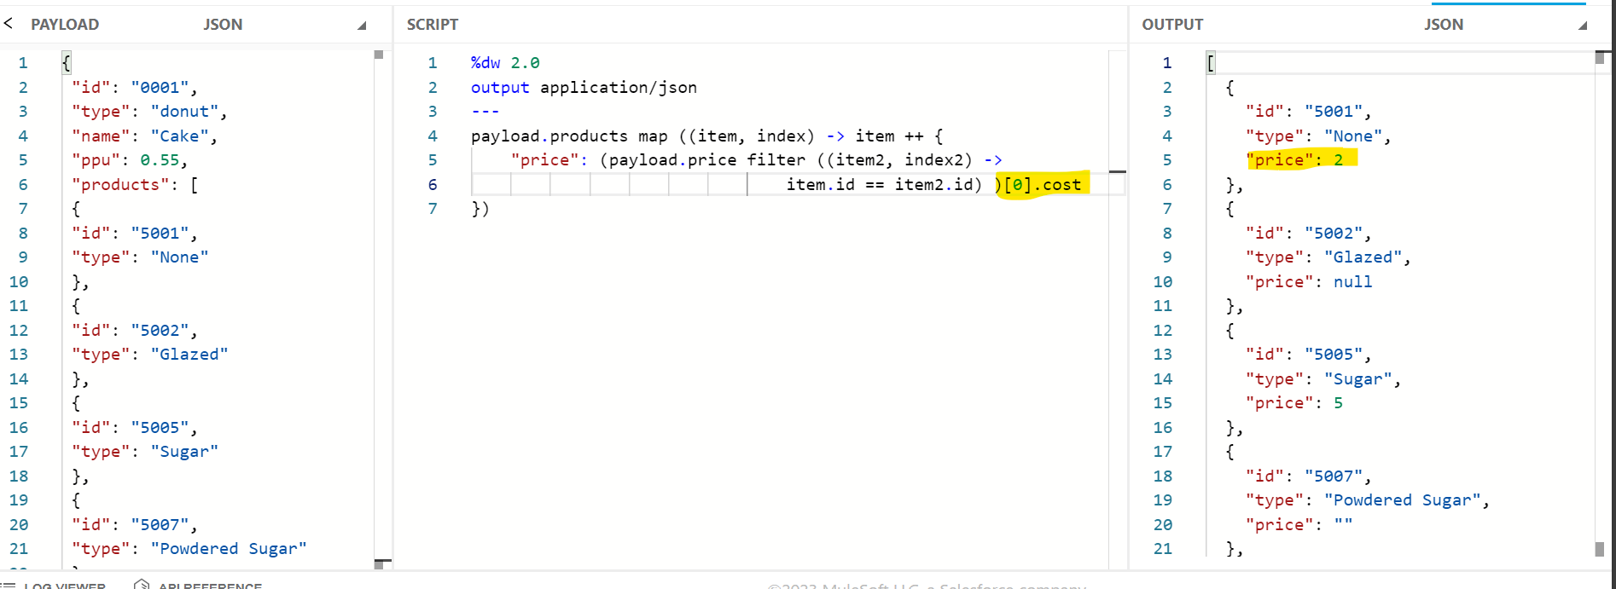

Reduce\*\*\*\*\*

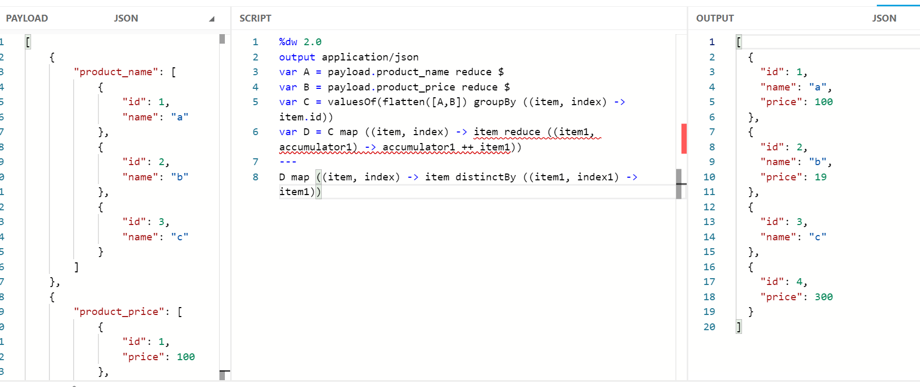

Even odd

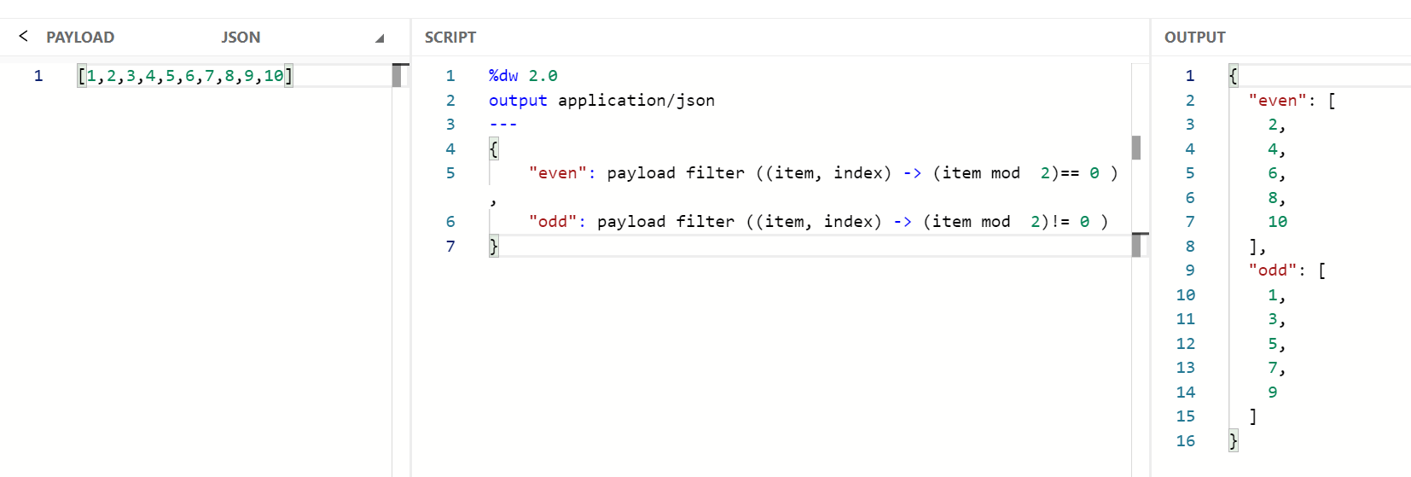

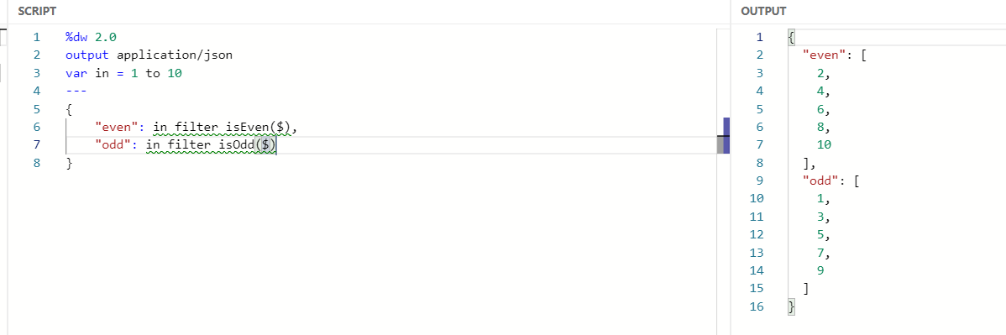

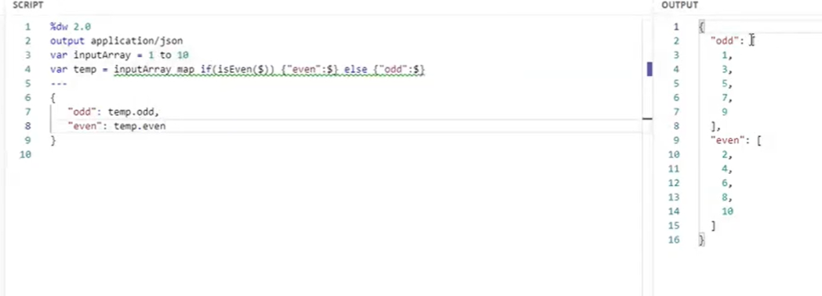

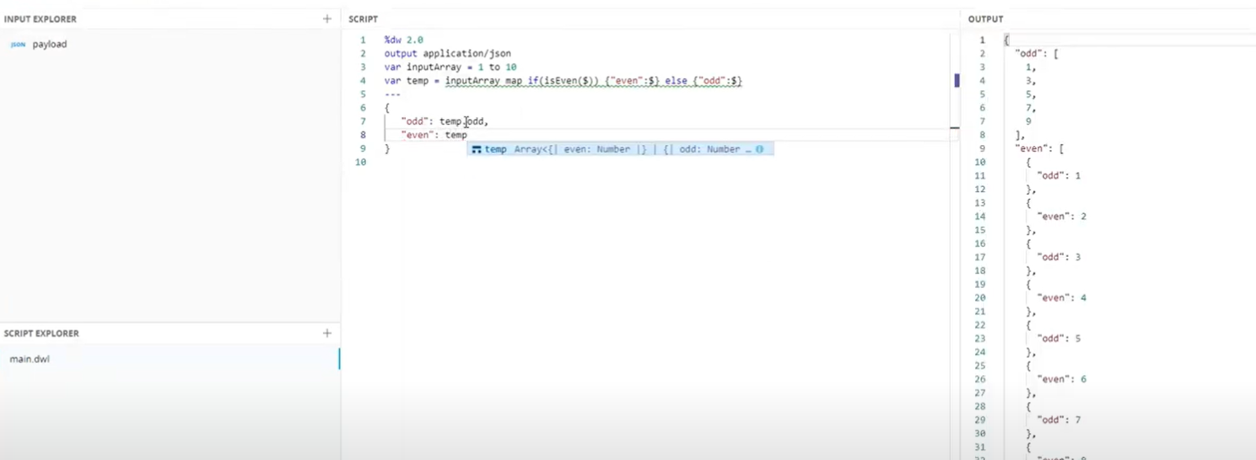

Reduce map

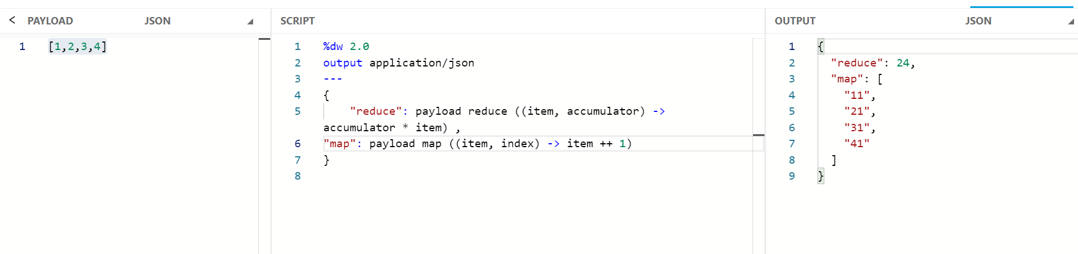

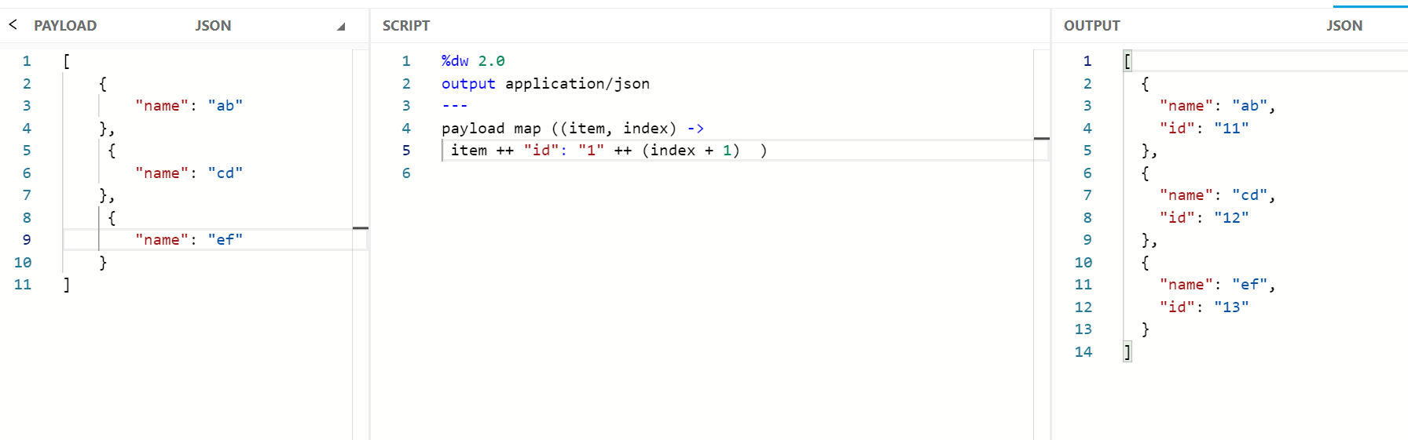

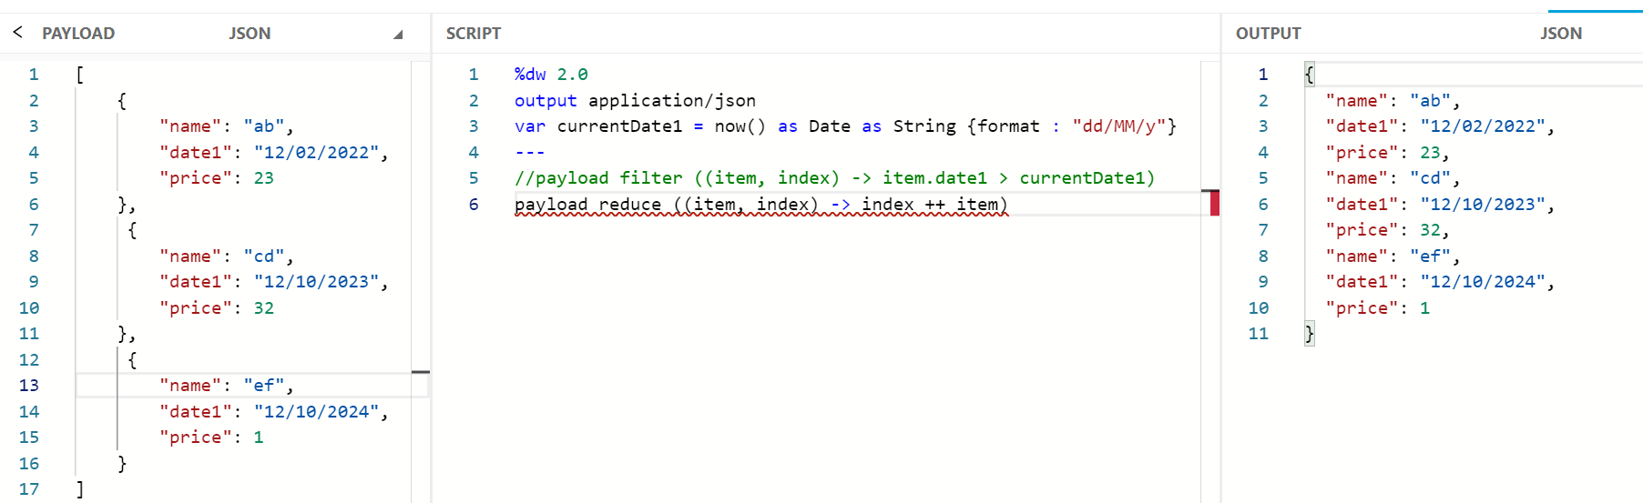

splitby

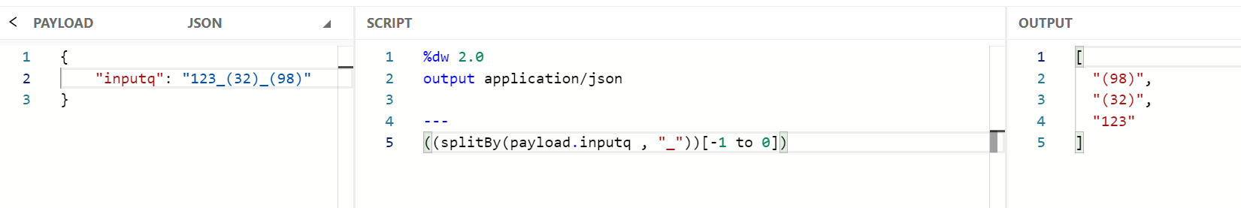

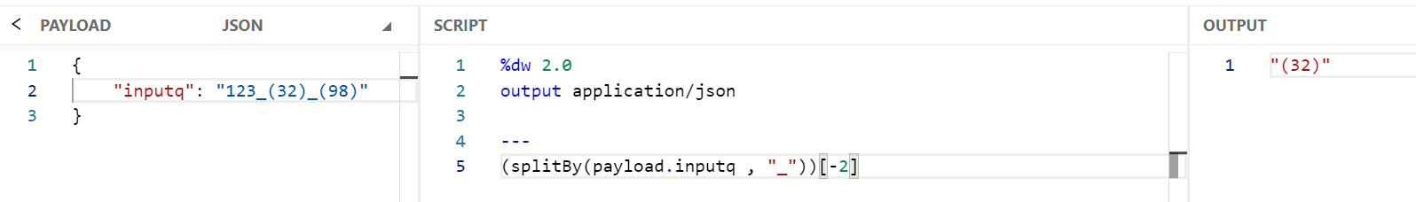

\*\*\*\*\*

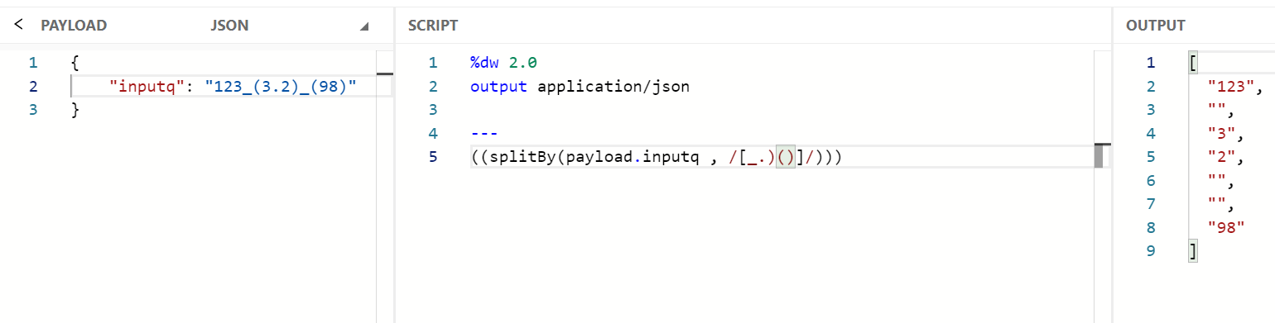

joinBy

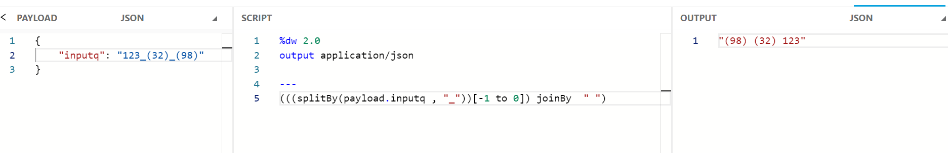

replace

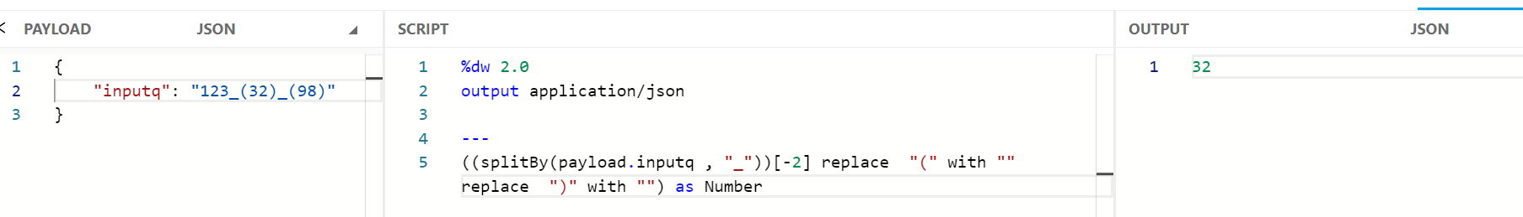



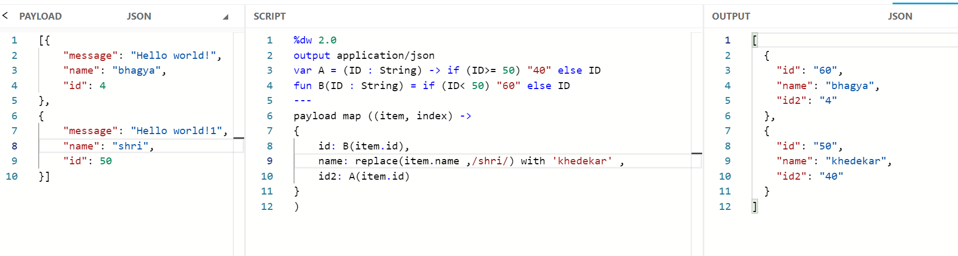



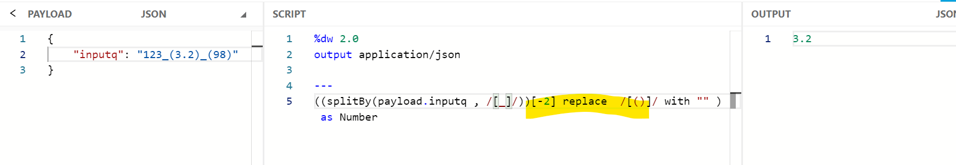

Mask dw::Values \*\*\*\*\*

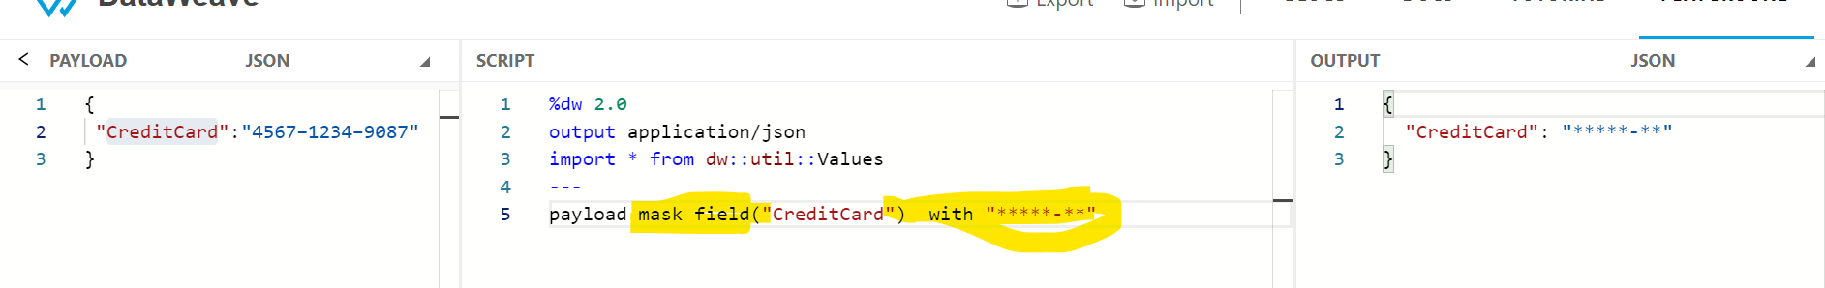

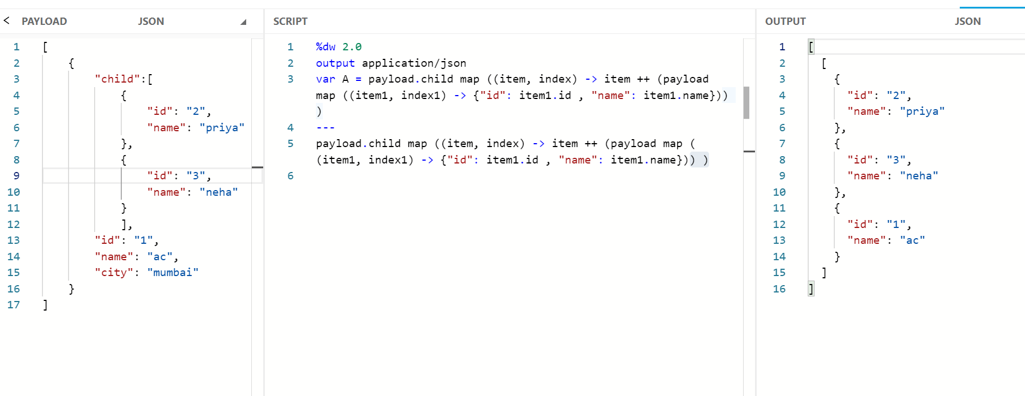

flatmap

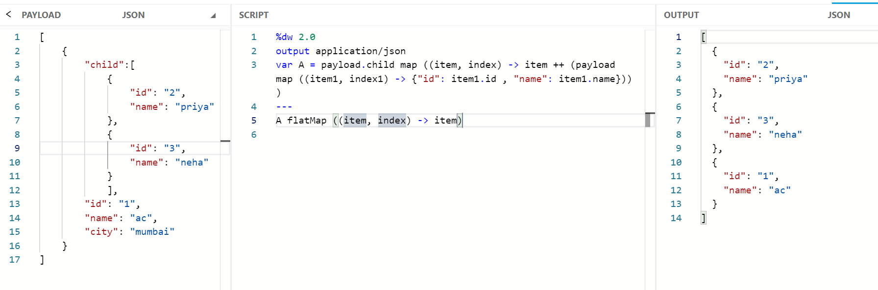

Flatten

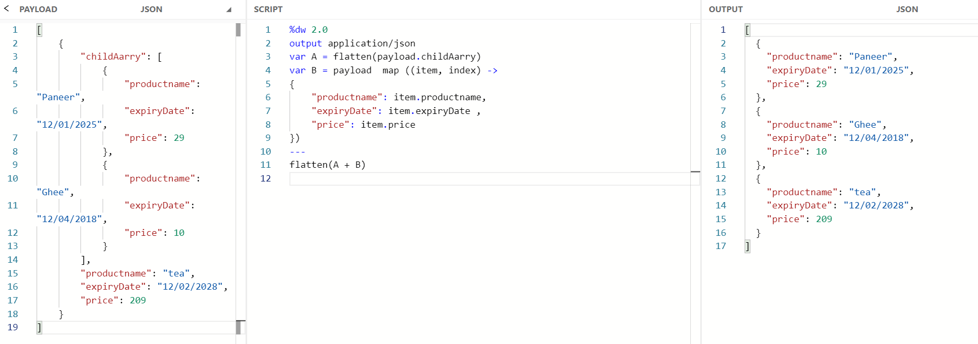

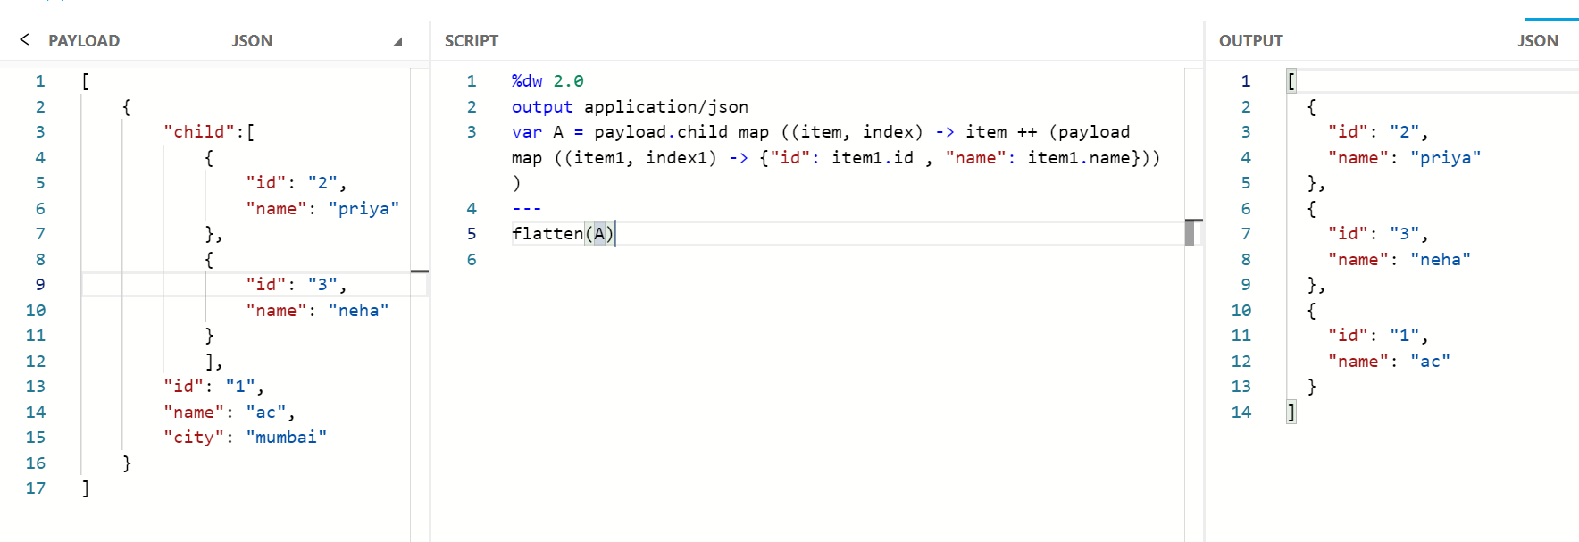

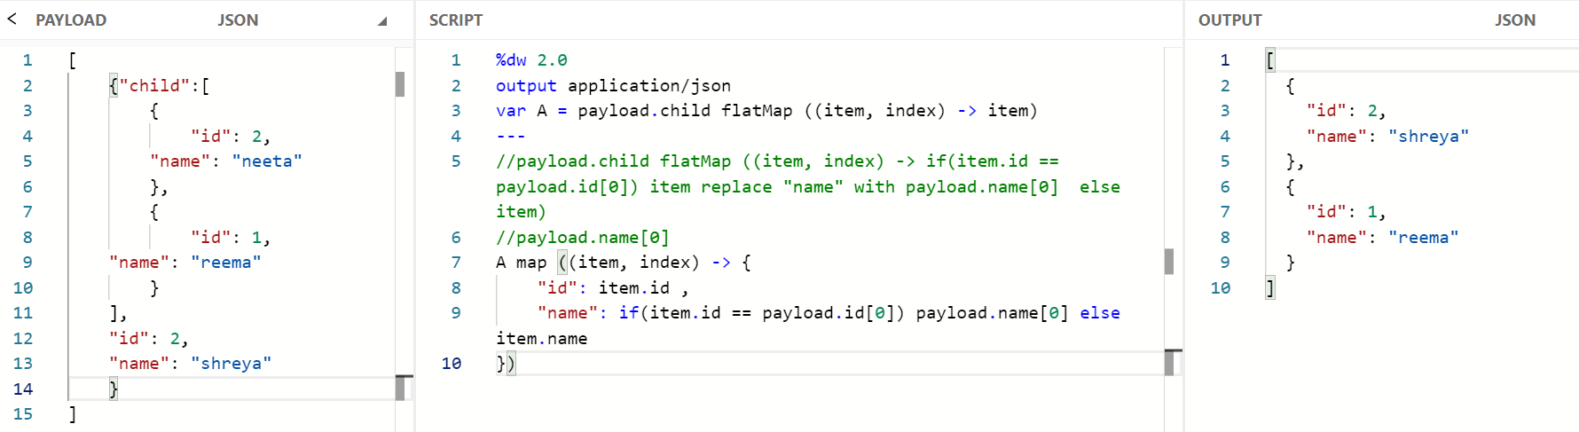

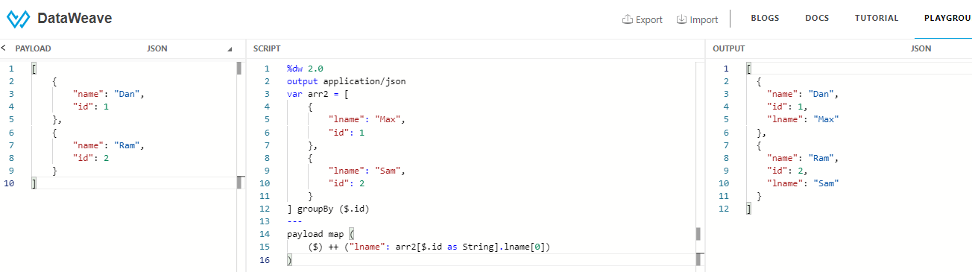

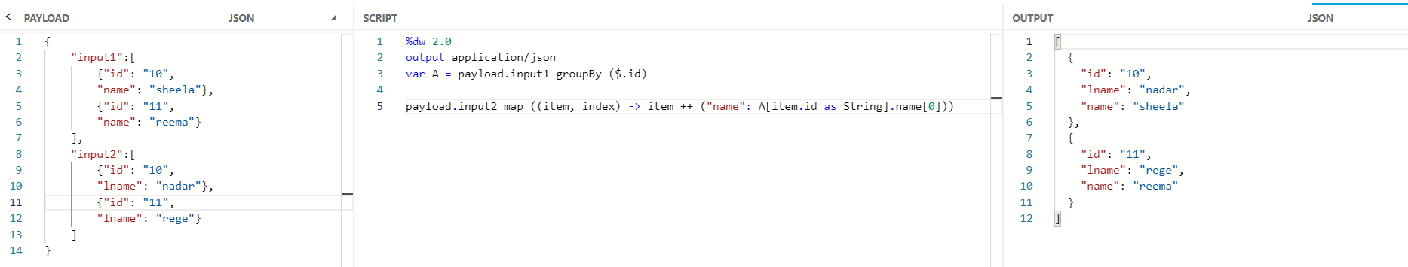

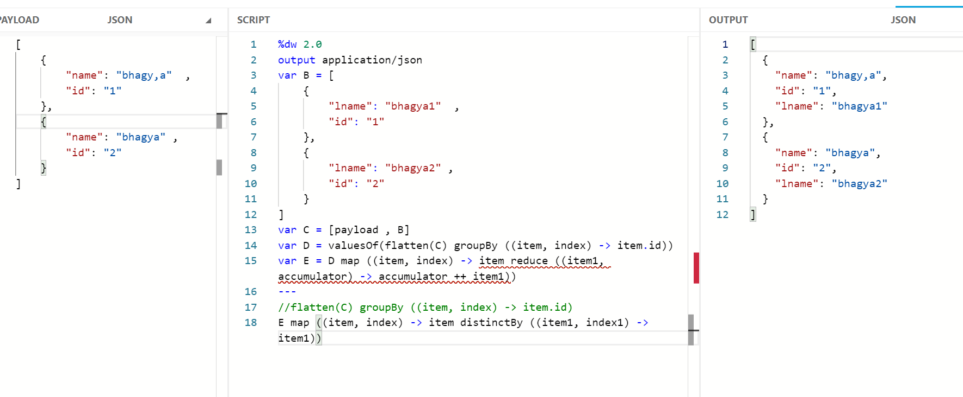

\*\*\*\*\*

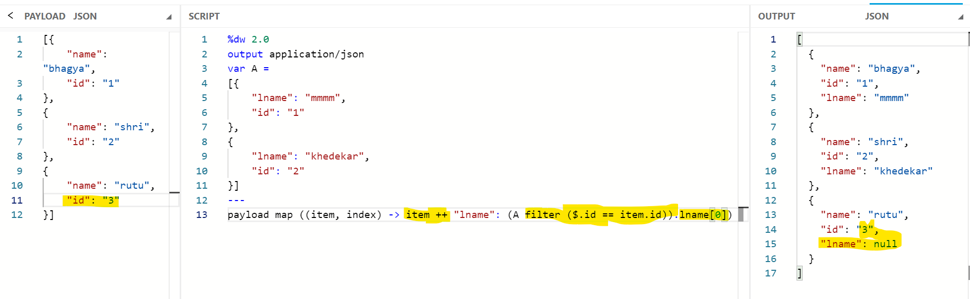



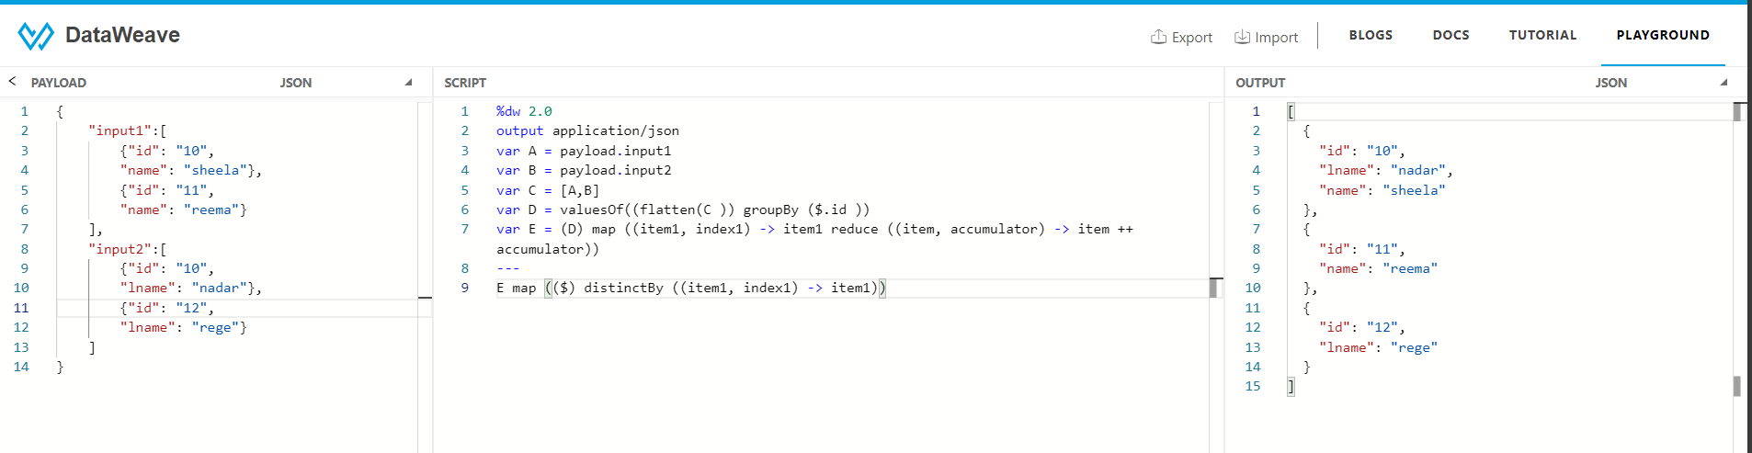

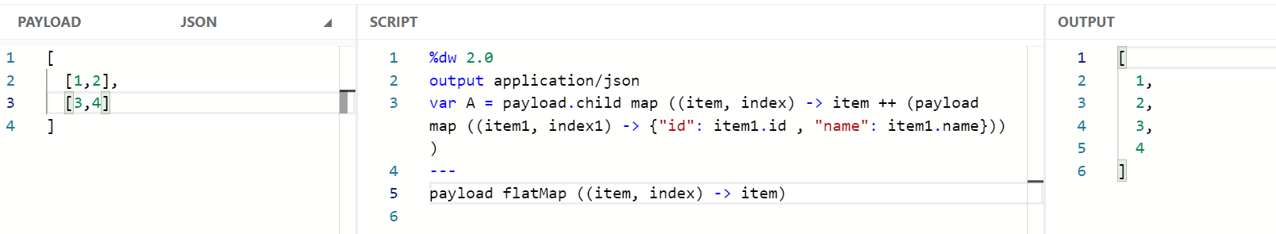

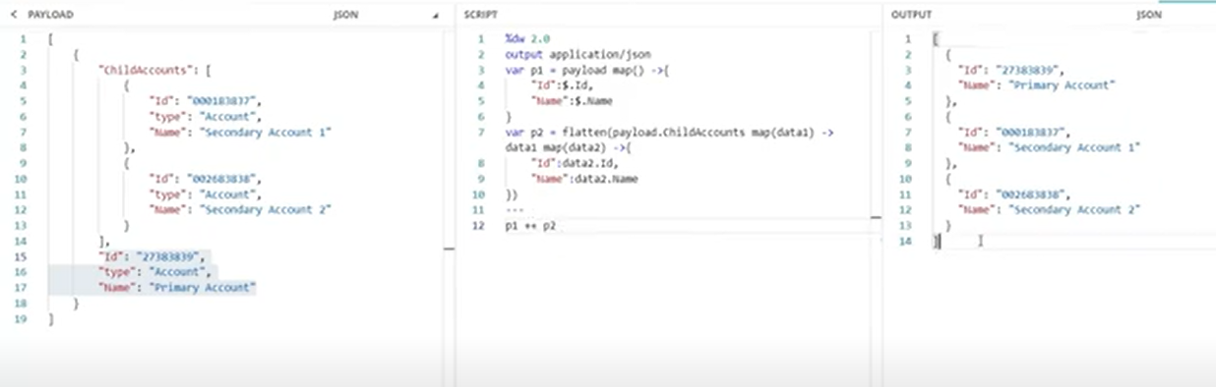

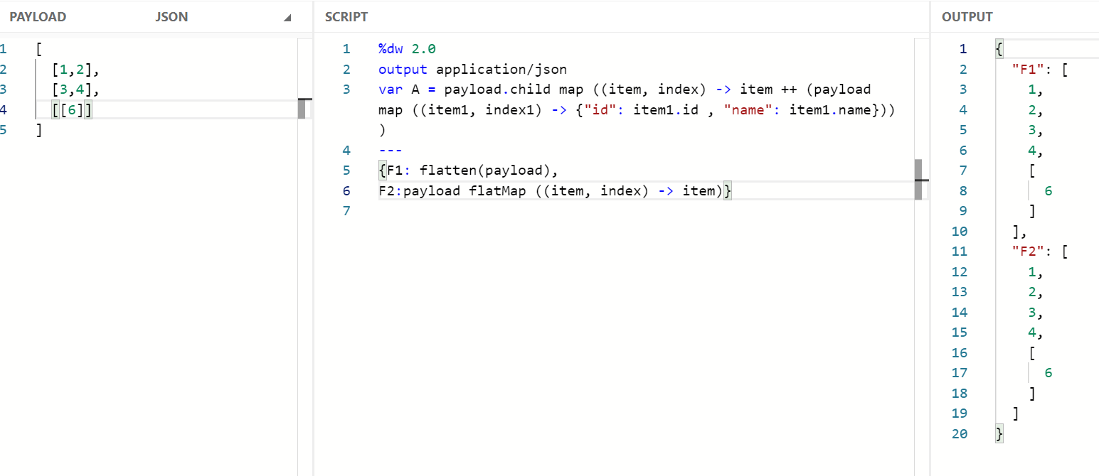

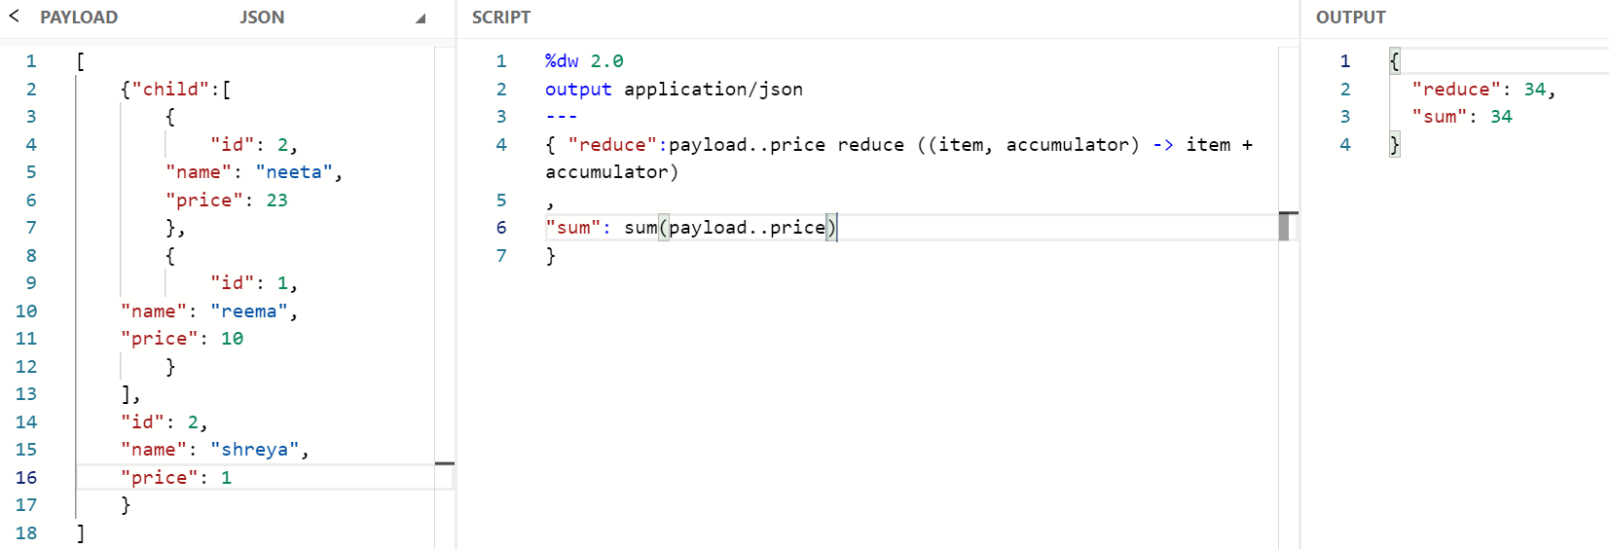

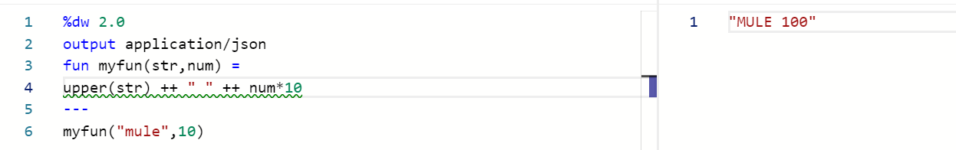

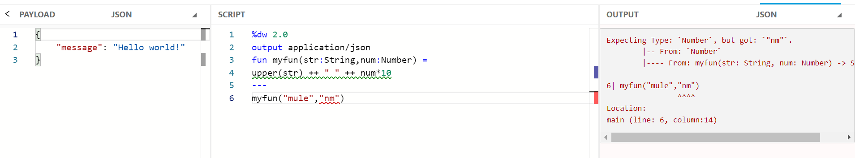

Filter

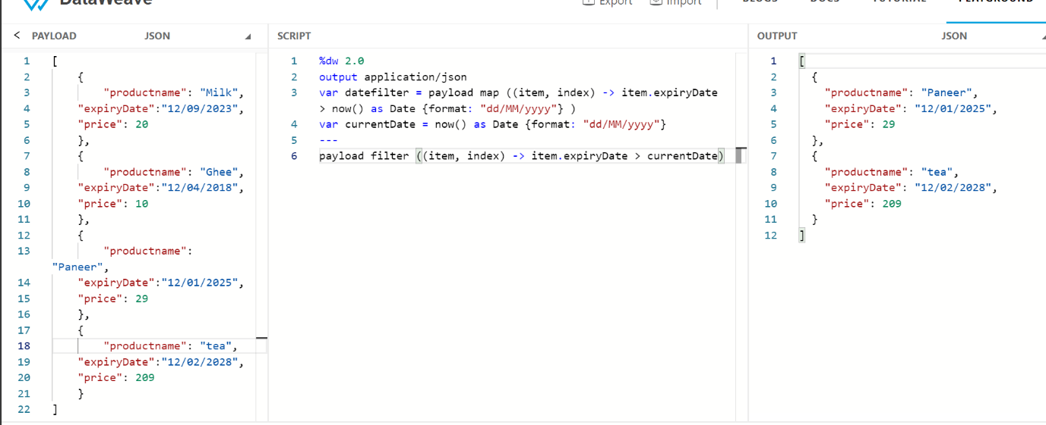

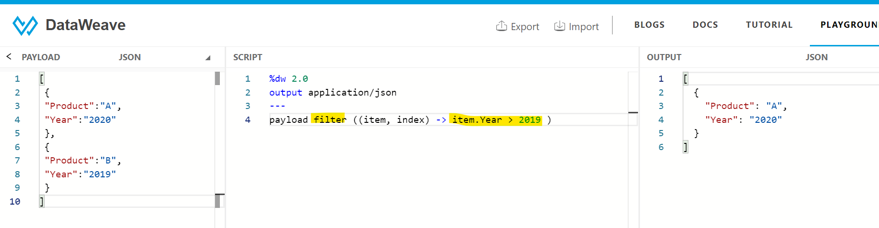

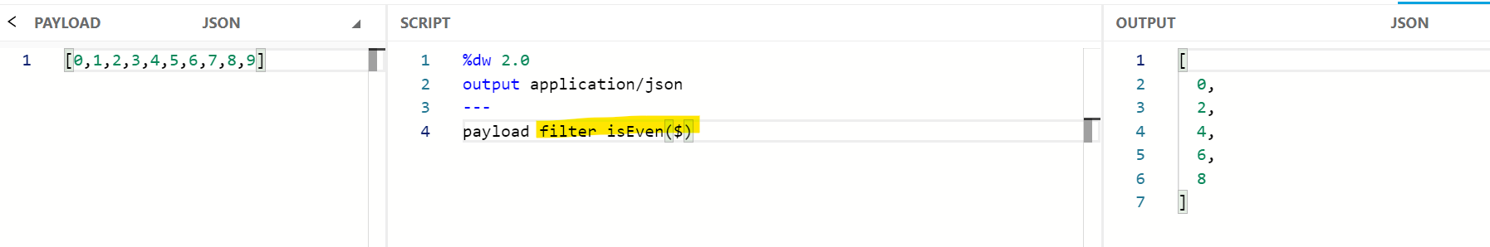

filterObject



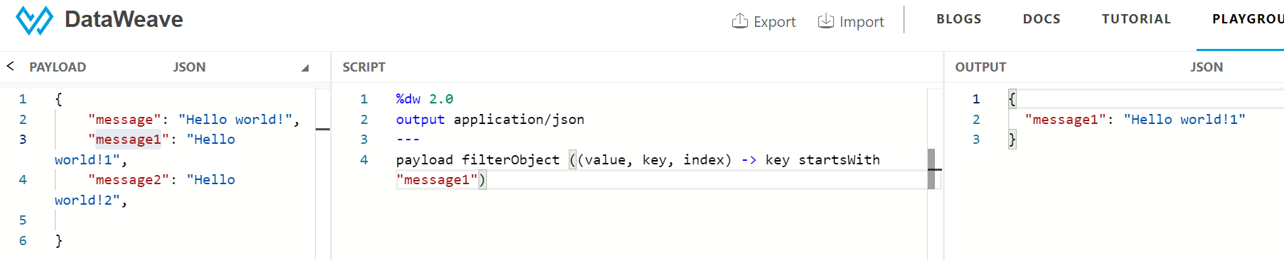

\*\*\*\*\*\*

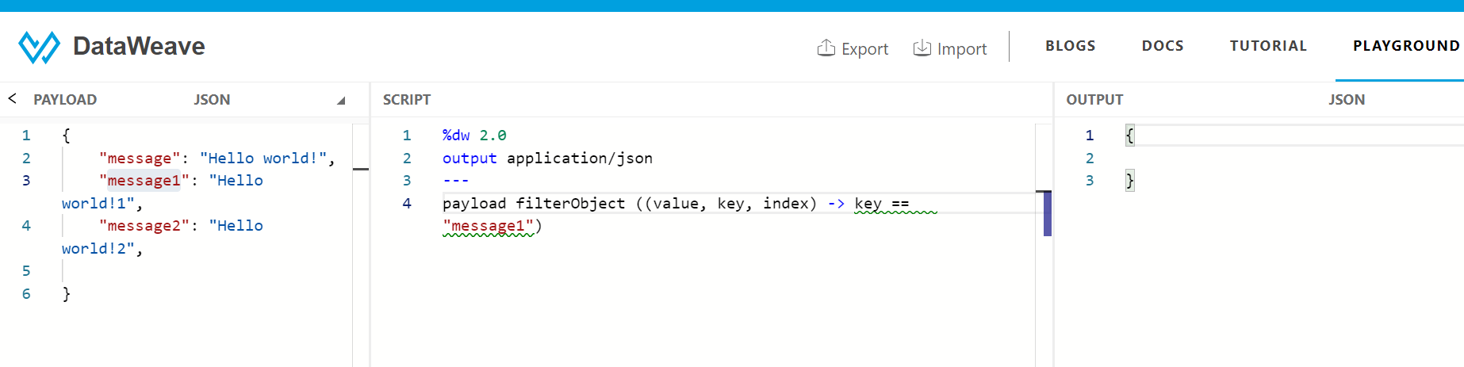



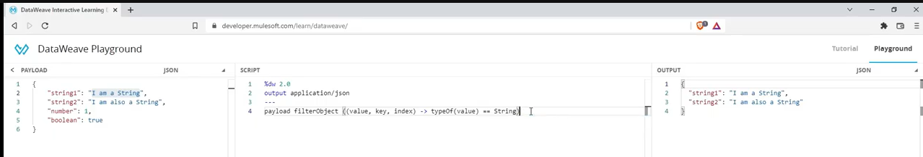

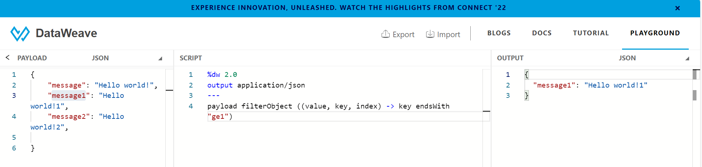

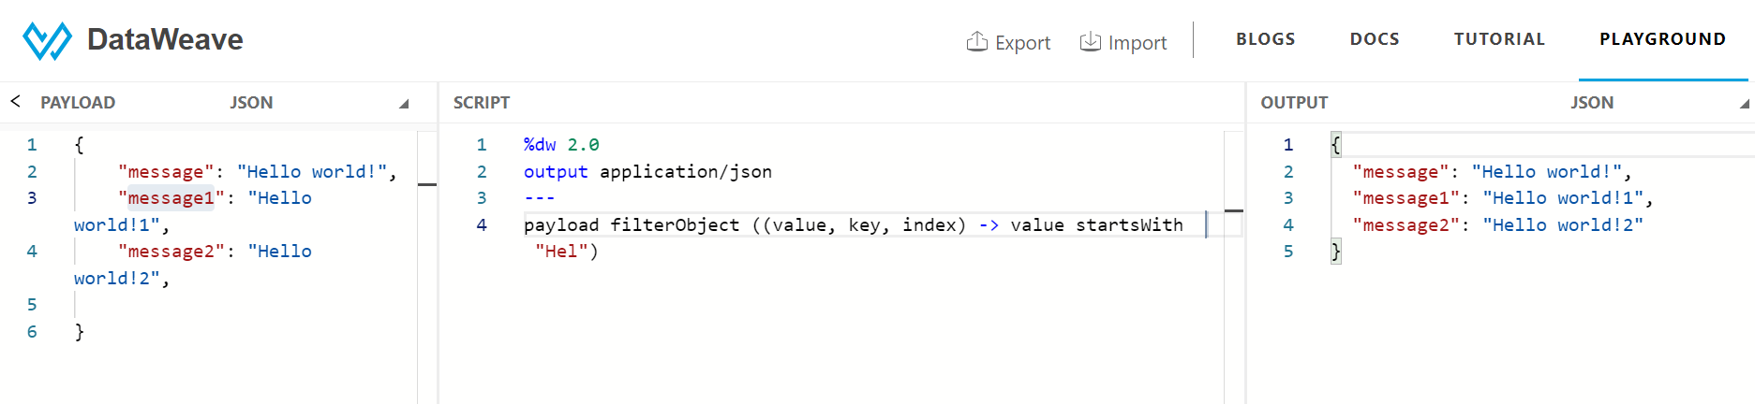

and condition

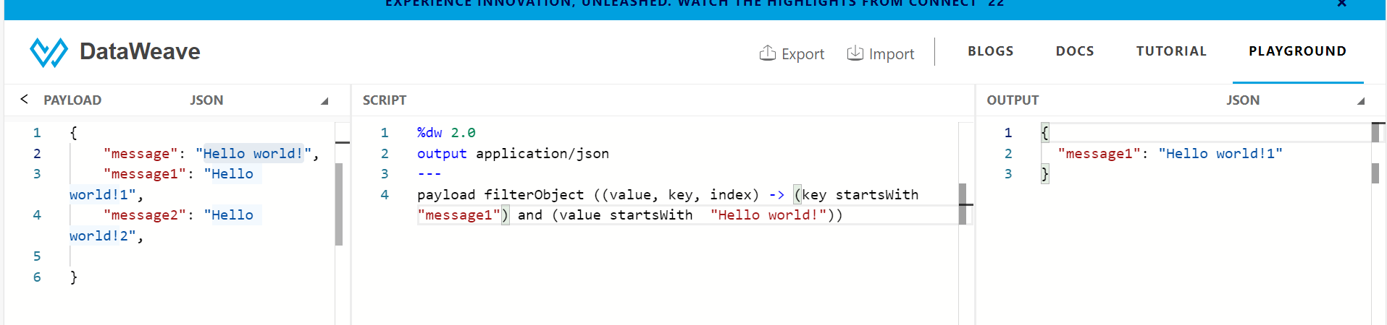



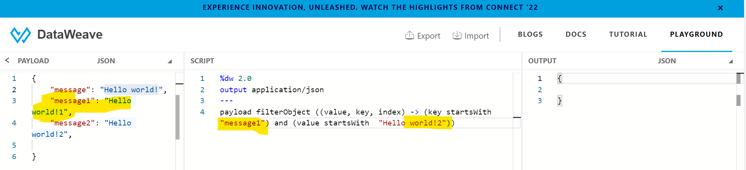

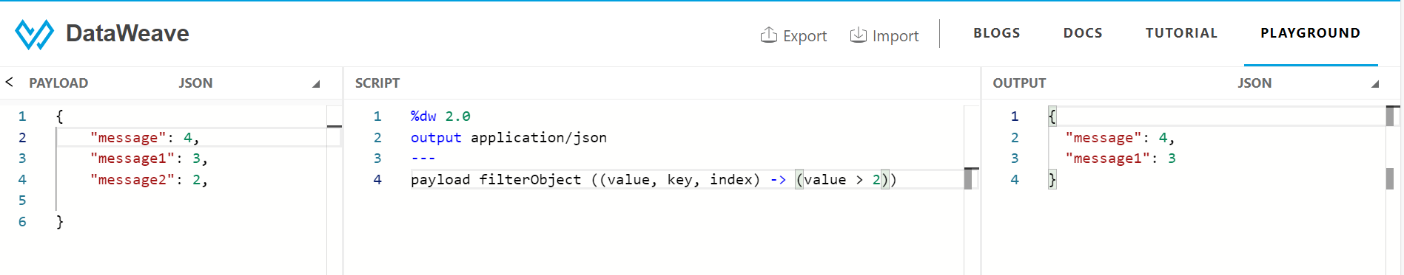

orderby

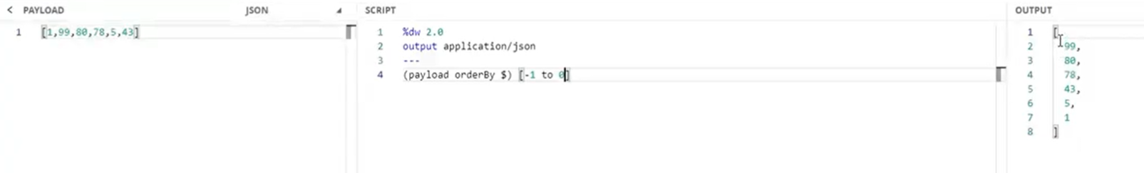

Map + adding new fields-

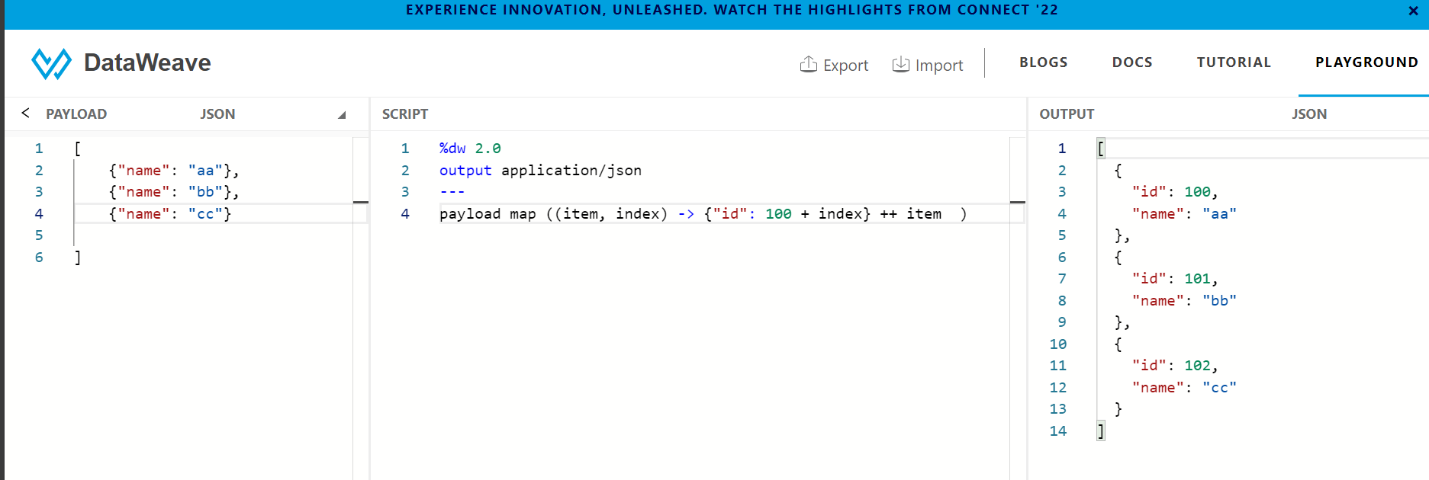

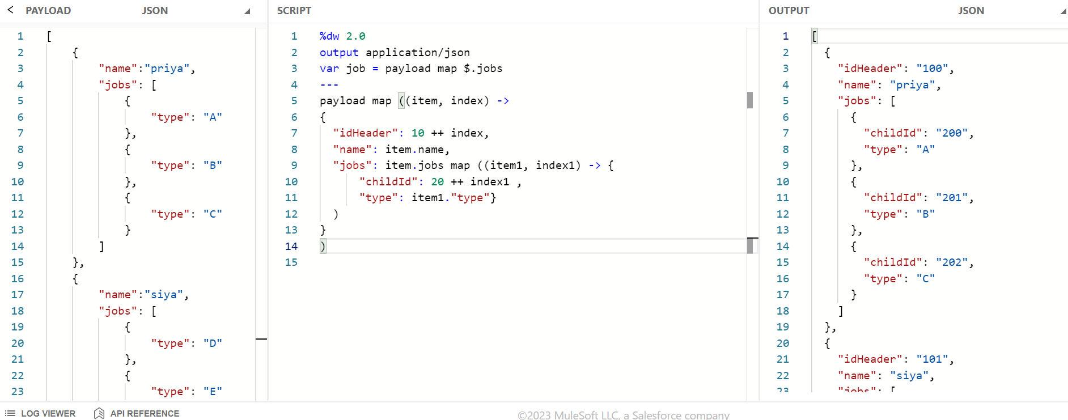

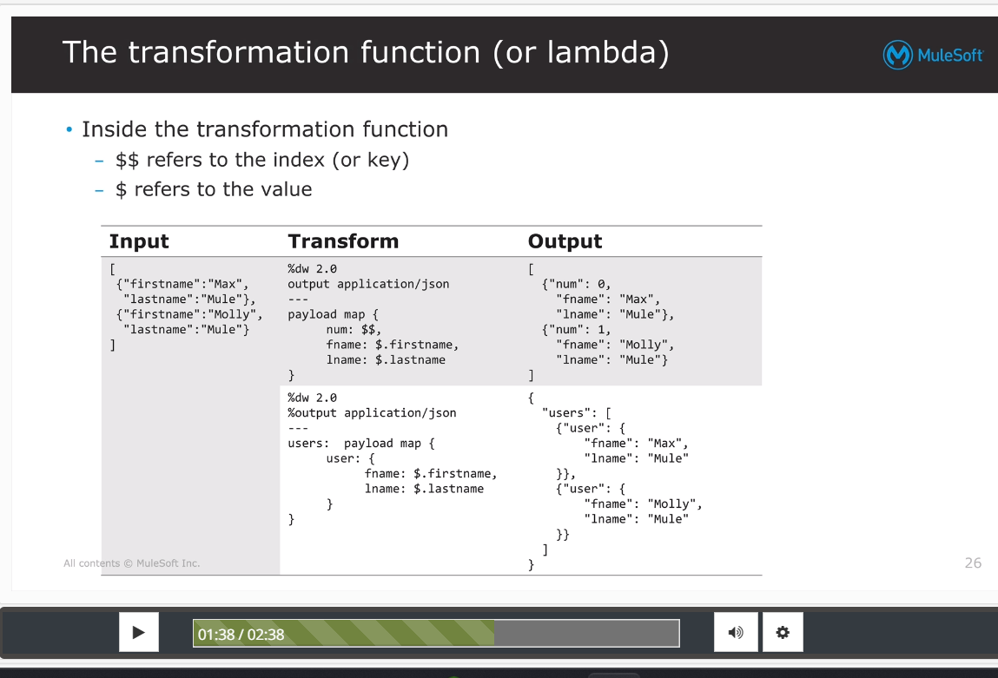

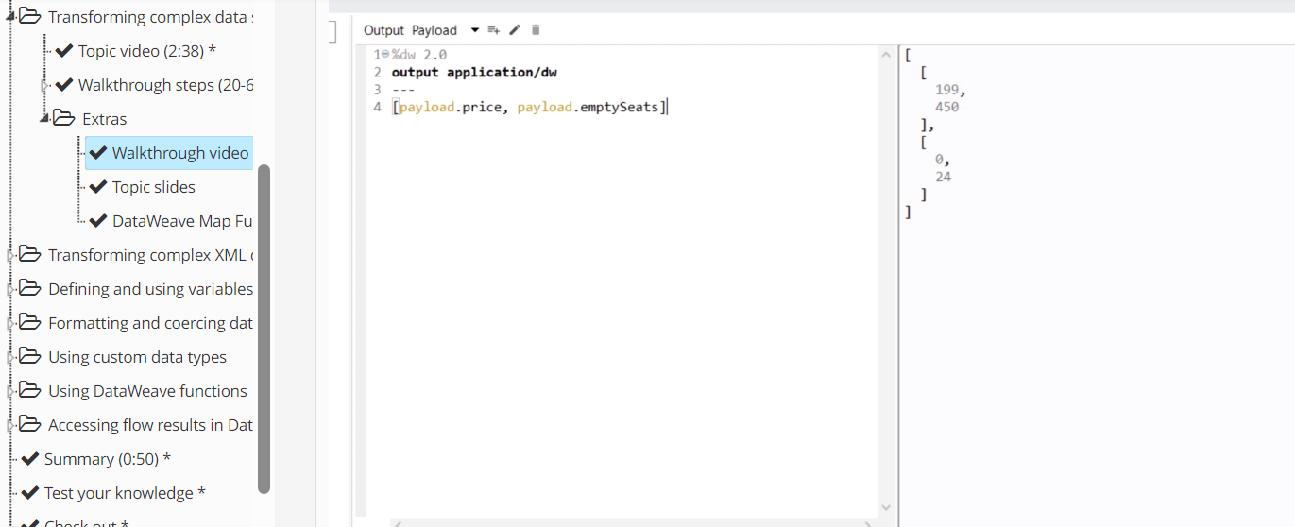

distinctBy

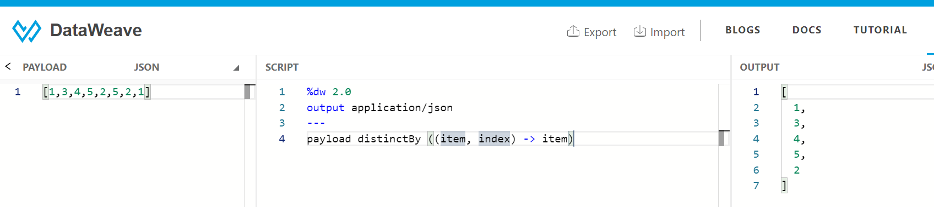

\*\*\*\* applicable for object also

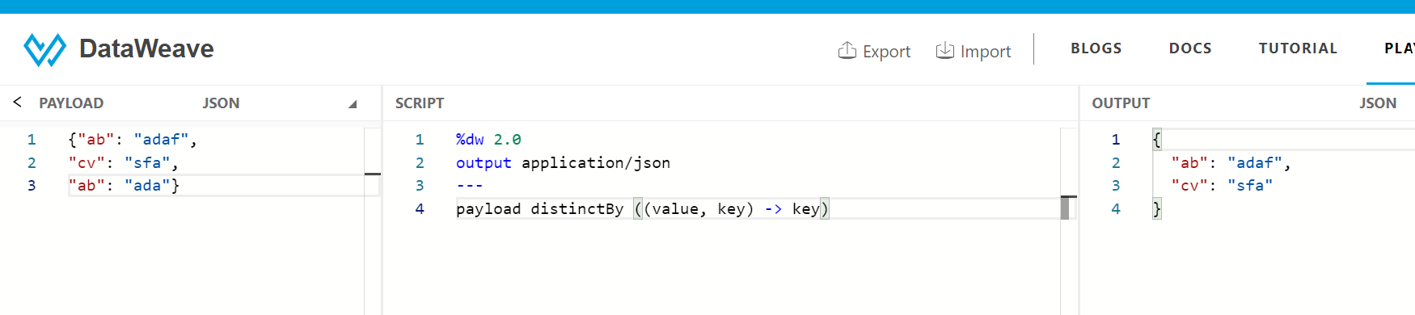

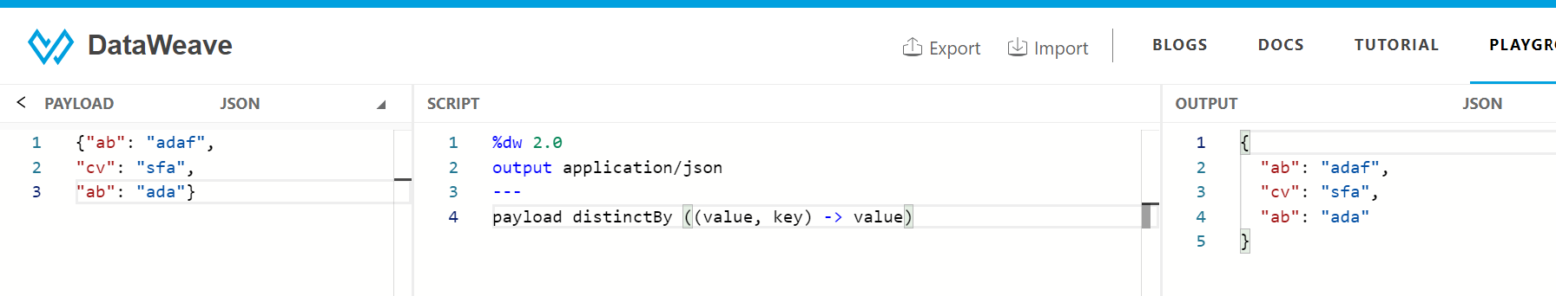

Key value pair unique \*\*\*\*\*\*

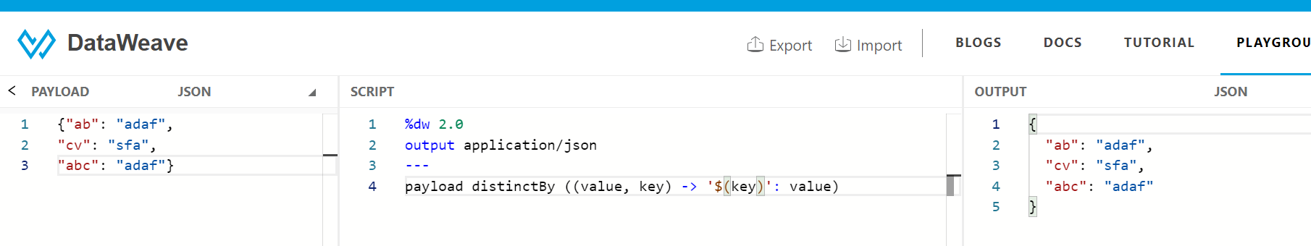

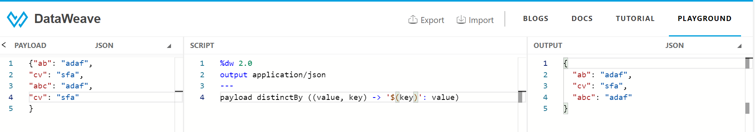

Value selector

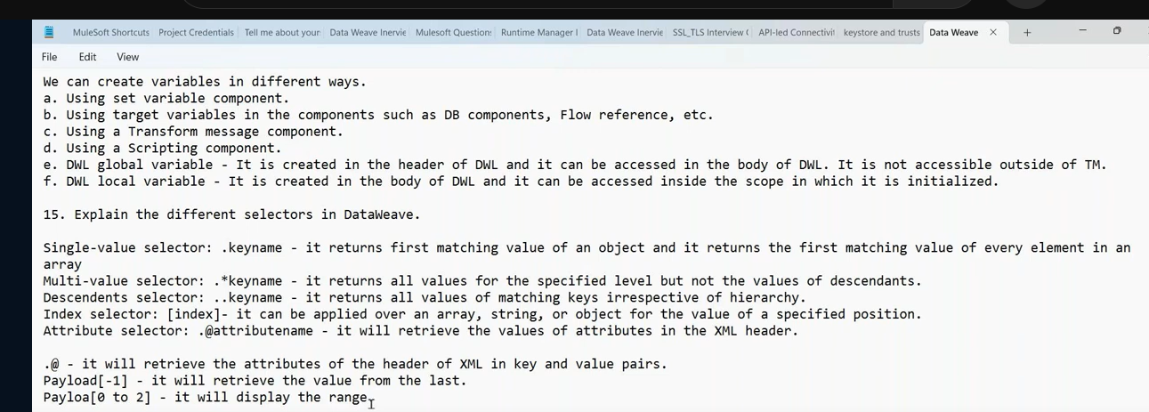



Date

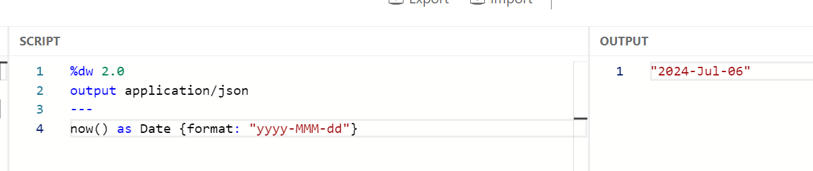



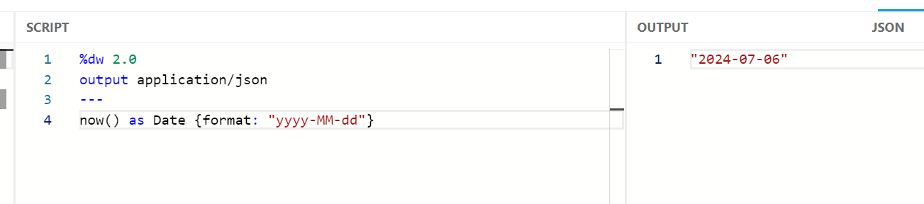



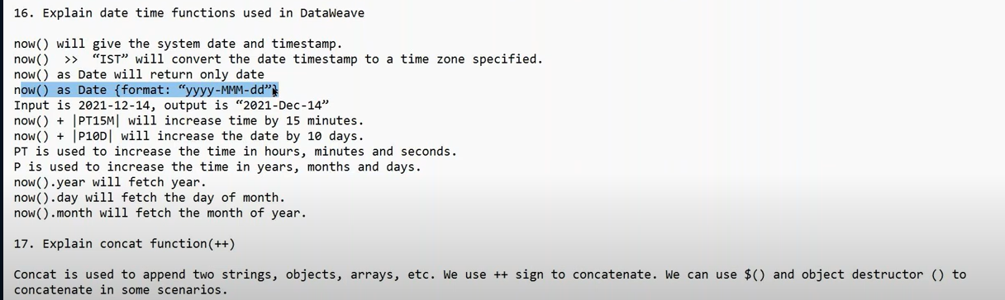



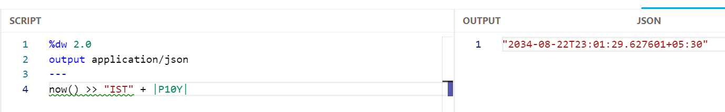

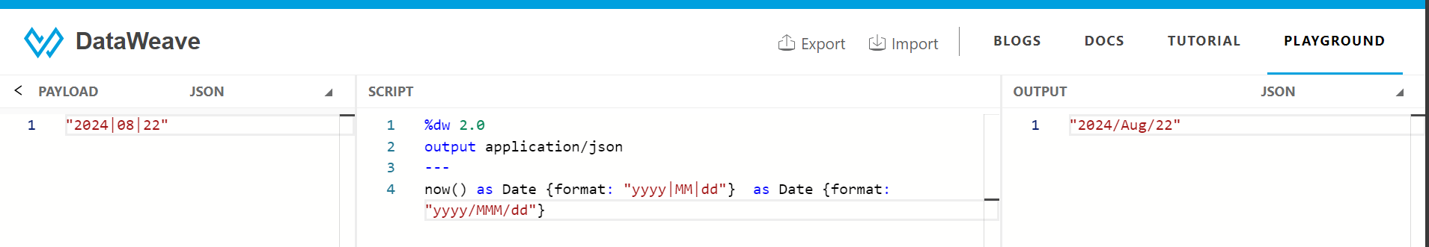



Print start date dw::Dates

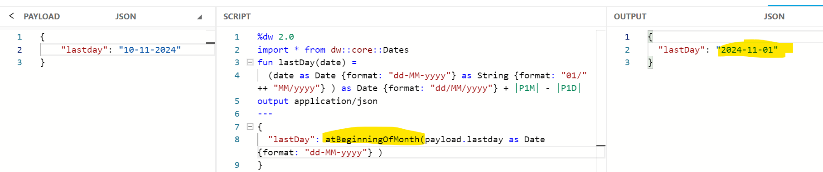

**Print Last Date of the Month given a date as input**

**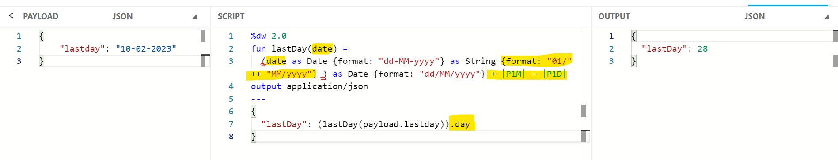**dw :: date

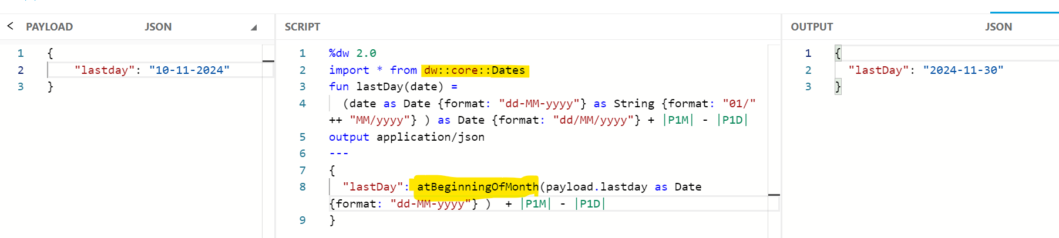

joinBy

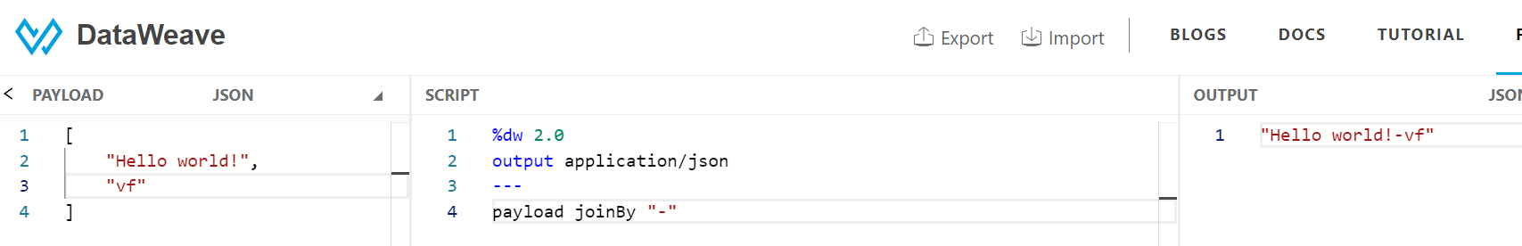

PUT and PATCH

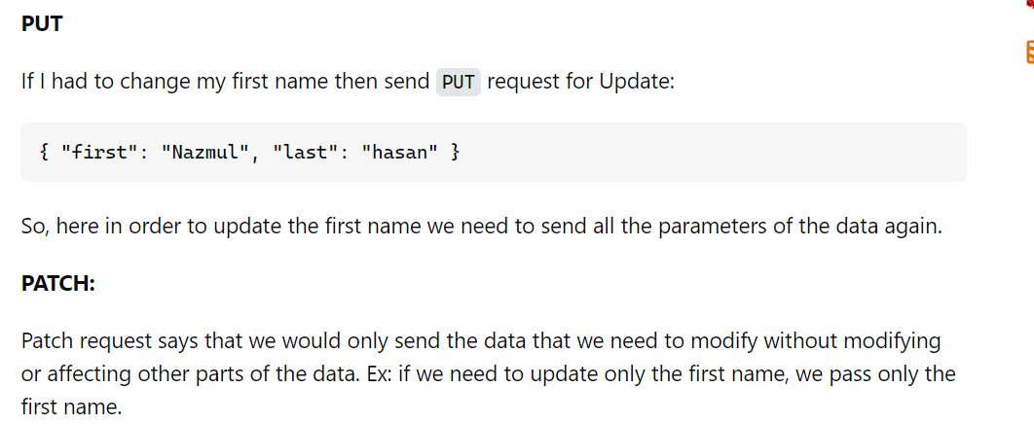

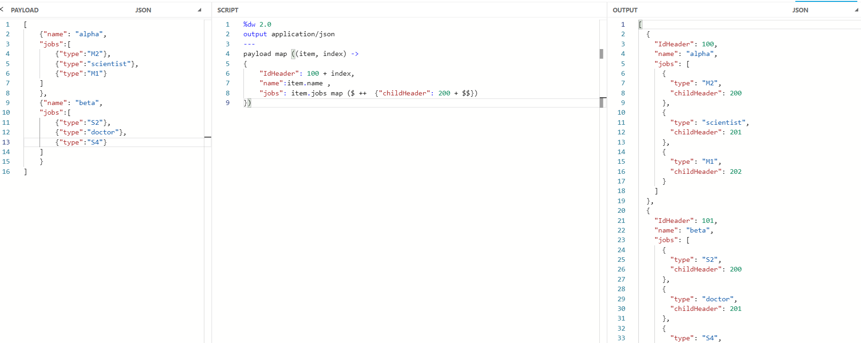



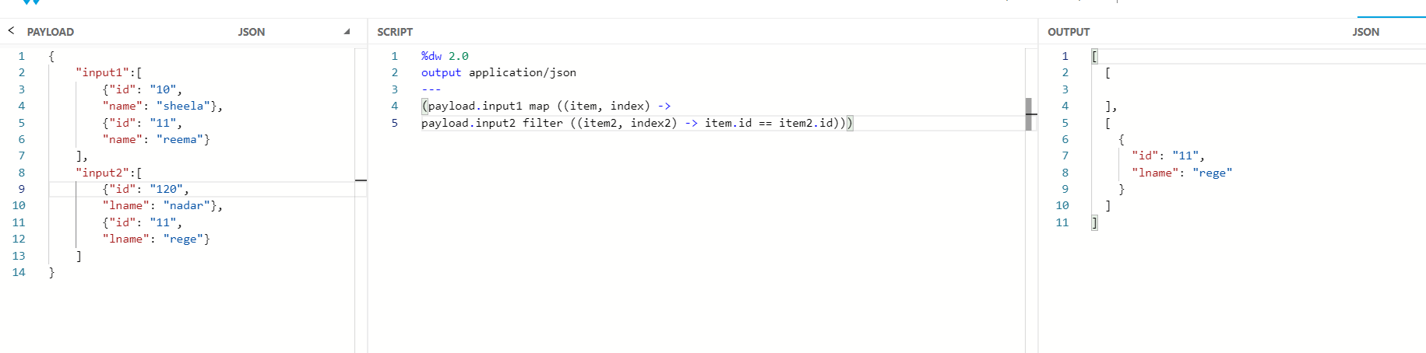

Max and min value

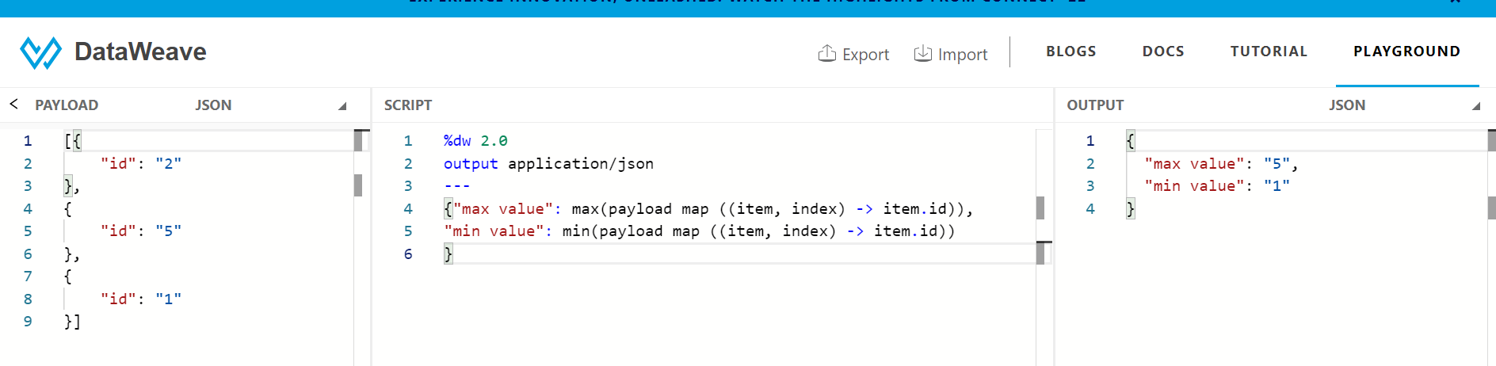

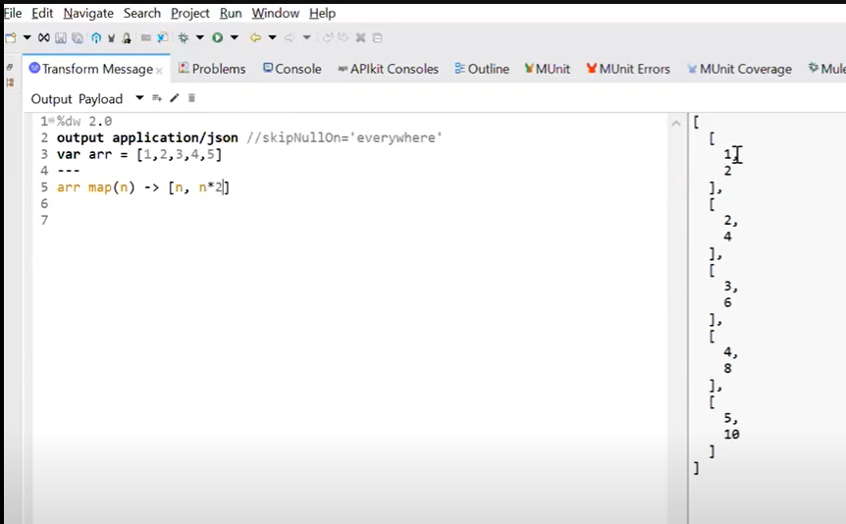

**Print Last x characters of a number or String dw::Strings last**

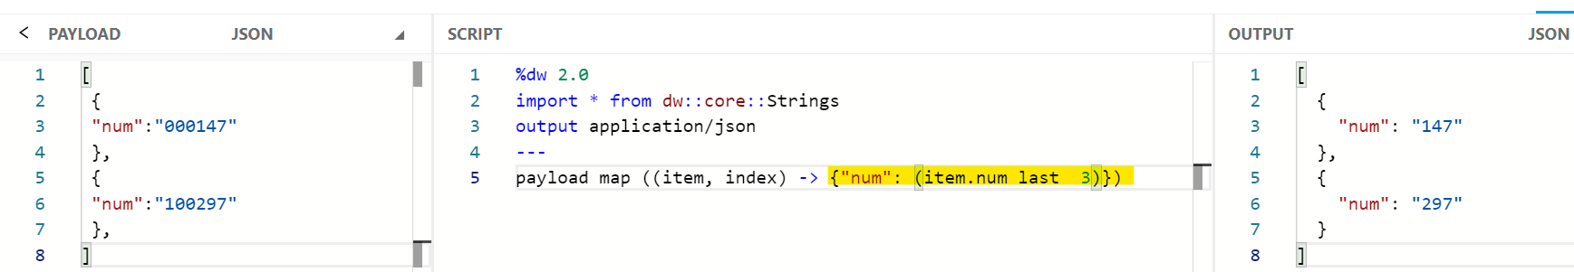

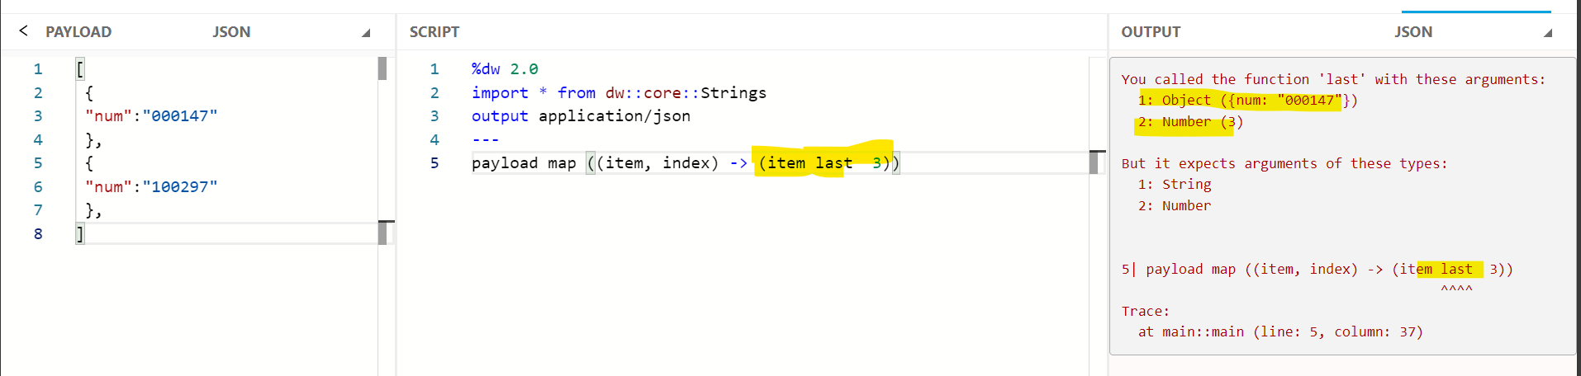

**Count the Number of Characters in a String dw::Strings isAlpha, countCharactersBy \*\***

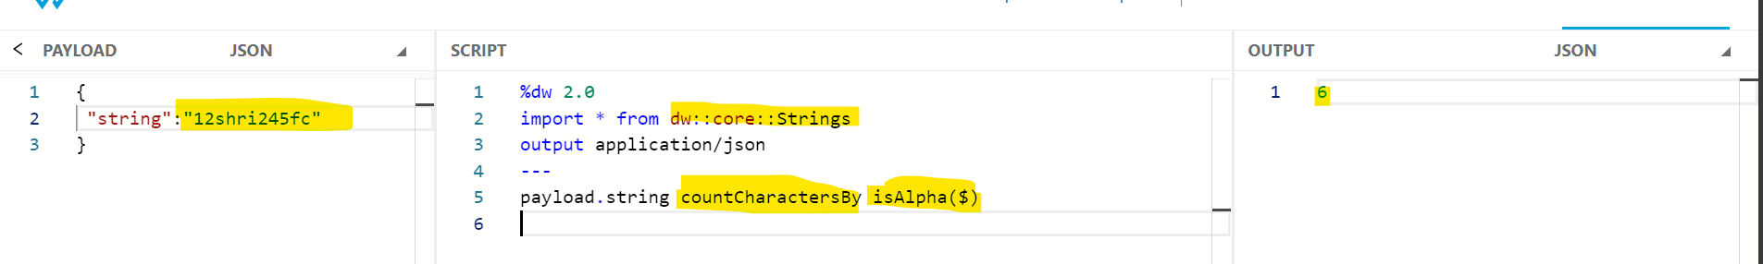

**Count the Number of numeric values in a String isNumeric**

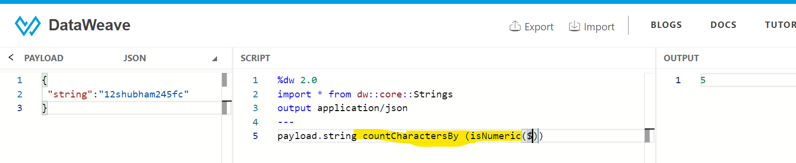

**Hamming Distance -**The Hamming distance between two equal-length strings of symbols is the number of positions at which the corresponding symbols are different dw::Strings

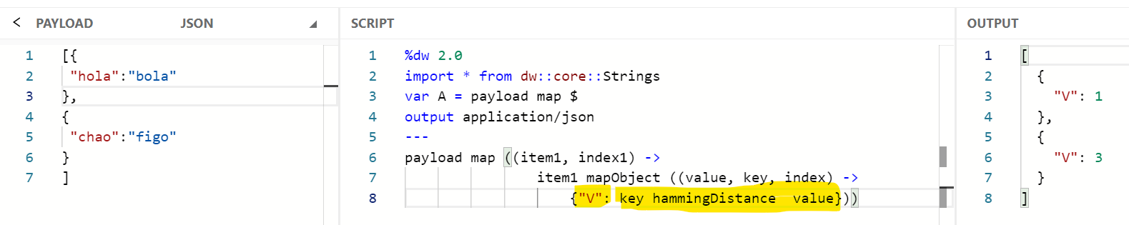

sizeOf

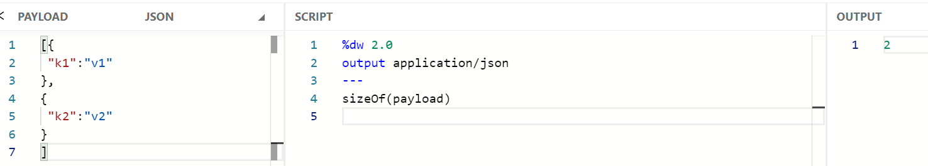**Generate Random Numbers ( randomInt ) \***

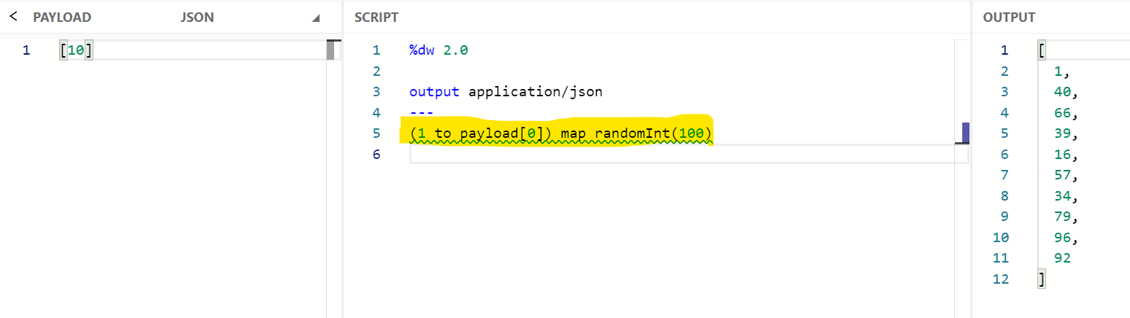

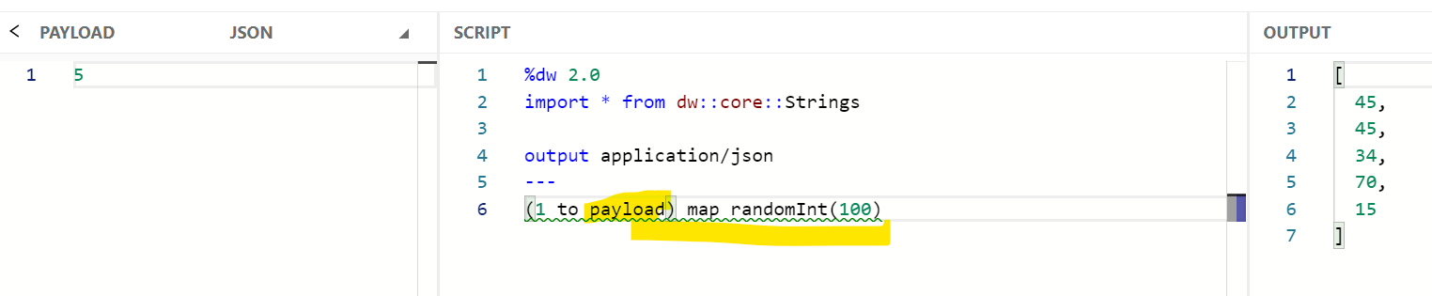

Repeat – dw::Strings

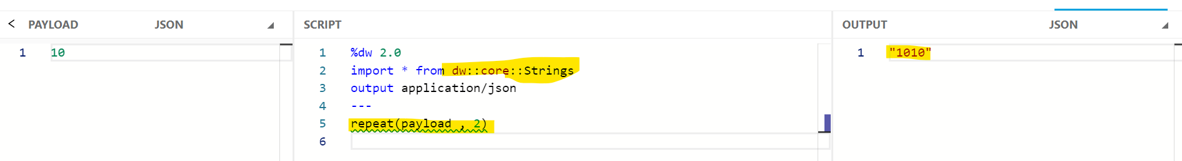

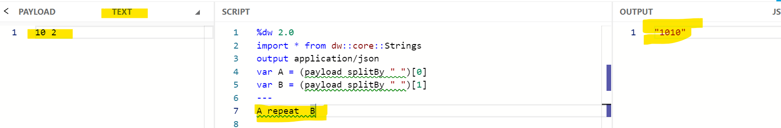

**Array to Object \*\*\*\*\***

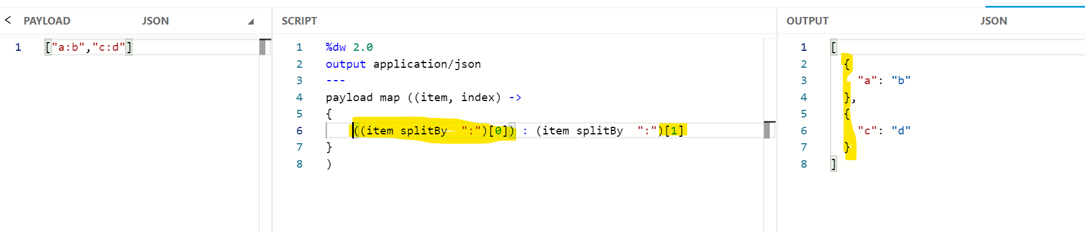

**Search a field in the same payload using other field values \*\*\***

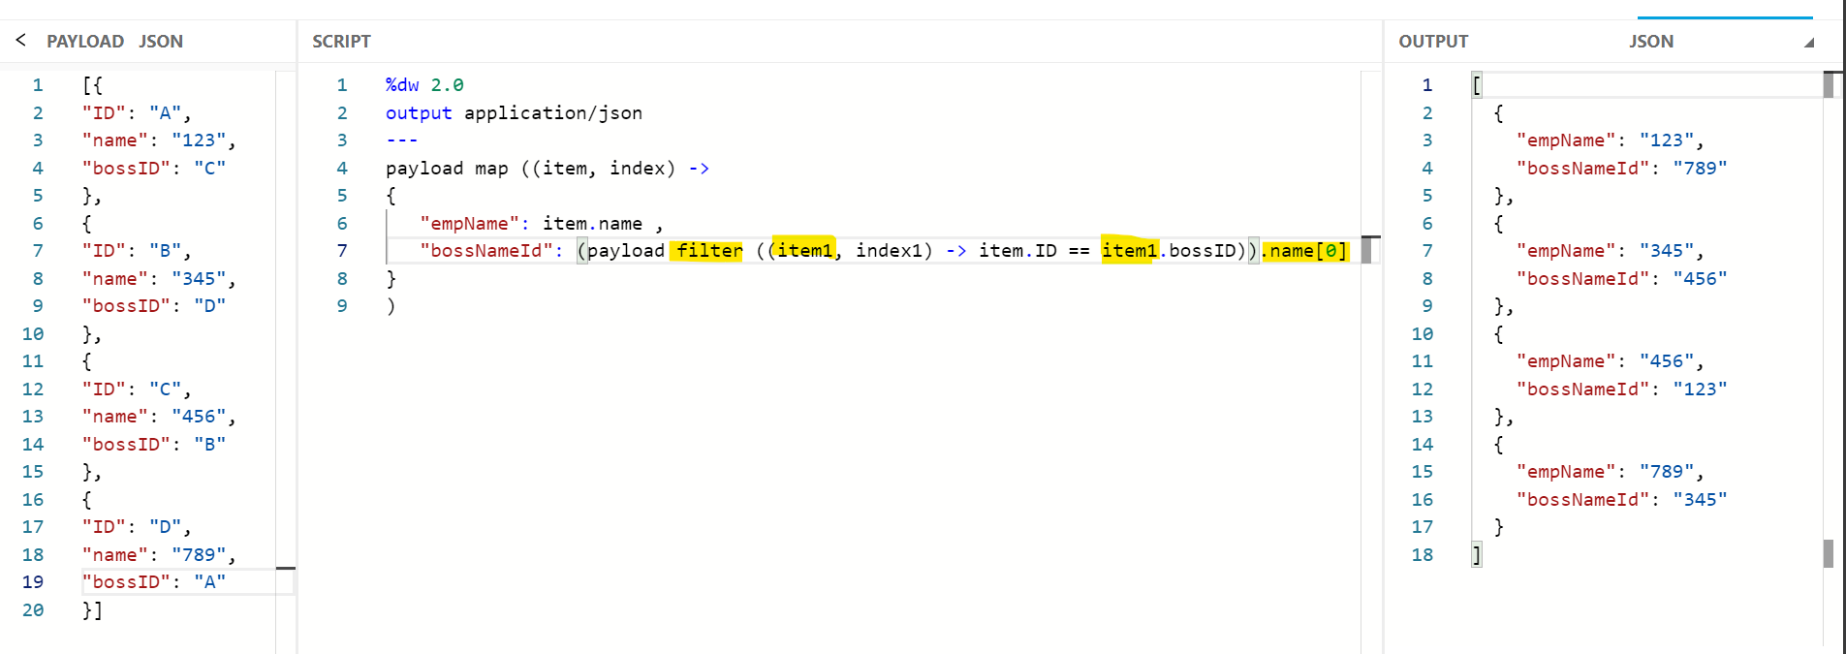



**Group By Year present inside a String subStringAfter \*\*\*\*\*\* dw::String**

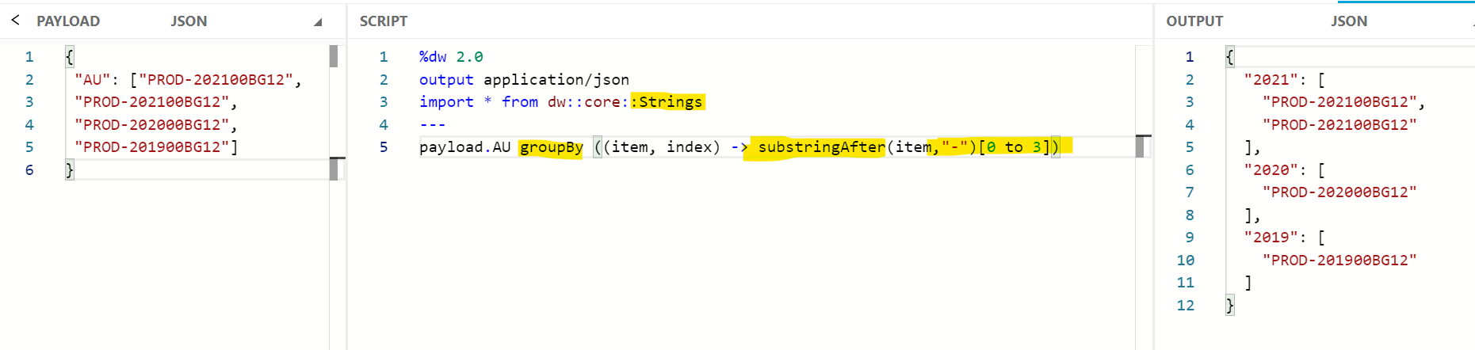

**Output the Following Pattern \*\*\***

**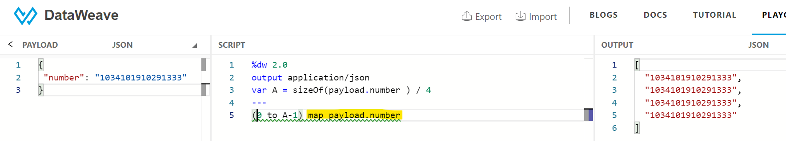**

**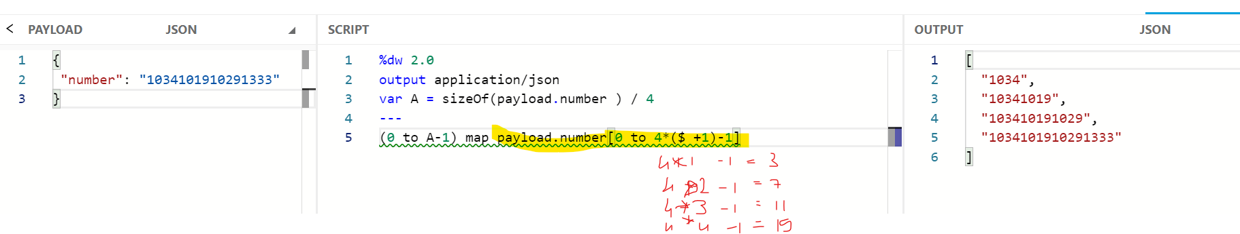**

**Filter based on field value and form a String**

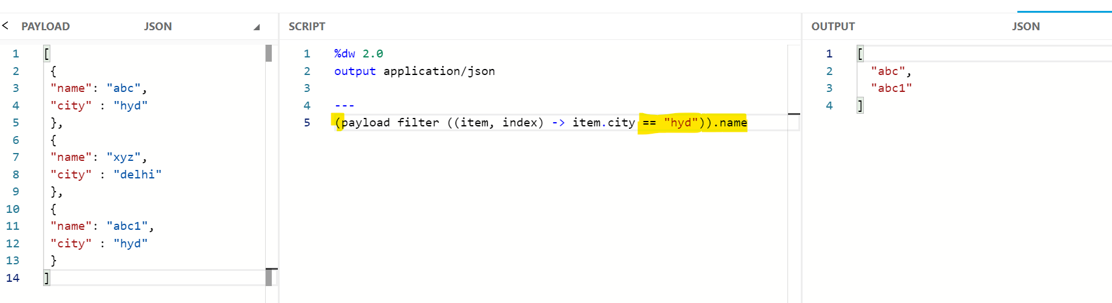

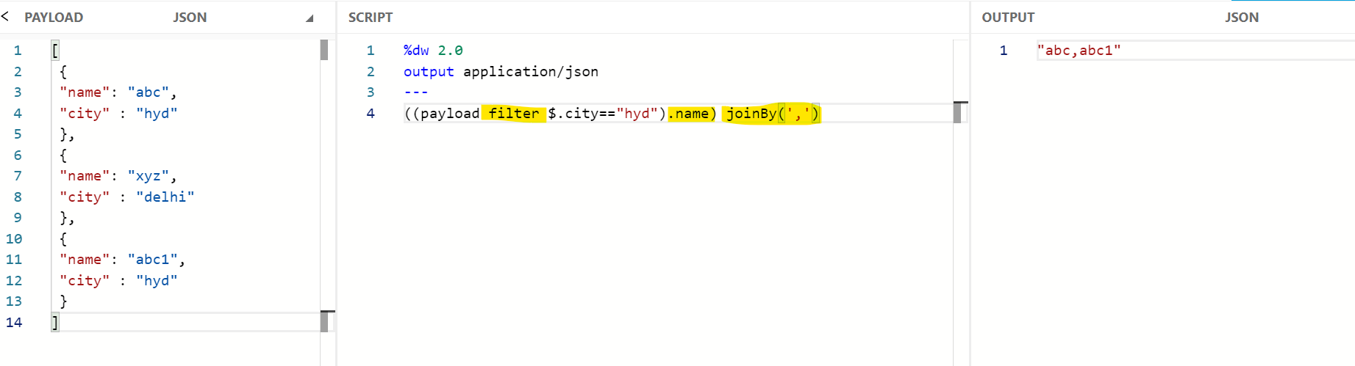

**Round down Value to Nearest Whole Number -- floor**

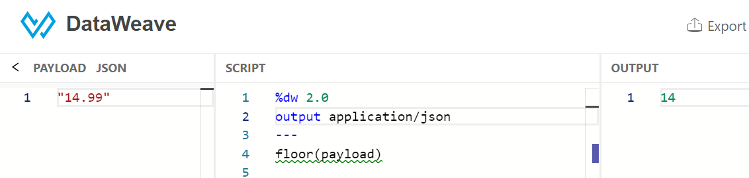

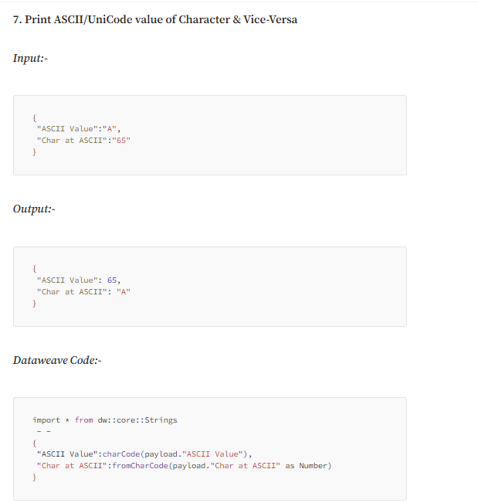

endsWith - **Filter files based on File extension**

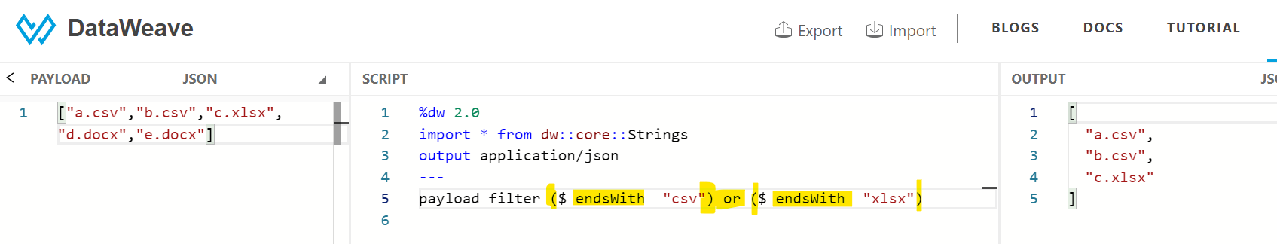filter out common values in 2 different arrays \*\*

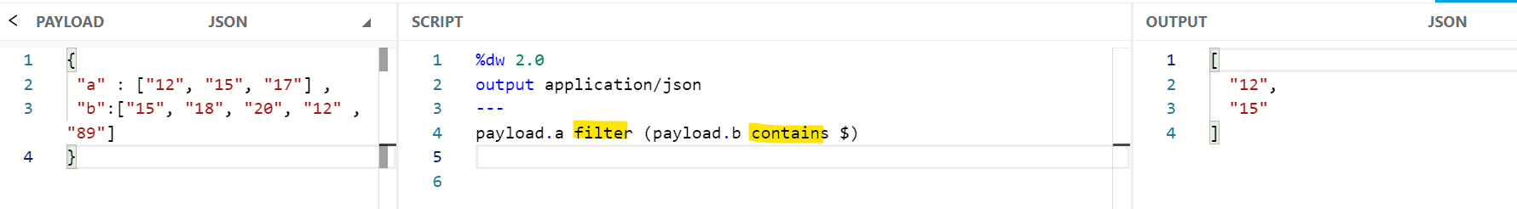

Filterobject for empty values \*\*

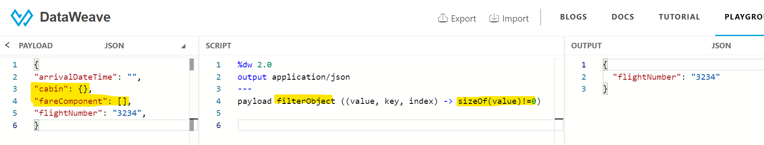

**Find out Available Time Zones for Date Time Conversion**

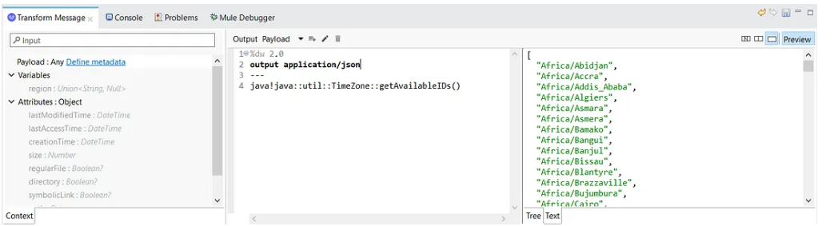

isNumeric – filter out numbers

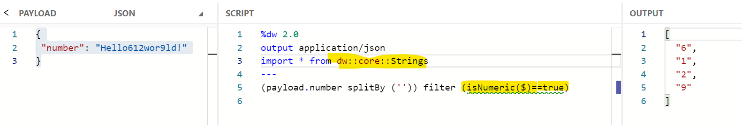

maxBy

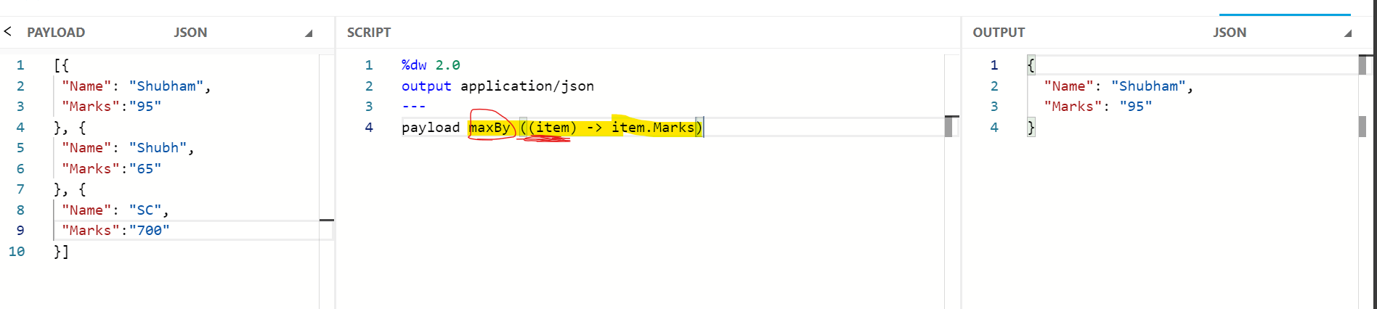

**Difference between “not” & “!” operator \*\*\***

not --- operator works on the result of overall logical operation but

! --- works on the first result of logical operation

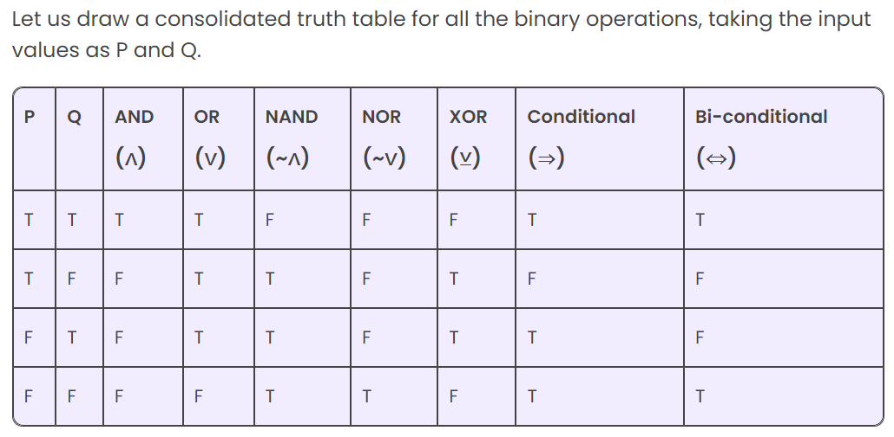

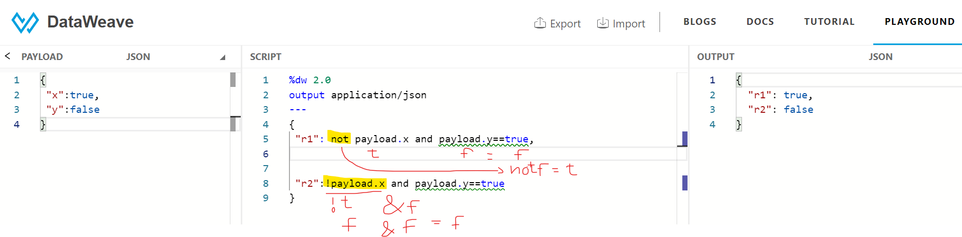

Scan - extract only integer

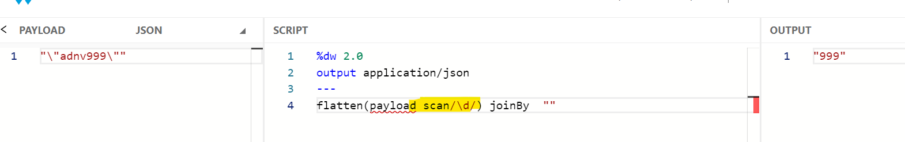

**Extract the URI Parameter/Value from a URL**

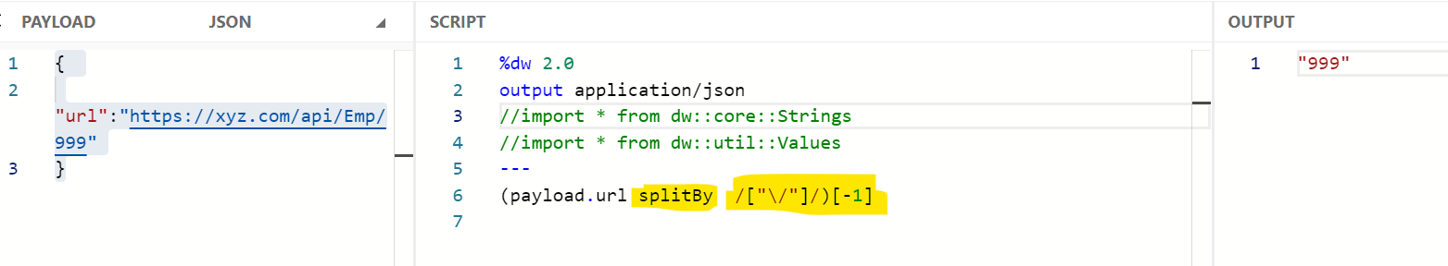

**Extract the URI Parameter/Value from a URL – slice dw:: Arrays**

**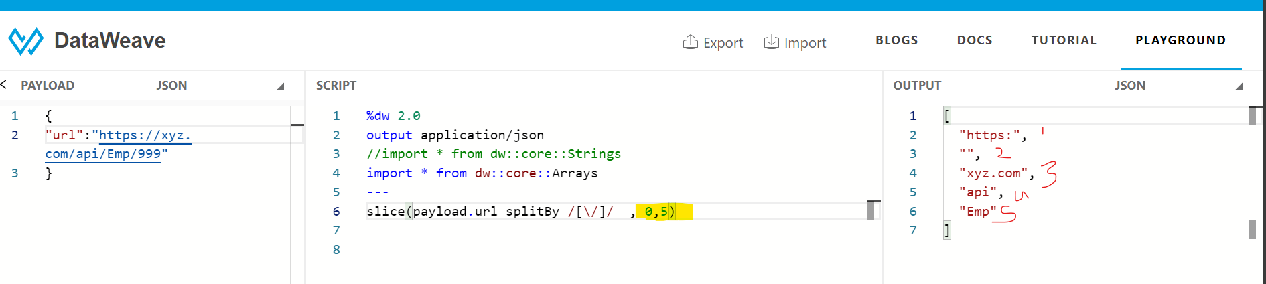**

**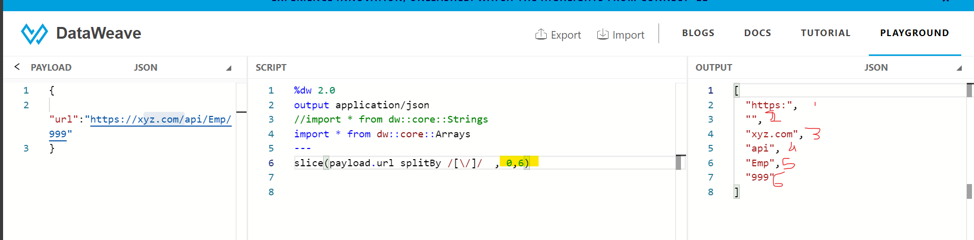**

**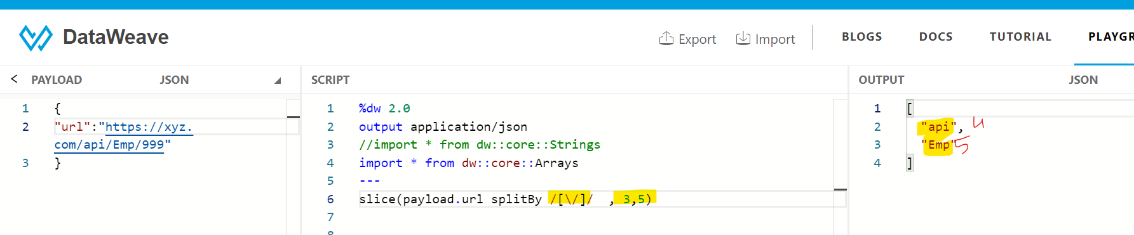**

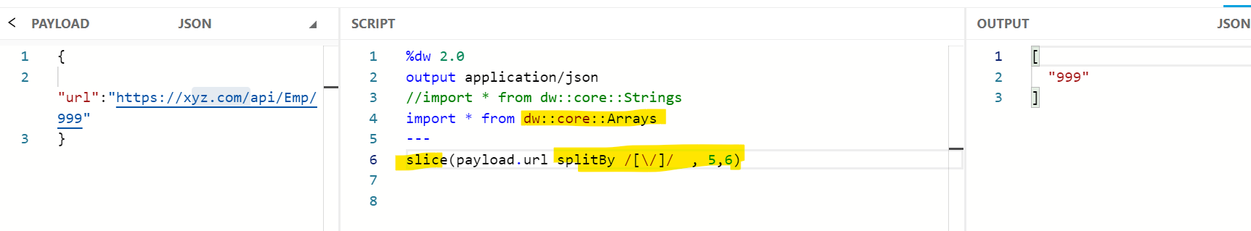

**Assign Array Key to Each Array Value**

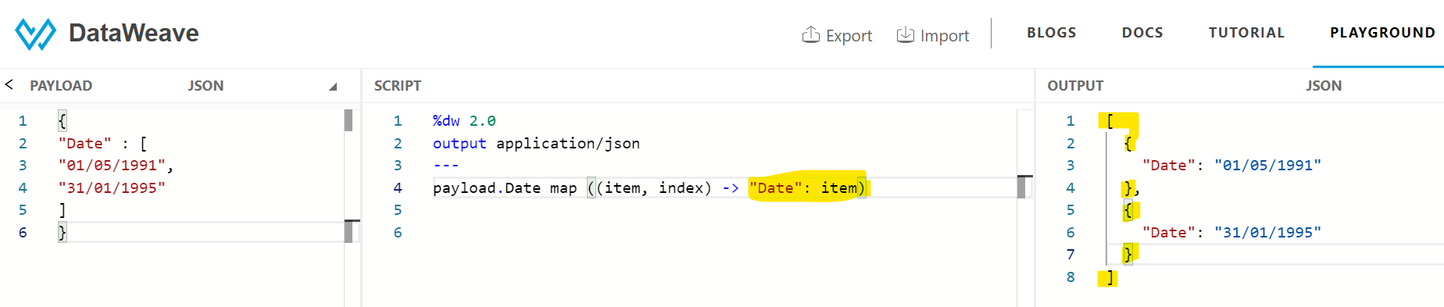

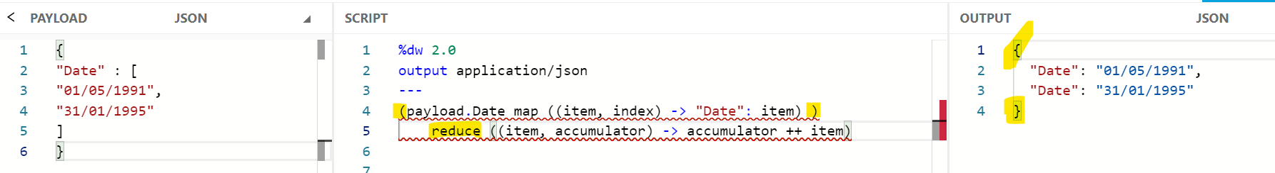

**Break Objects into SubObjects with specified number of key-value pairs \*\*\*\*\*\*\*\*\*\*\* dw::Objects**

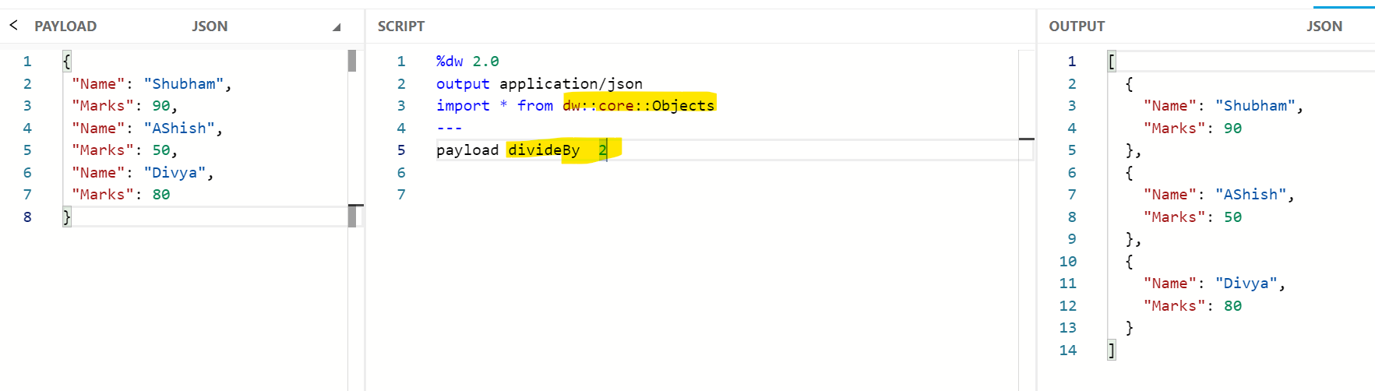

**Underscore Space, Dash & Camel-Casing in a String dw::String**

**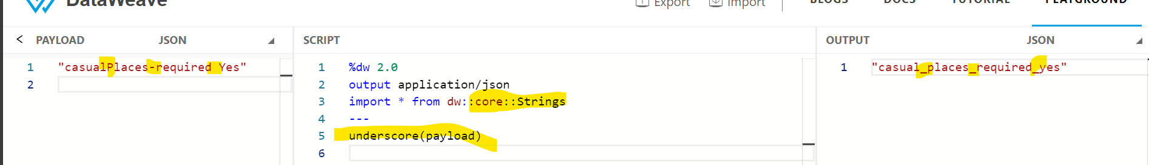**

**Dynamic Value of Key in Key-Value Pair**

**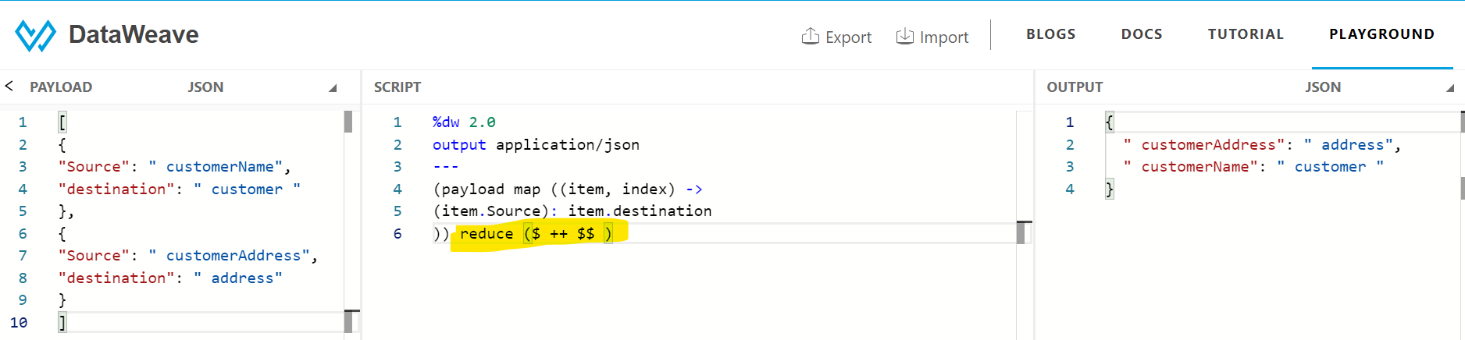**

**Filter department and count – countBy \*\*\*\*\*\*\*\*\*\*\* dw::arrays**

**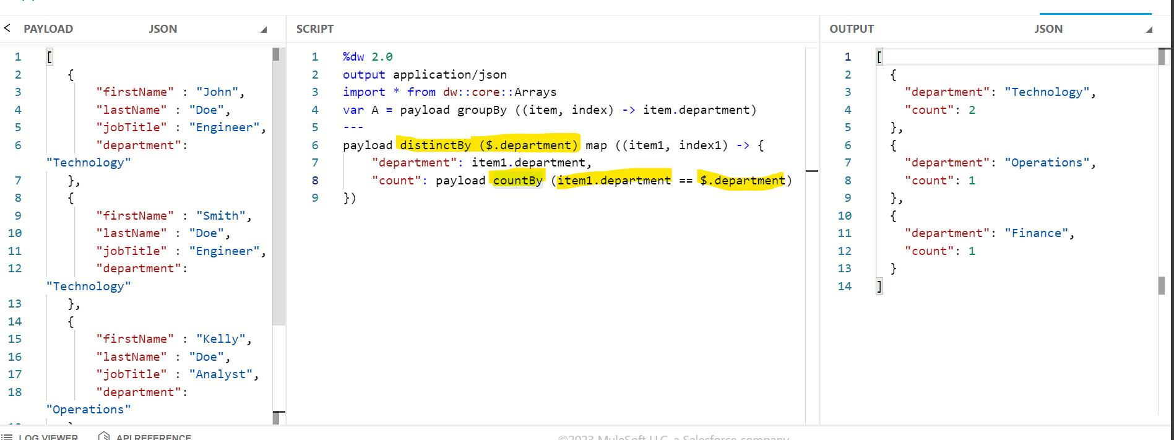**

**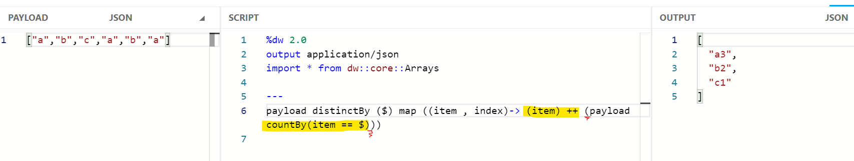**

**Write If Condition without Else**

**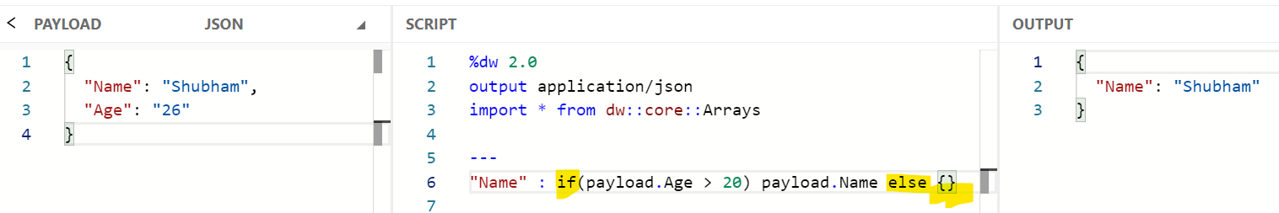**

**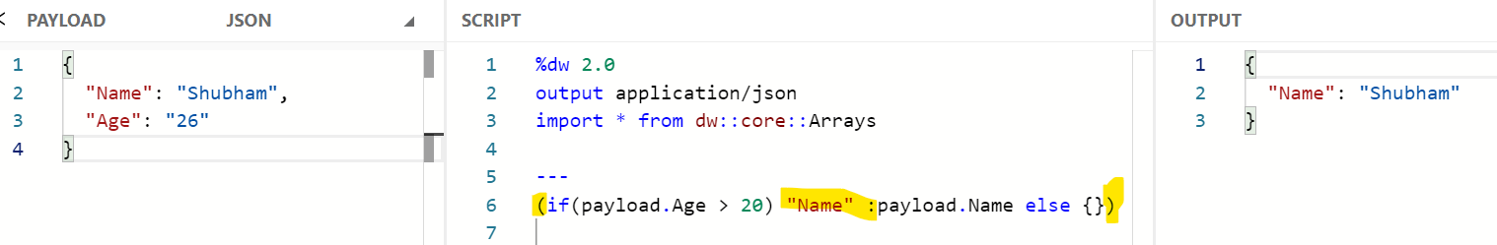**

**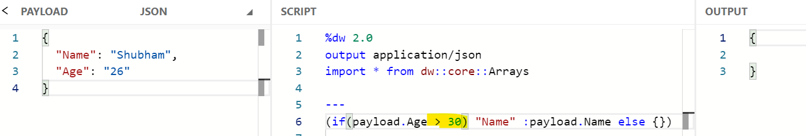**

**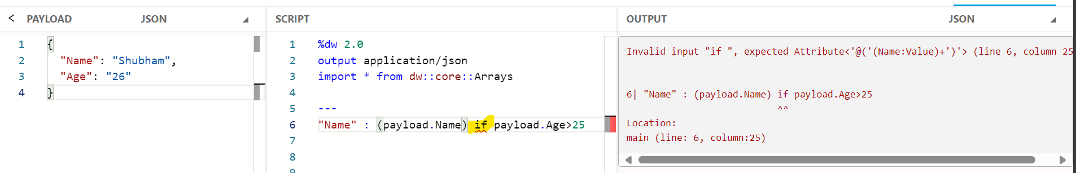**

**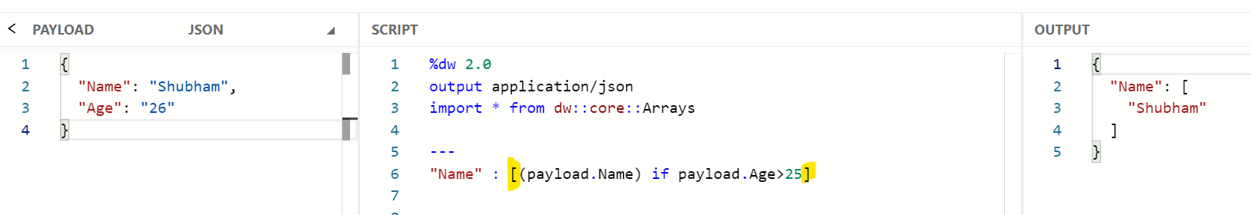**

**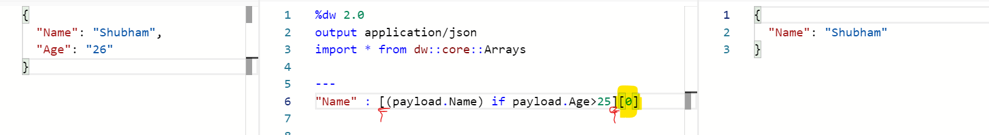**

**Trim**

**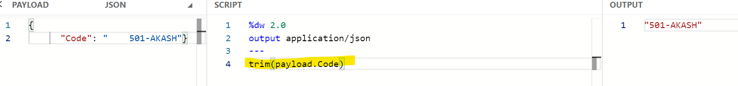**

**\*\*\*\*\* case**

**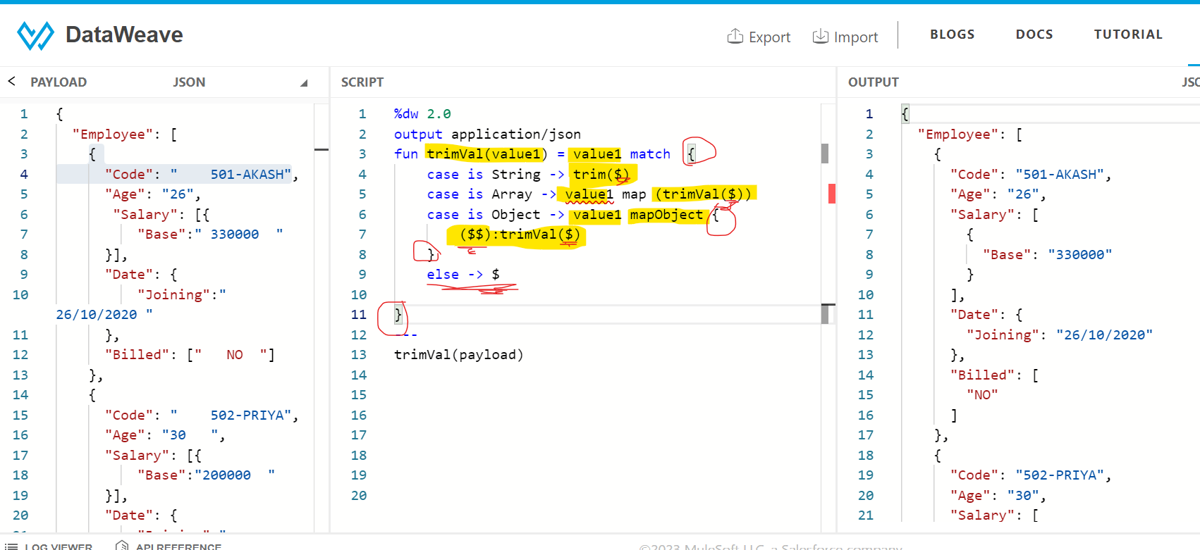**

**Separate Multiple Values with Single Key into Different Objects**

**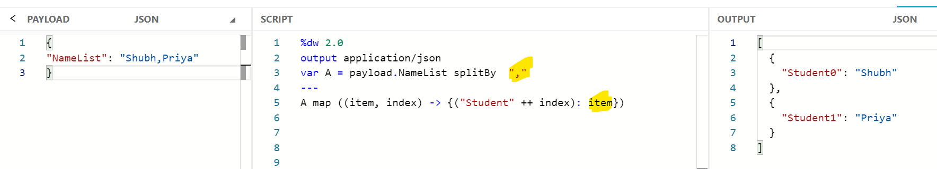**

**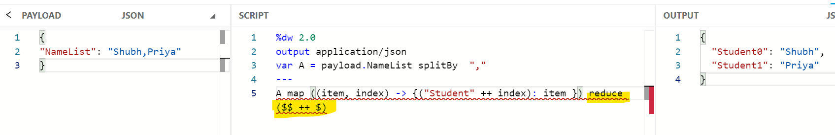**

**Usage of FilterTree Function – dw::Tree \*\*\*\*\* case**

**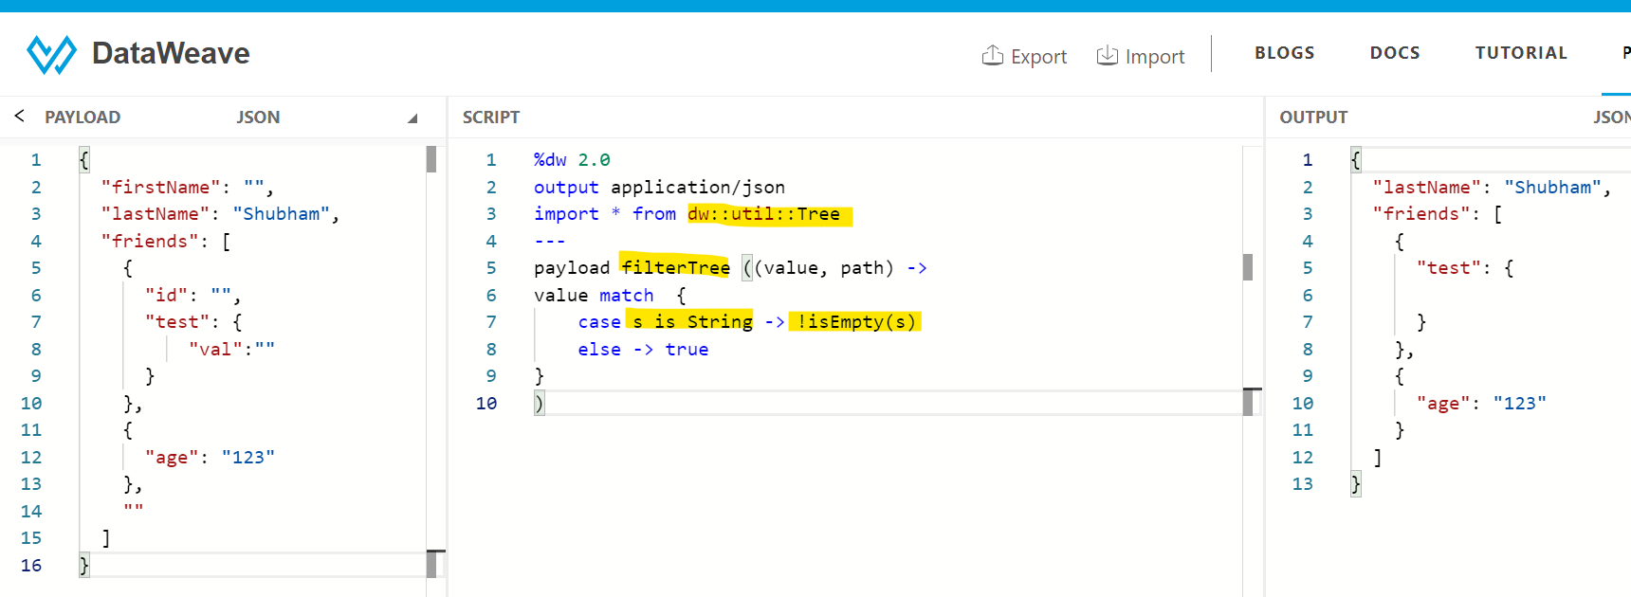**

**Capitalize the leaf values of nested object: Usage of mapLeafValues function dw::Tree**

**Upper case all the values**

**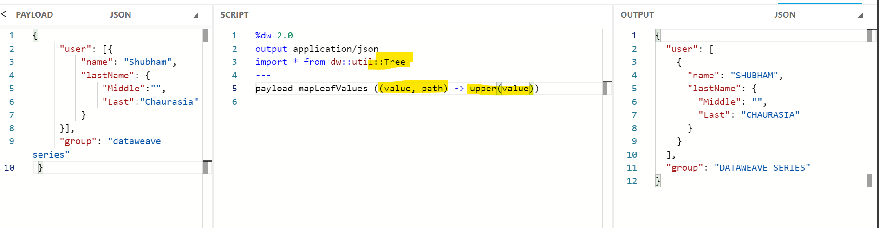**

**Print Last Date of the Month given a date as input**

****

****

**Add/Update values in objects from other array objects based on matching ID field \*\*\*\*\*\***



****

**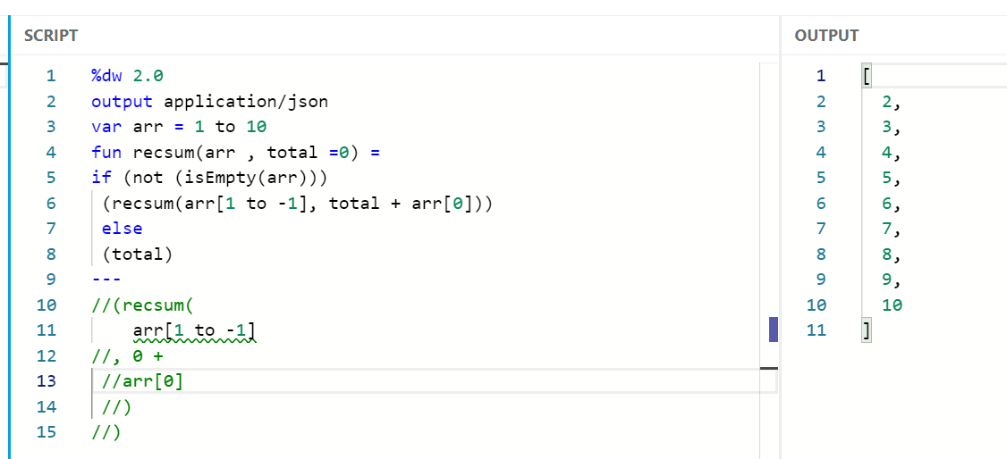**

**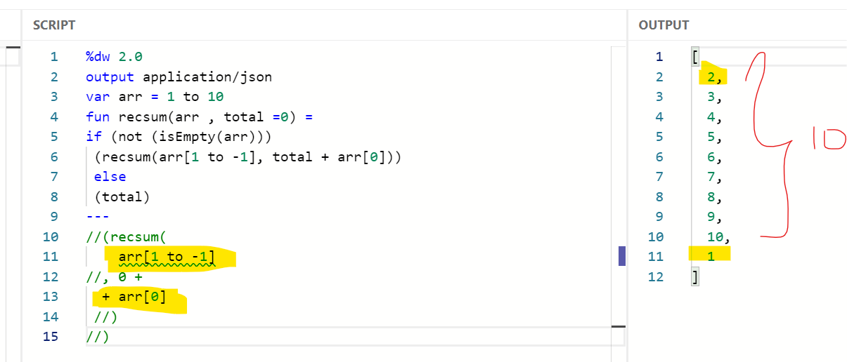**

**Addition of all the numbers -- reduce**

**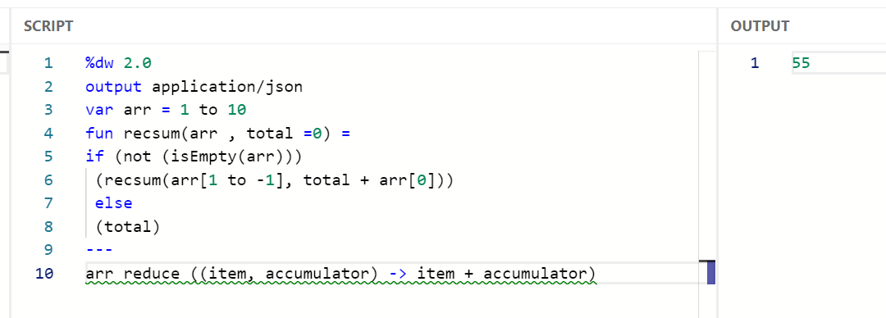**

**recsum**

**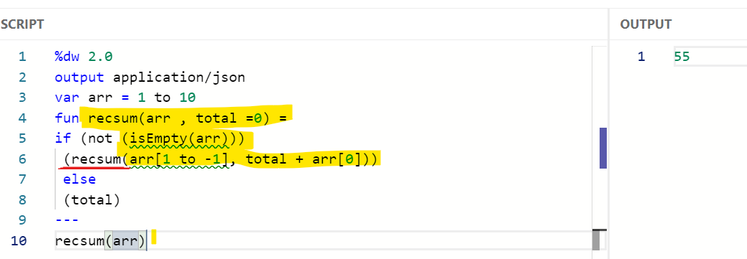**

**Adjust DateTime Format Output – substringBeforeLast -dw :: Strings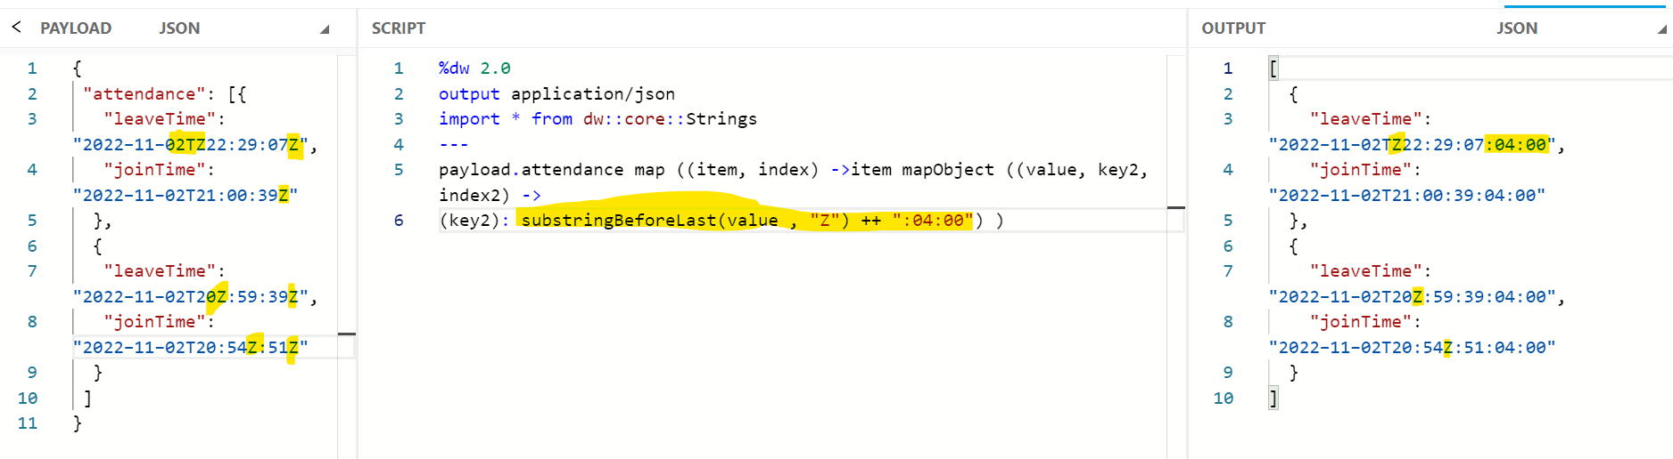**

**Flatten a nested JSON Array using Recursion \*\*\*\*\*\*\*\*\*\***

**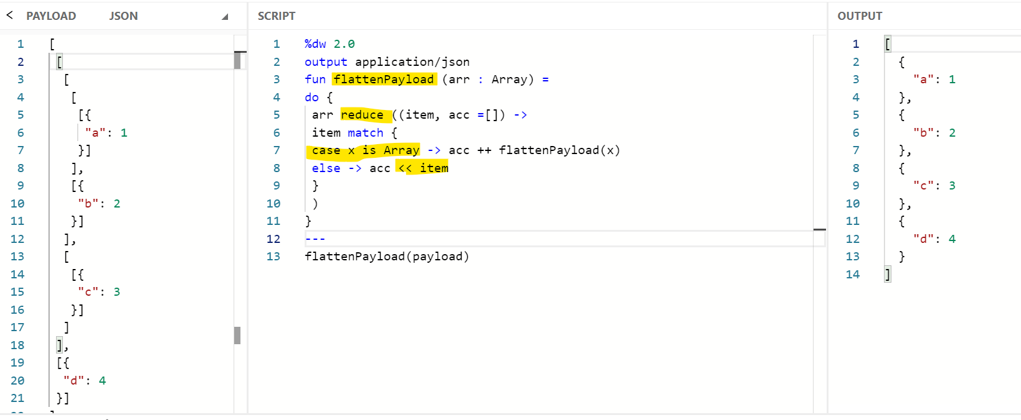Calculate the Total Price of All Orders**

**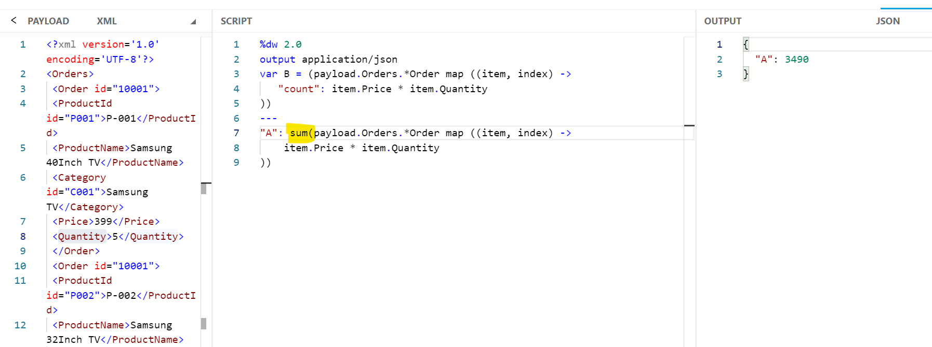**

**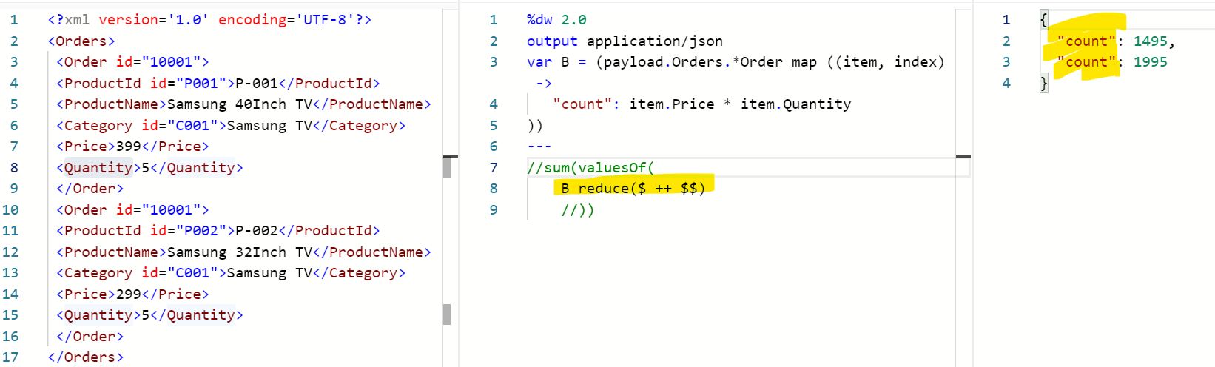**

**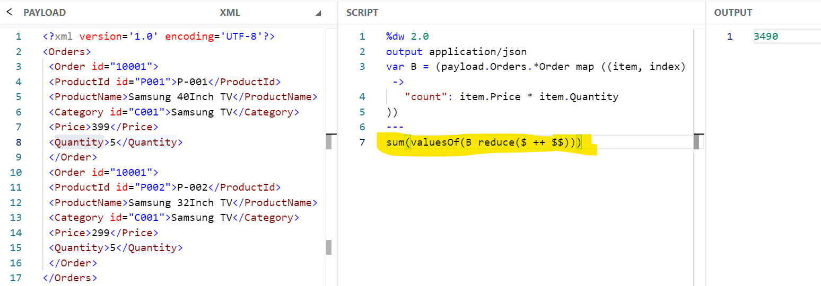**

**Array of objects to string – pluck , joinBy \*\*\*\*\*\*\*\*\*\*\*\*\*\*\***

**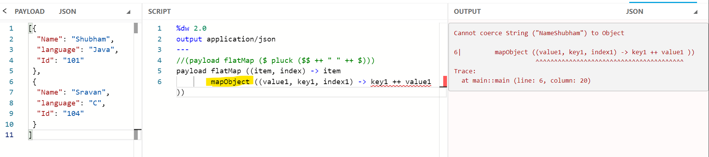**

**\*\*\*\* merging key value pluck**

**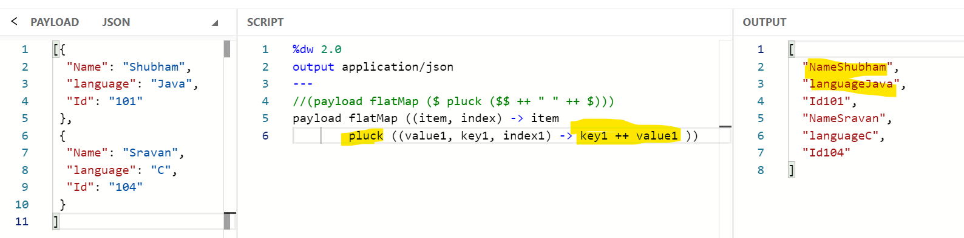**

**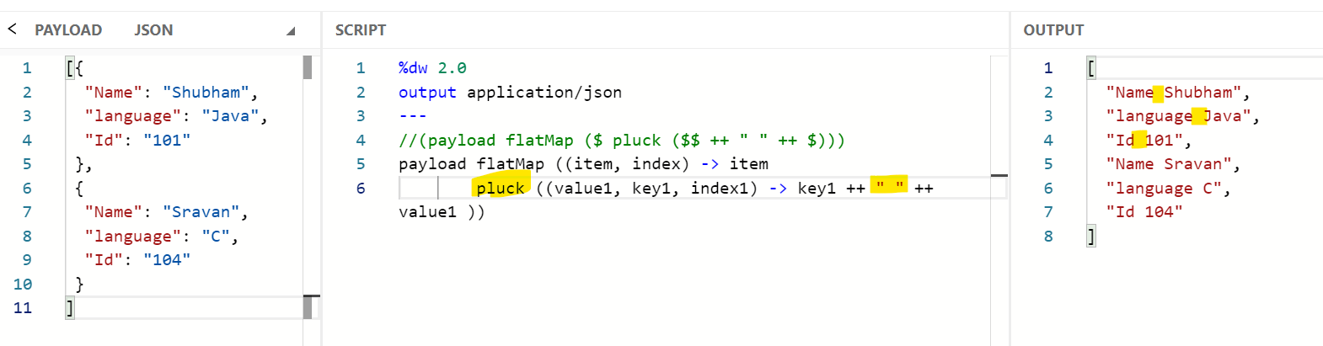**

**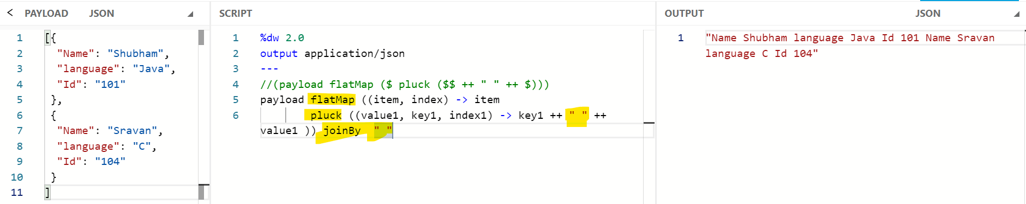**

**sumDigit \*\*\*\*\*\*\* Sum of Digits of a Number till its a single digit. (E.g:- 789 -> 7+8+9 = 24 | 2+4 = 6)**

**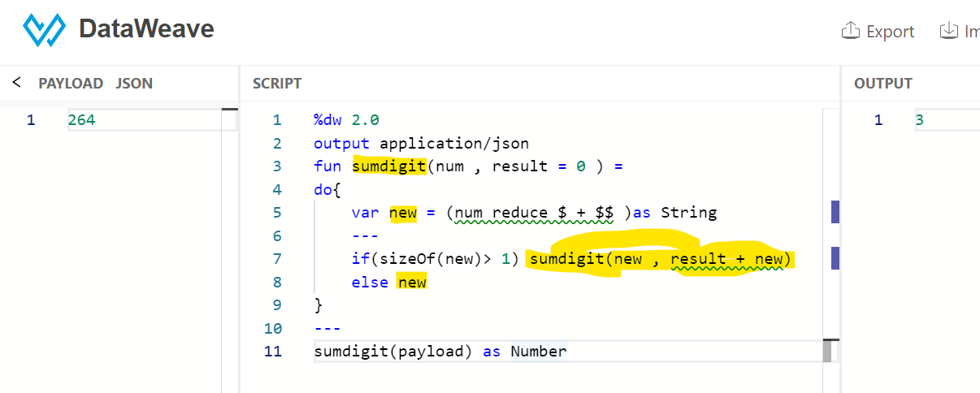**

**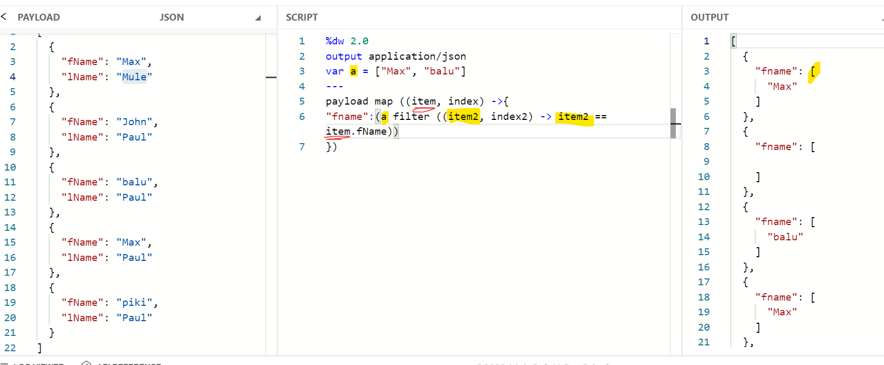**

**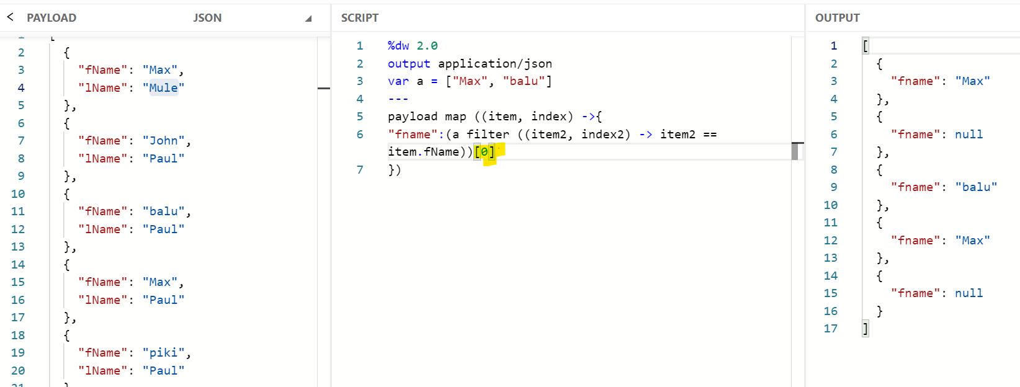**

**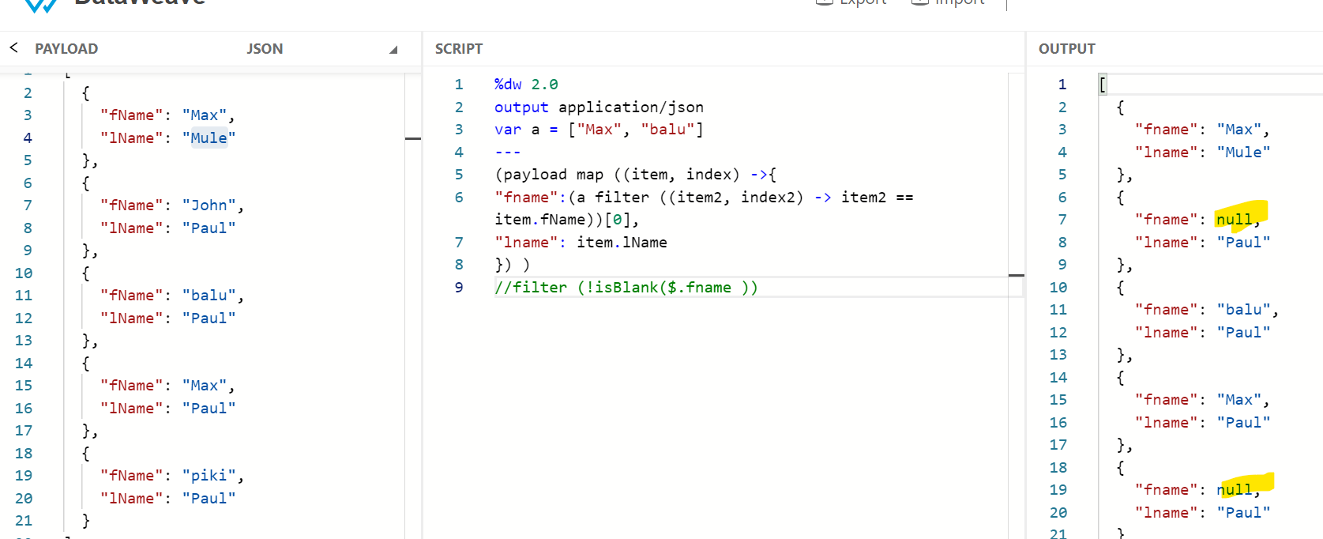**

**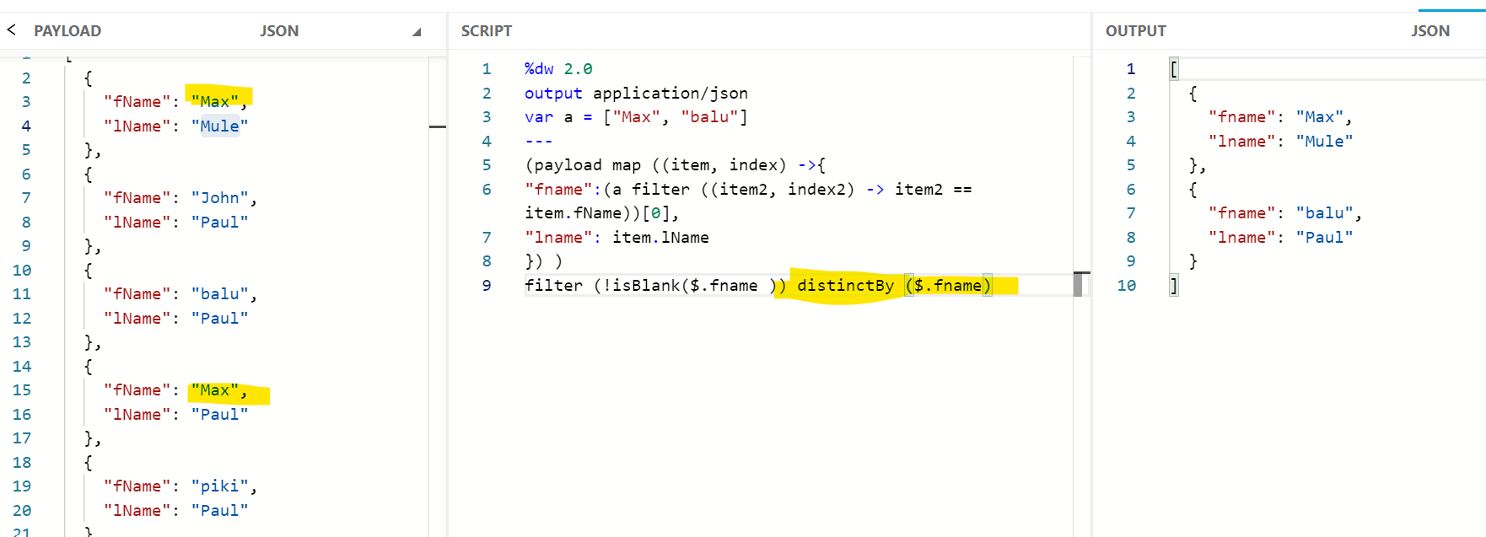**

**Pluck**

**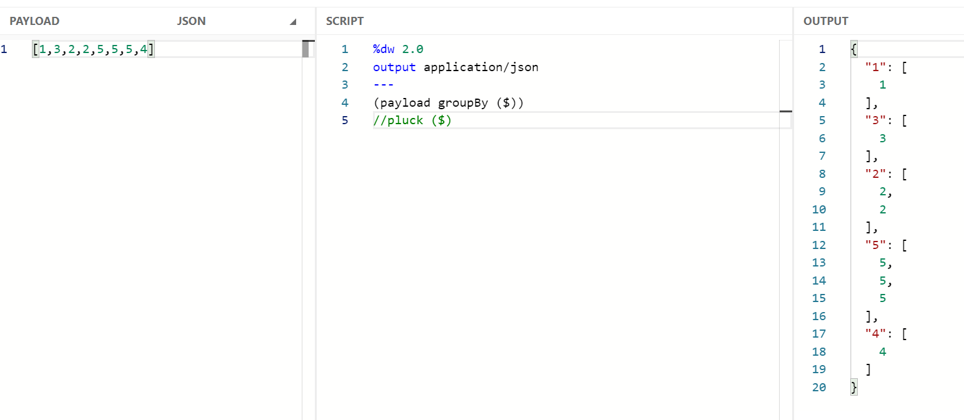**

**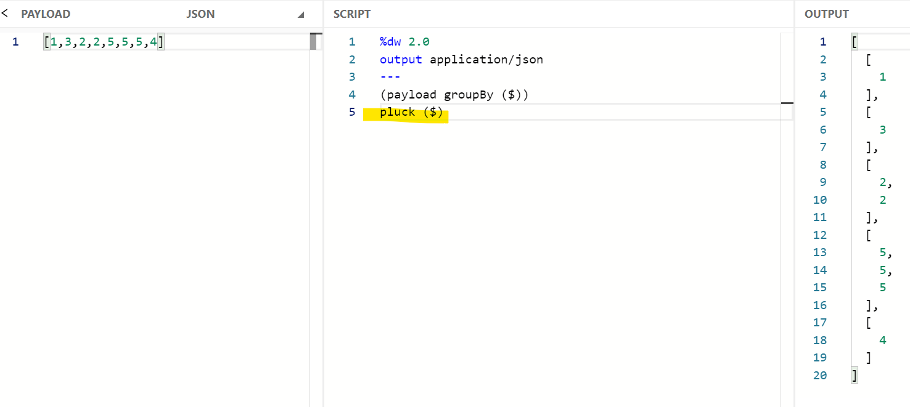**

**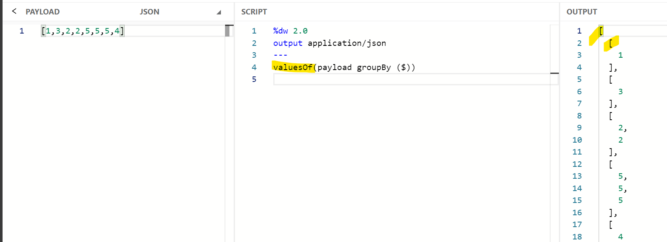**

**Size of array – how many times value is repeating**

**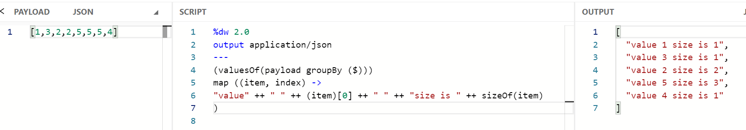**

**Pagination \*\*\*\*\*\*\*\*\*\*\*\*\*\*\*\*\*\*\*\*\*\***

**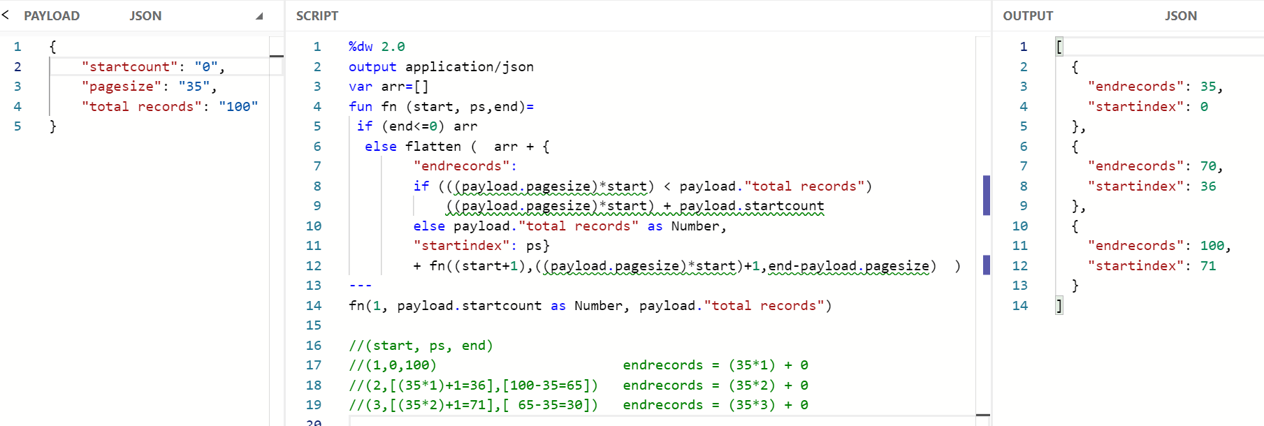**

**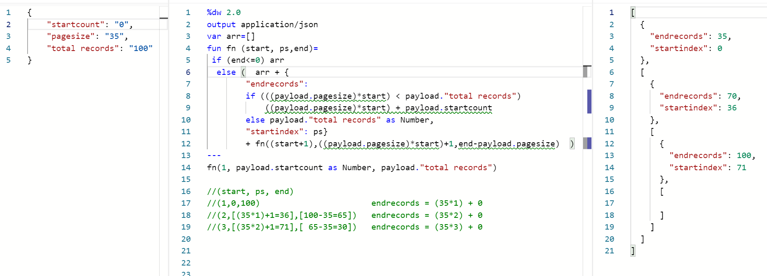**

**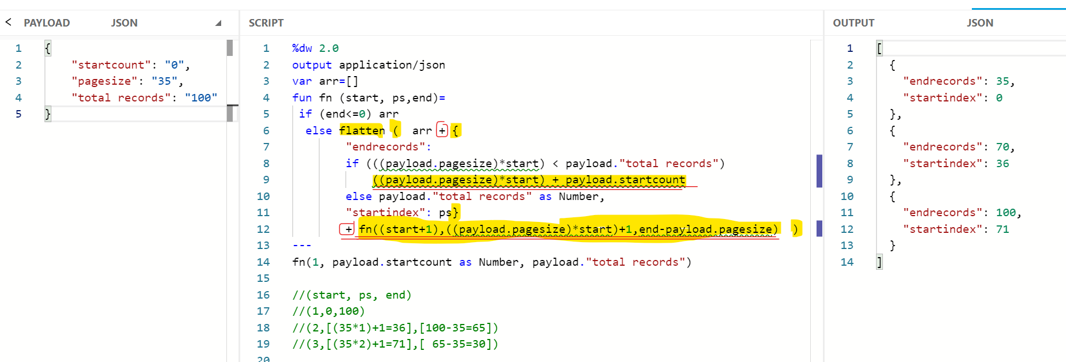**

**Date orderBy , daysBetween divide**

**By --- dw::Objects \*\*\*\*\*\*\***

**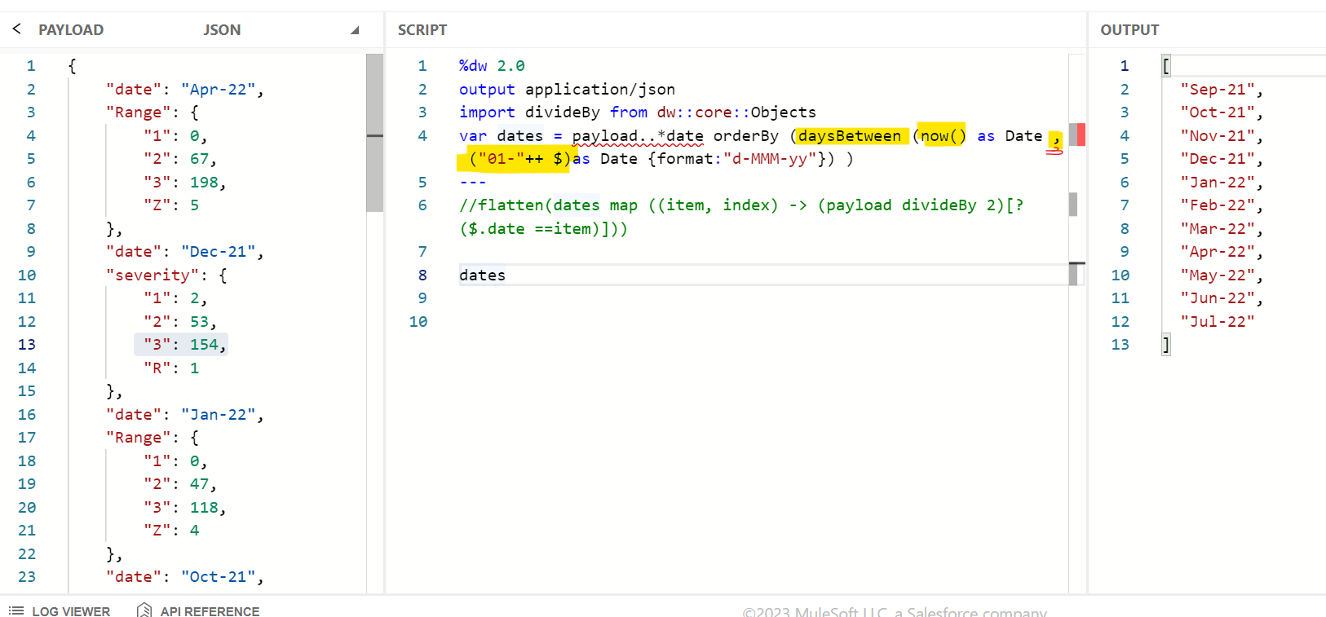**

**divideBy dw::Objects**

**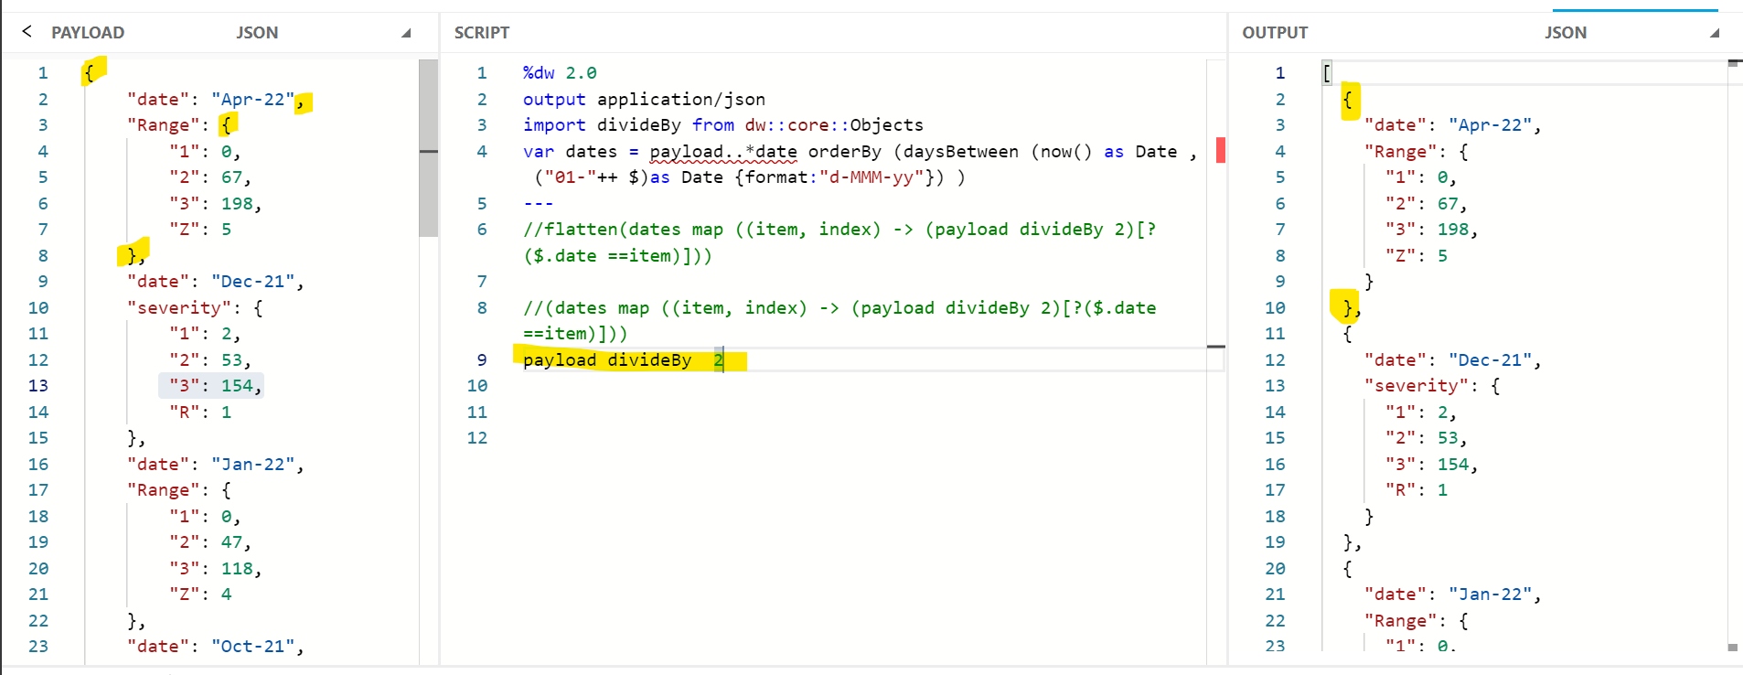**

**\*\*\***

**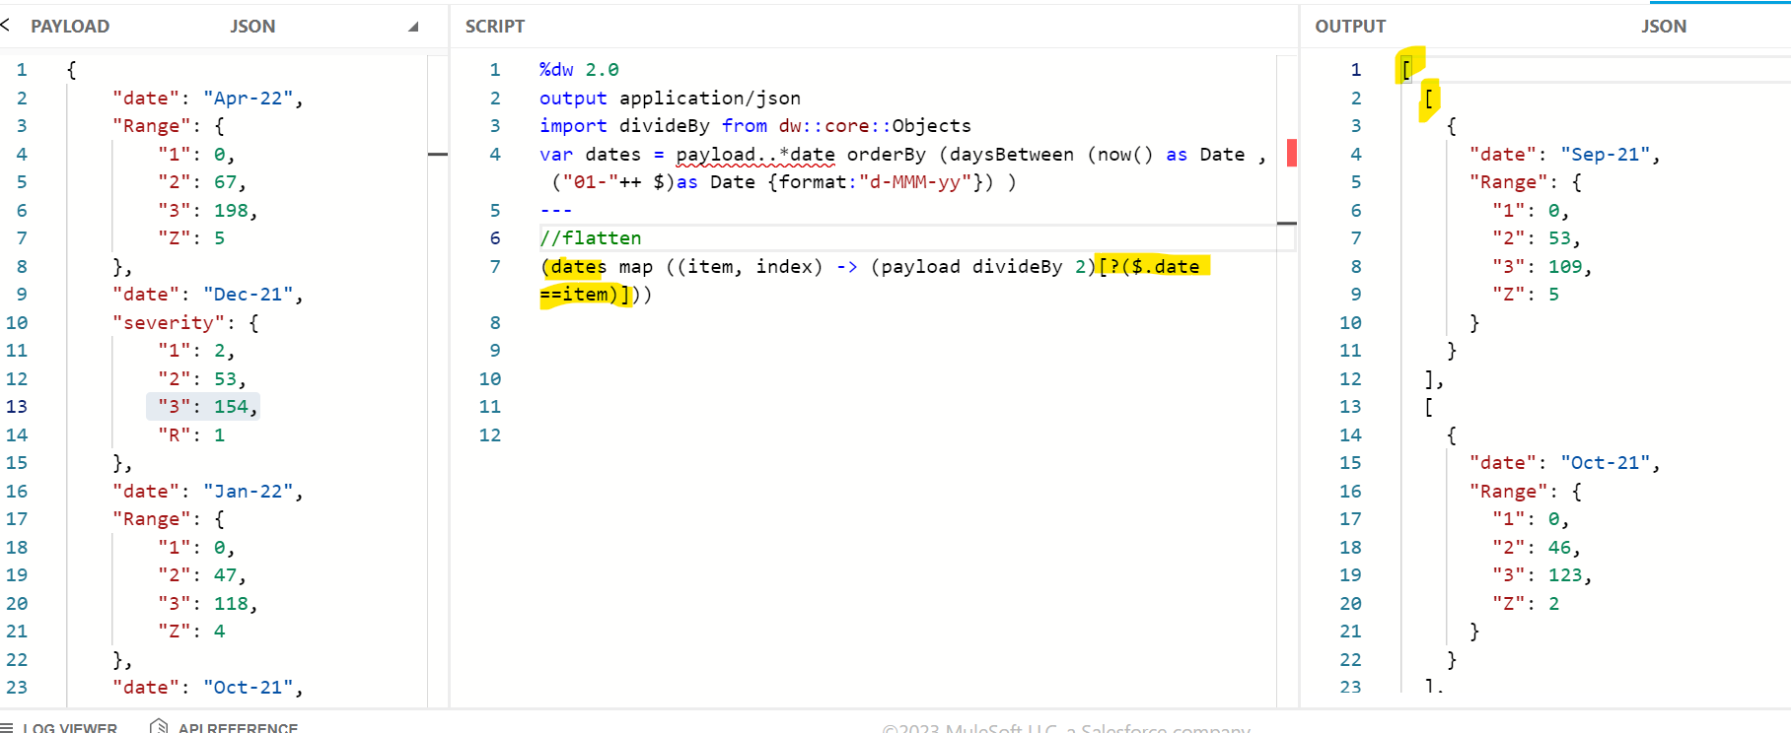**

**flatten**

**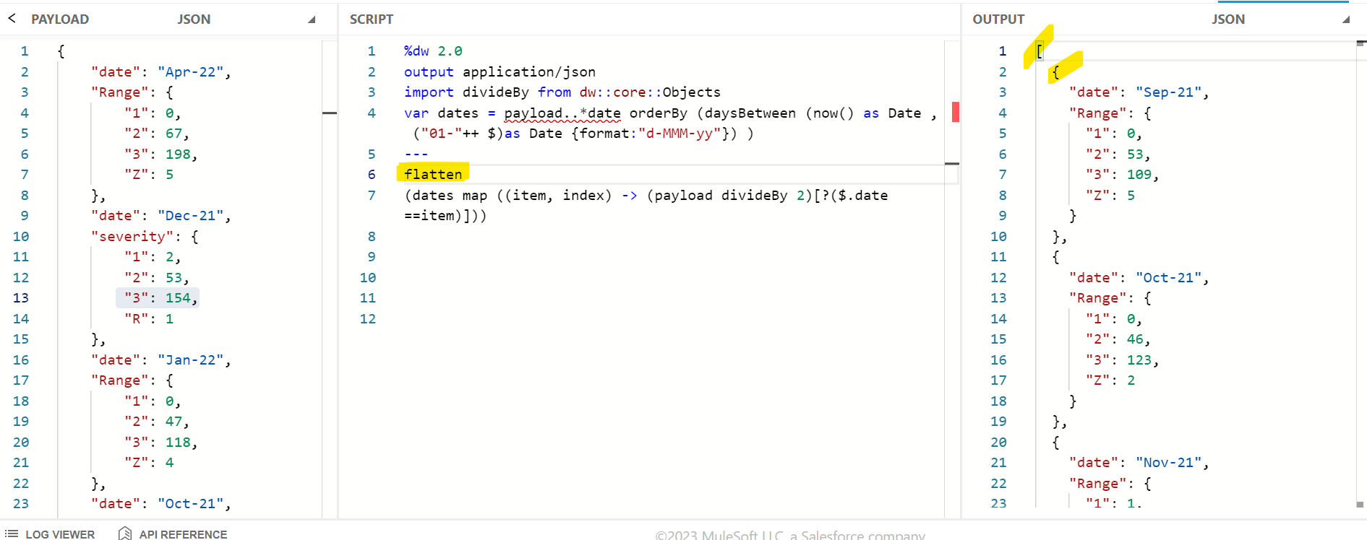**

**groupBy**

**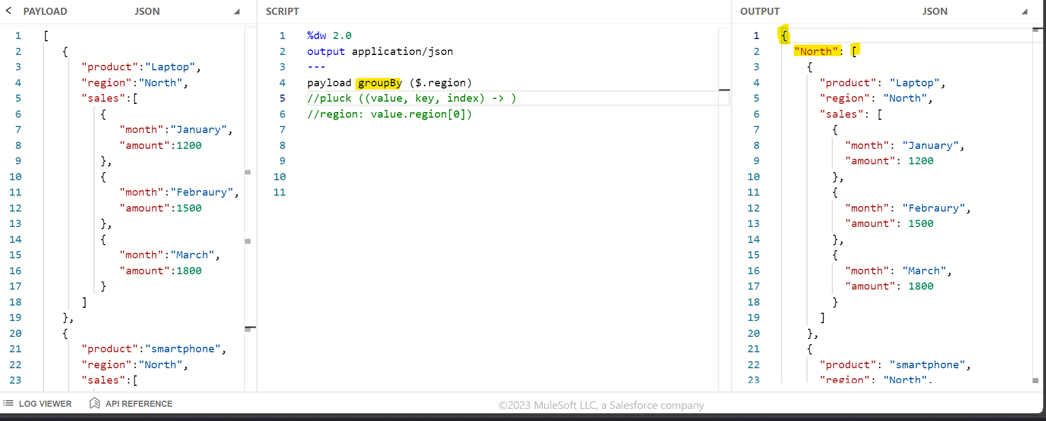**

**Pluck**

**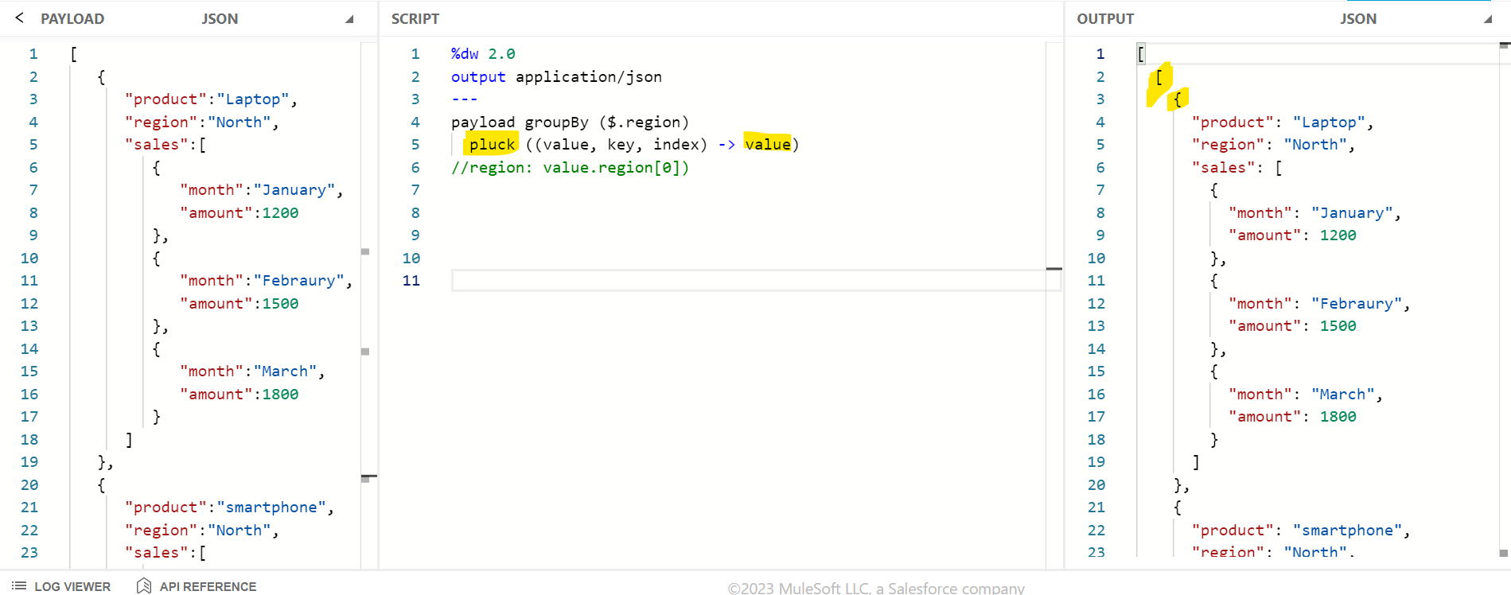**

**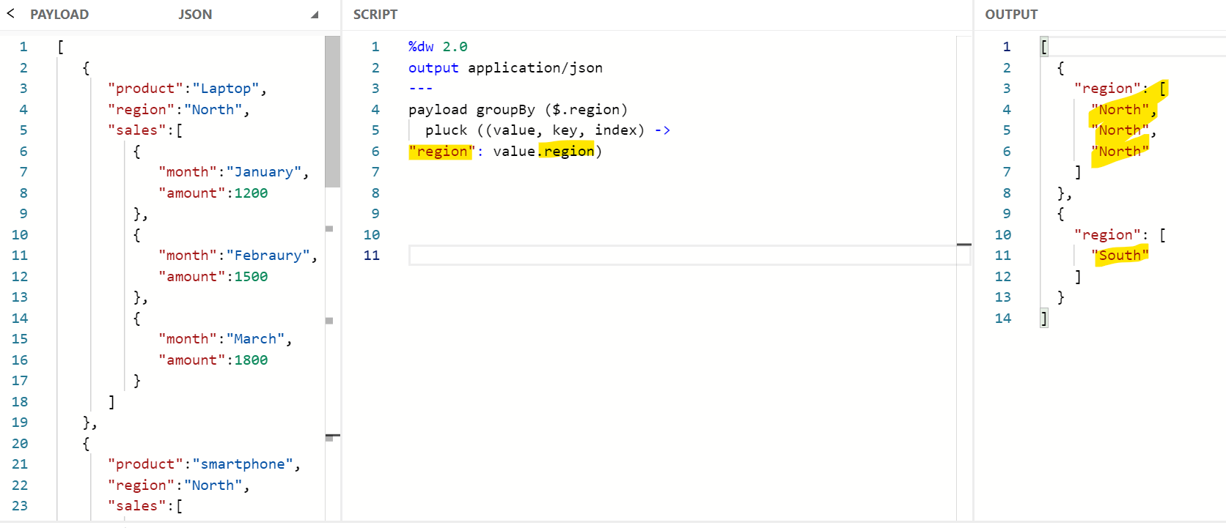**

**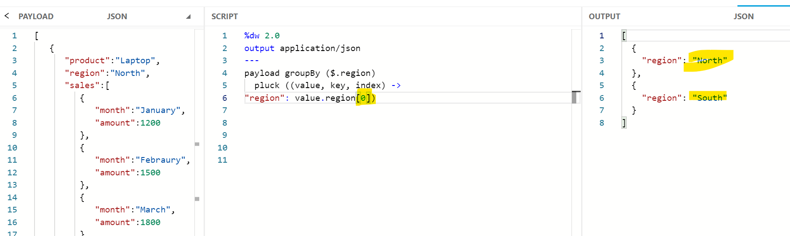**

**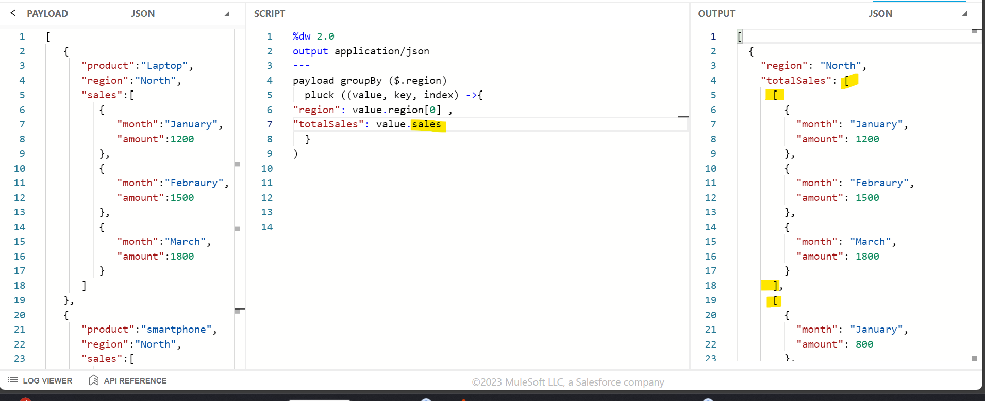**

**Flatten**

**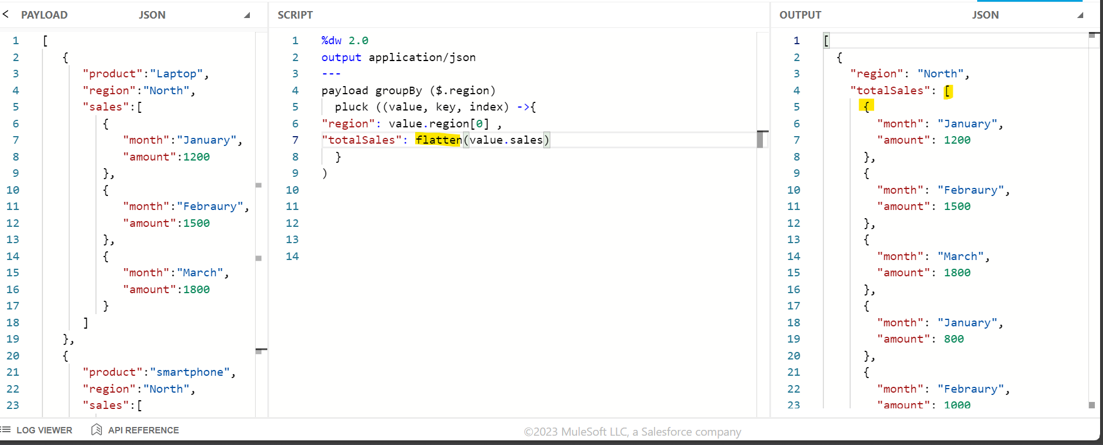**

**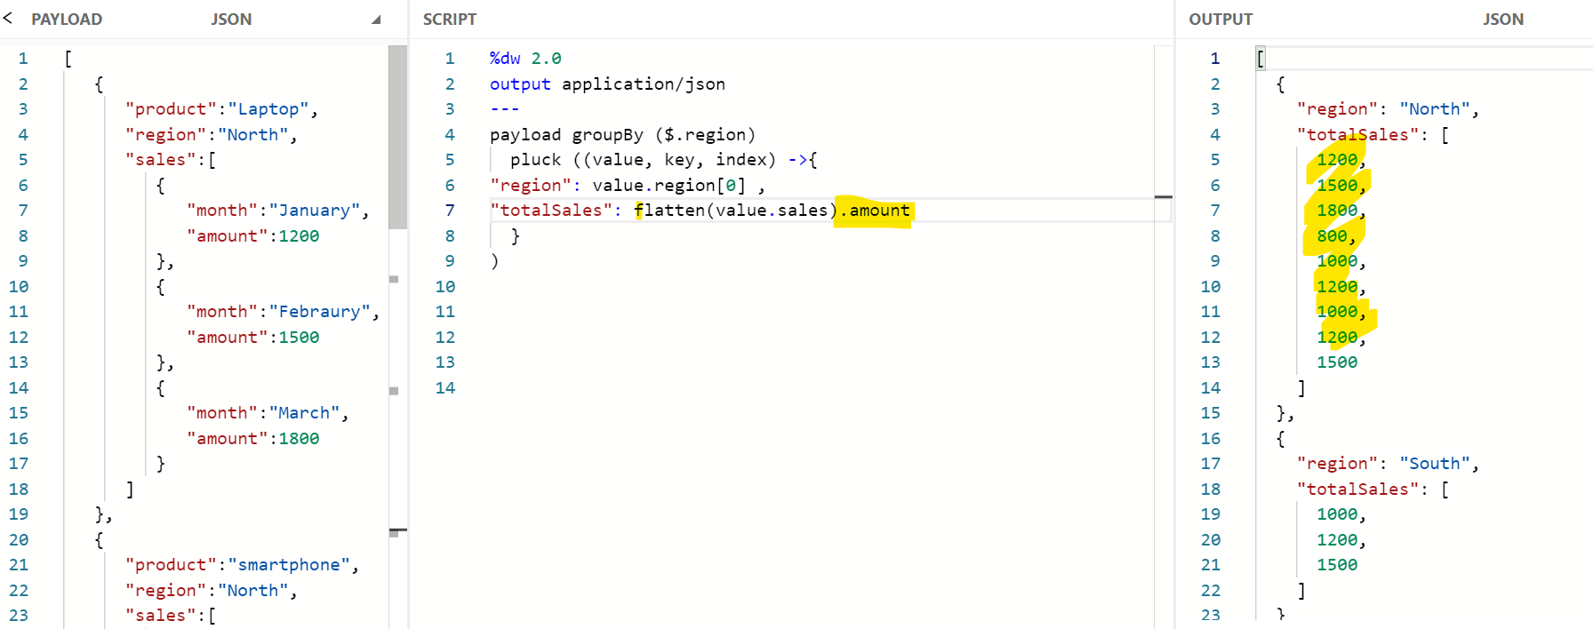**

**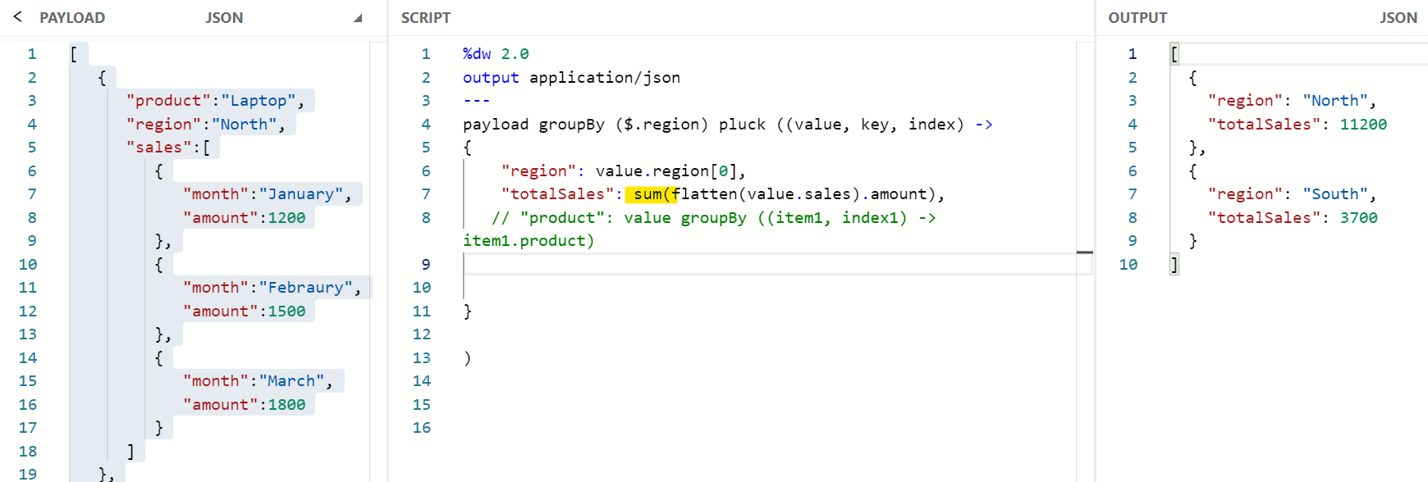**

**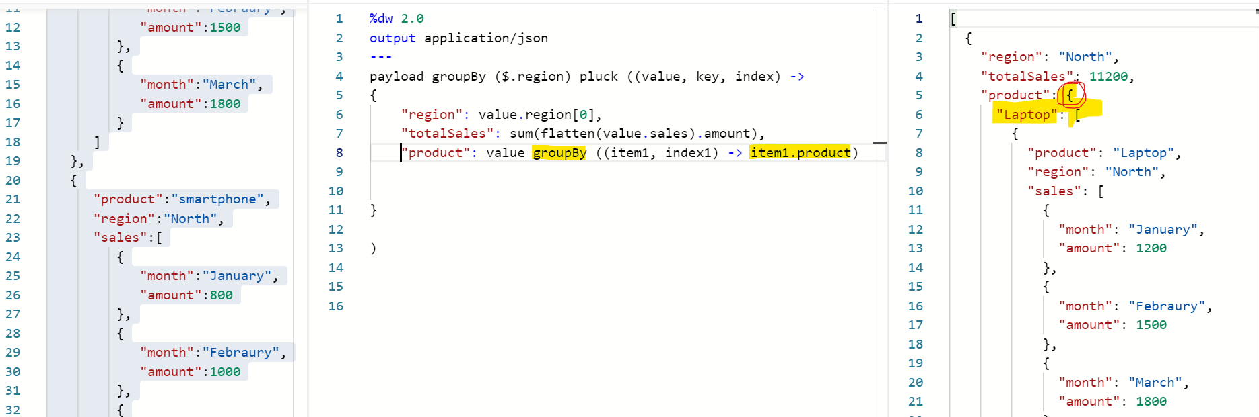**

**Pluck values of payload object to array**

**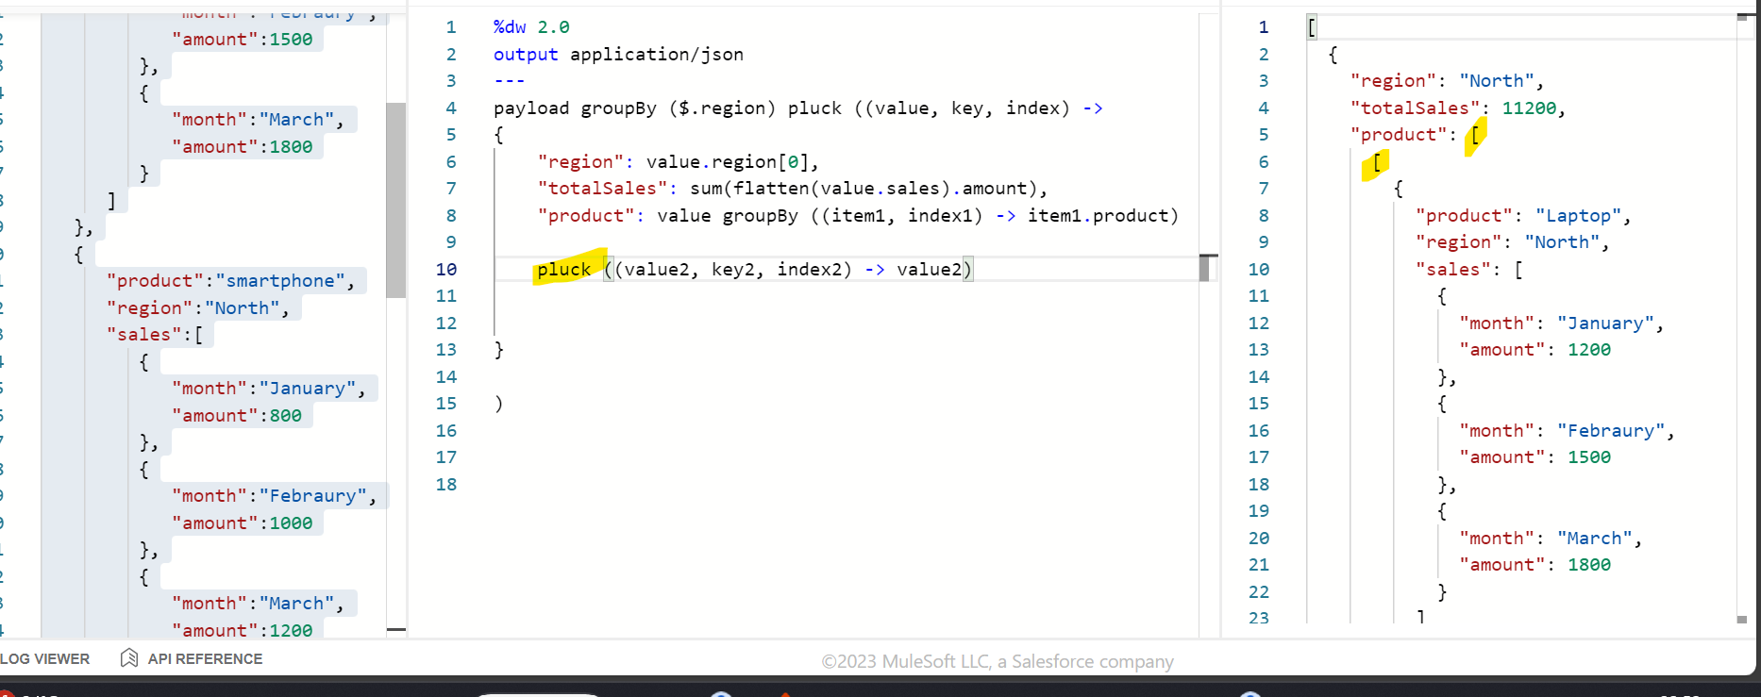**

**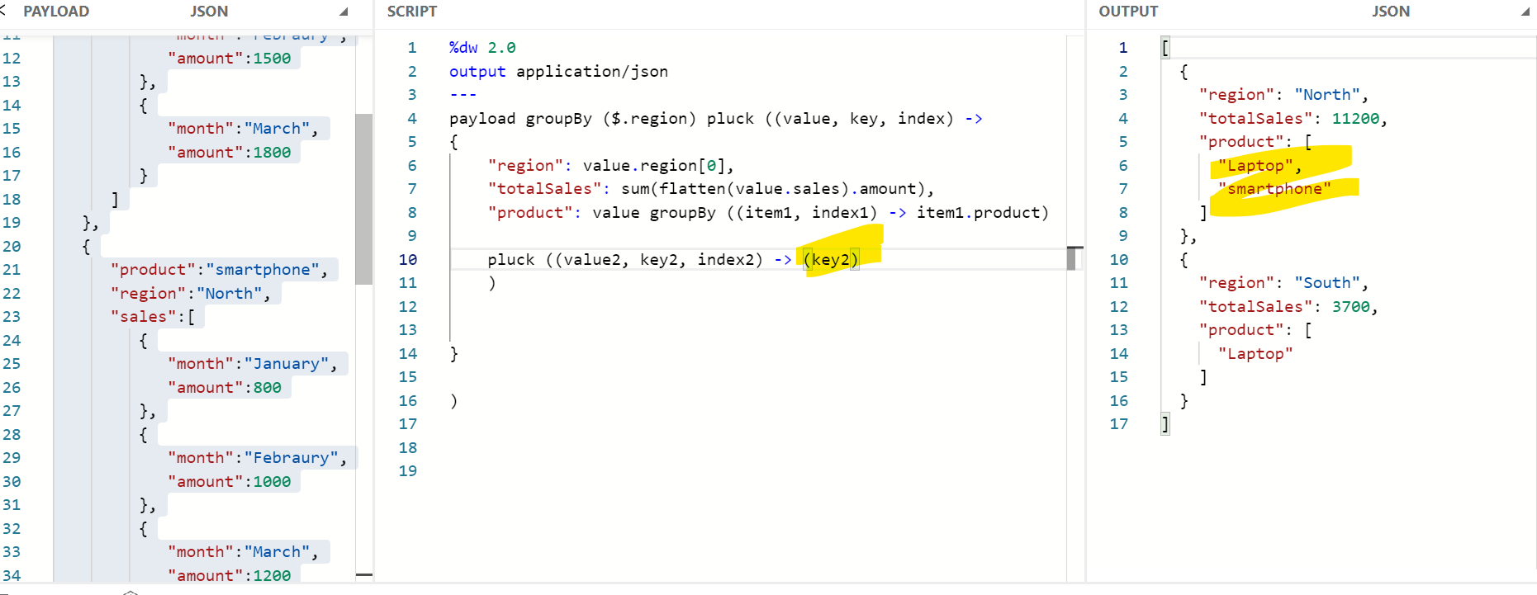**

**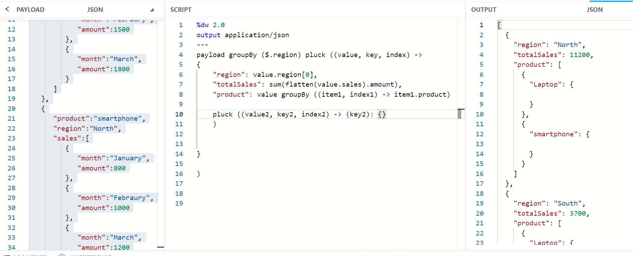**

**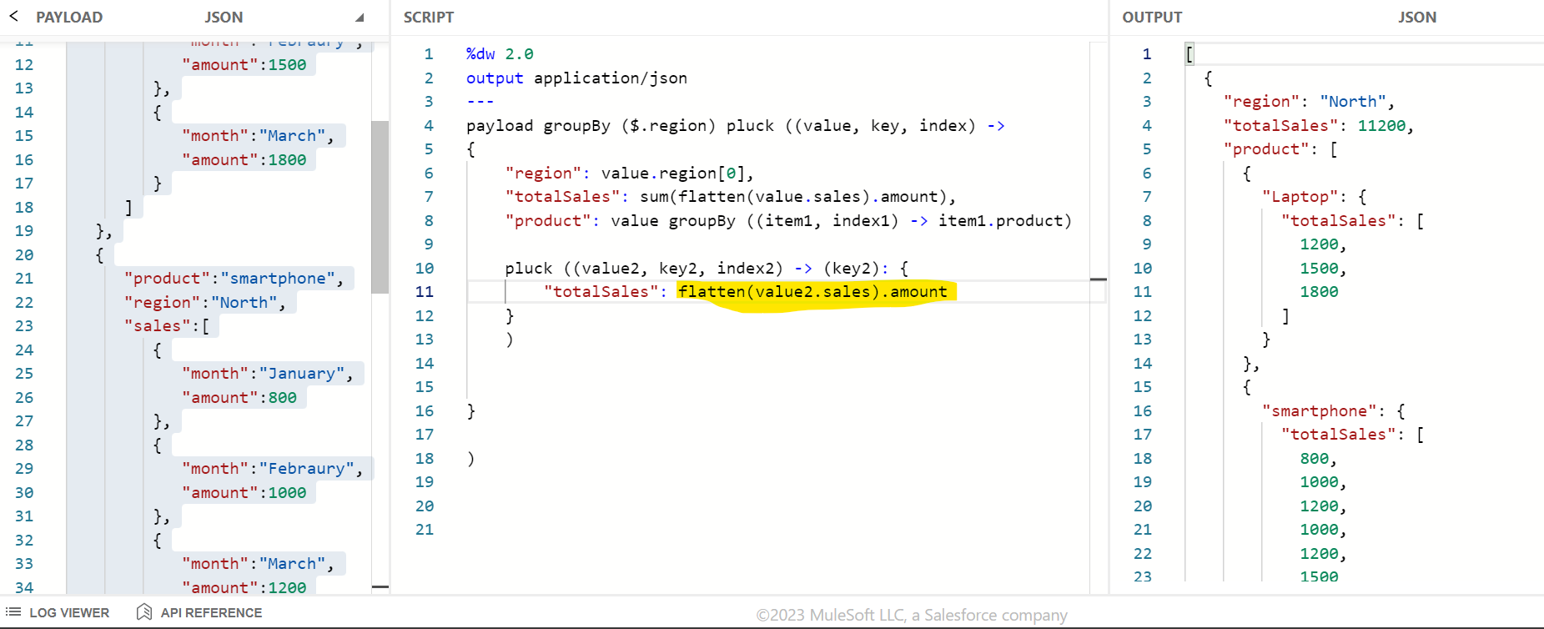**

**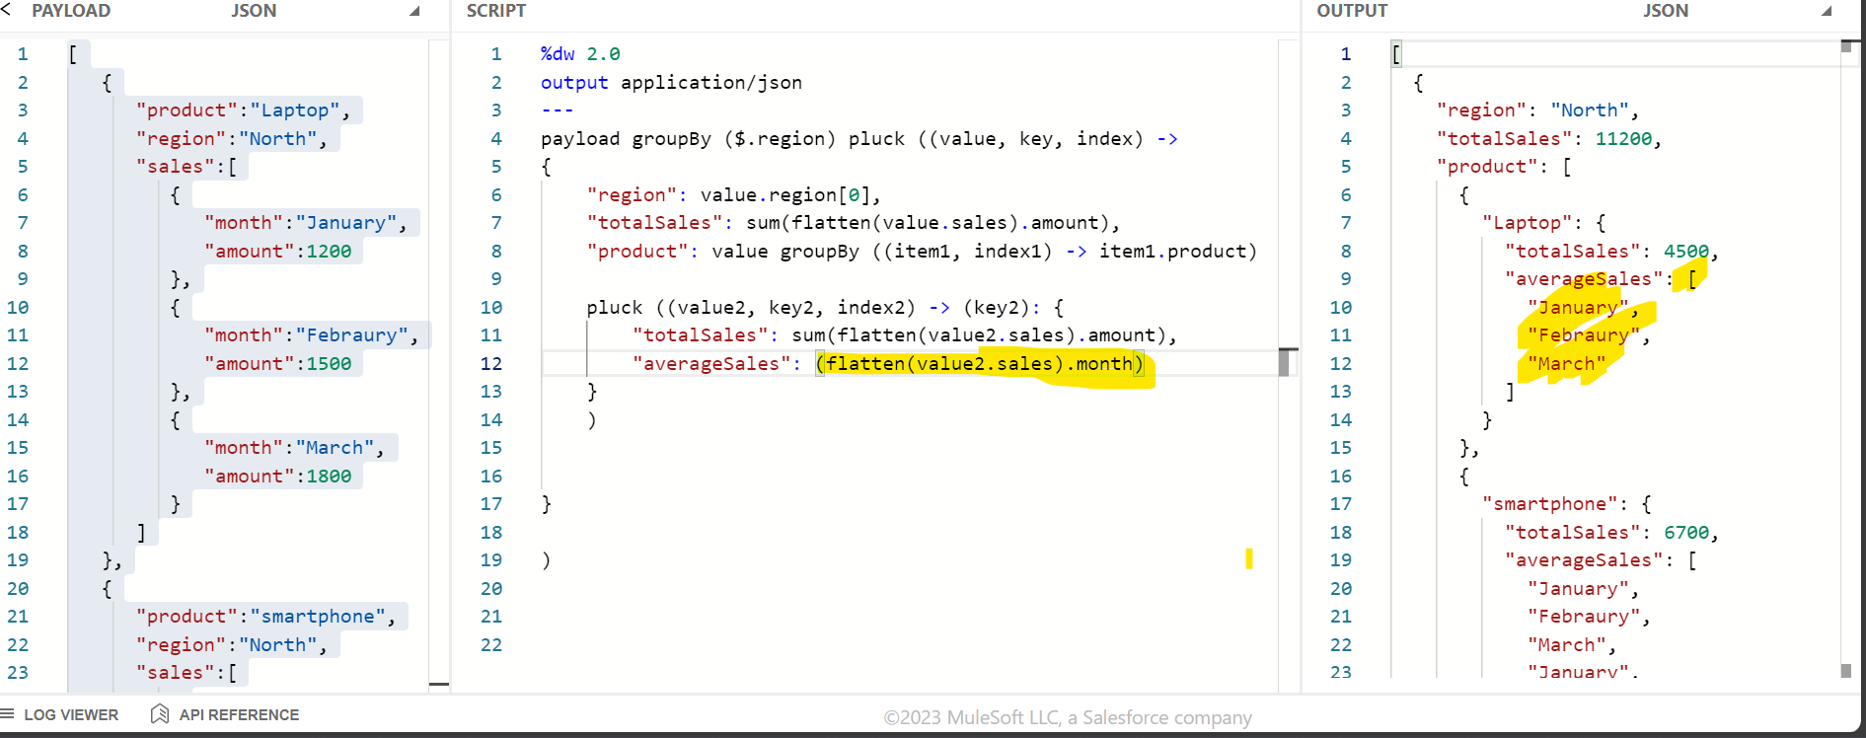**

**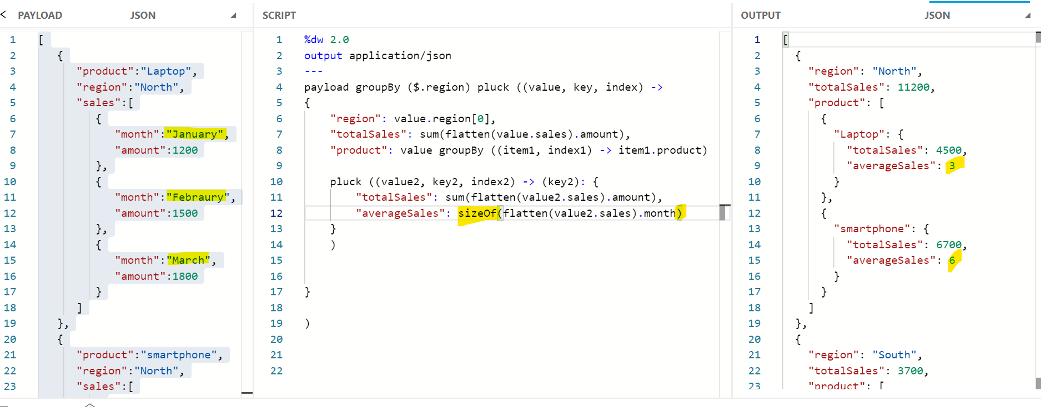**

**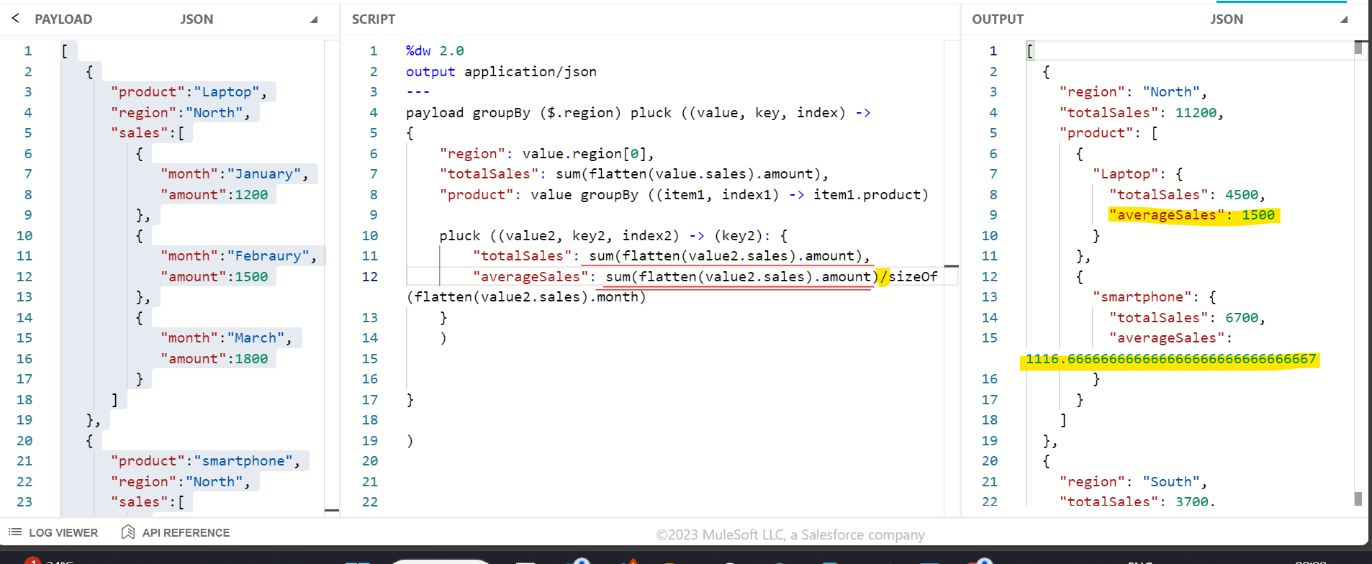**

**Trim**

**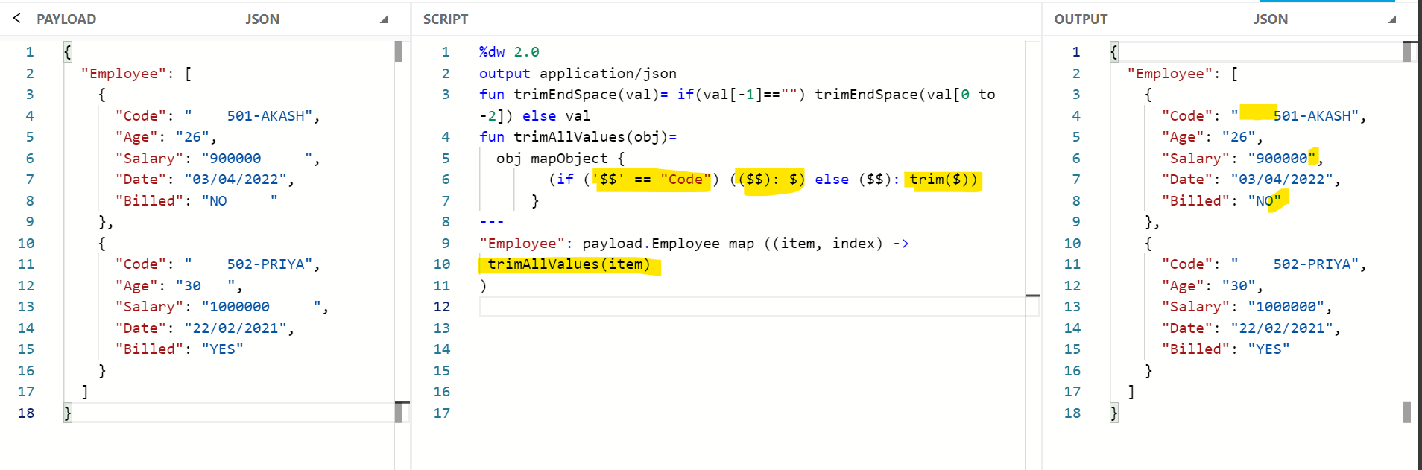**

**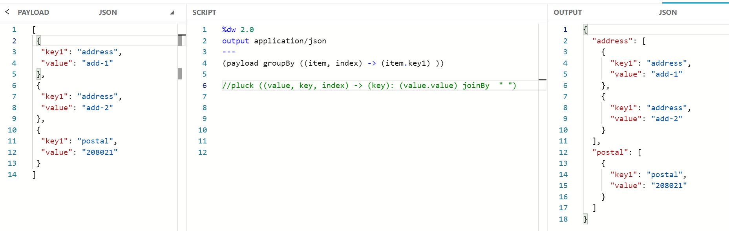**

**Pluck works on object and make it as array**

**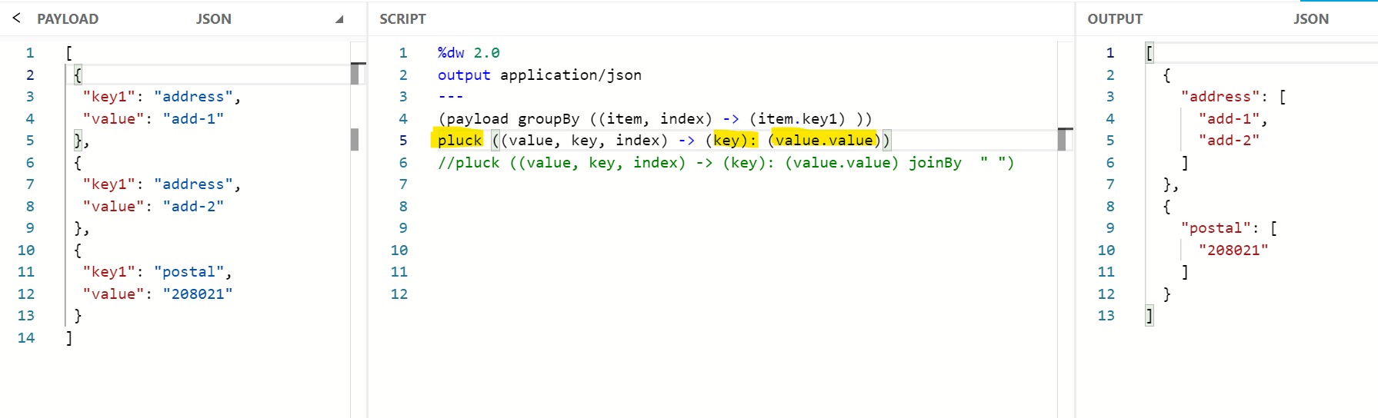**

**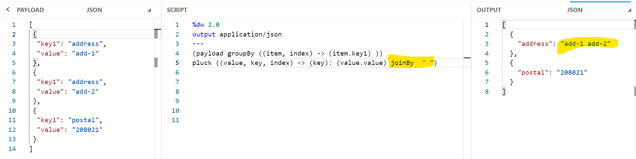**

**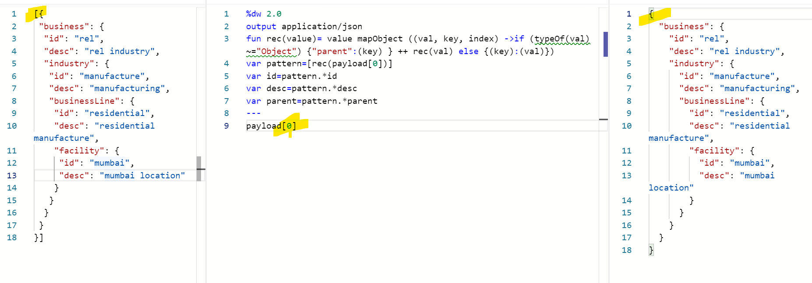**

**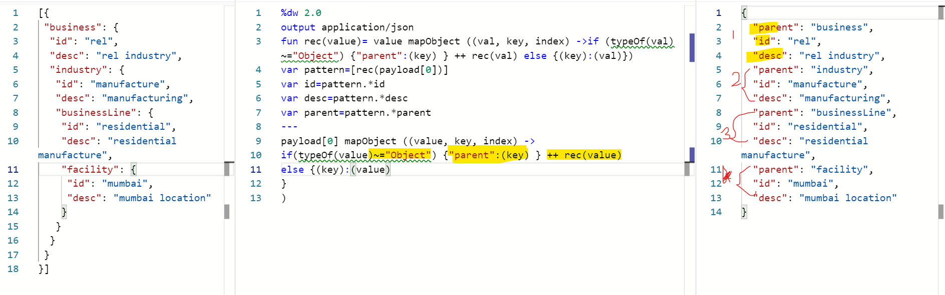**

**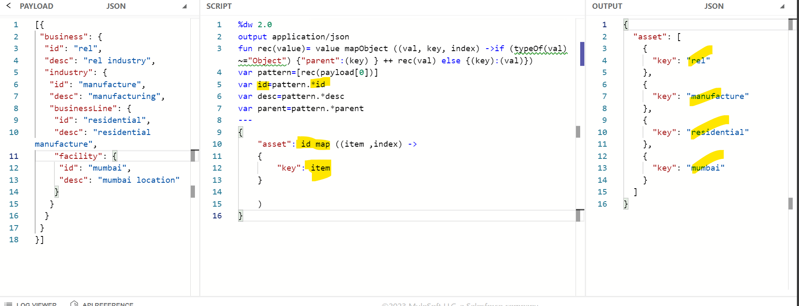**

**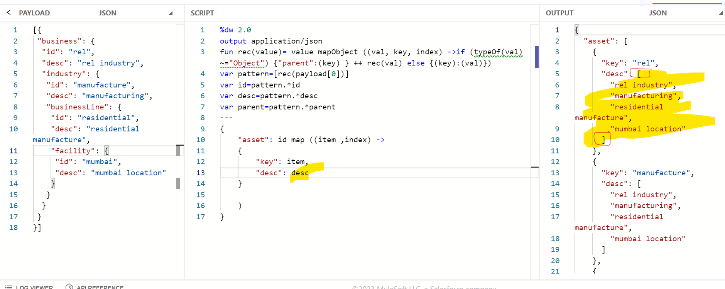**

**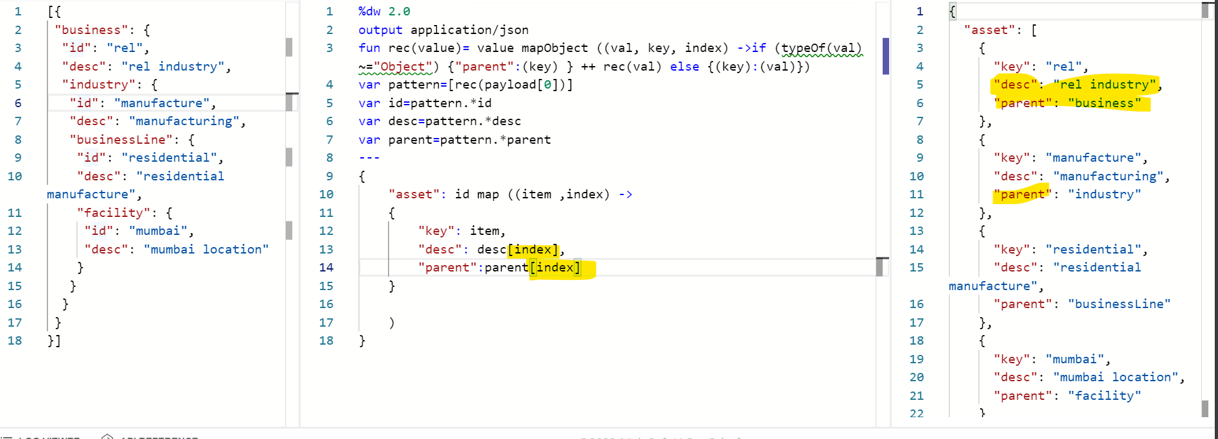**

**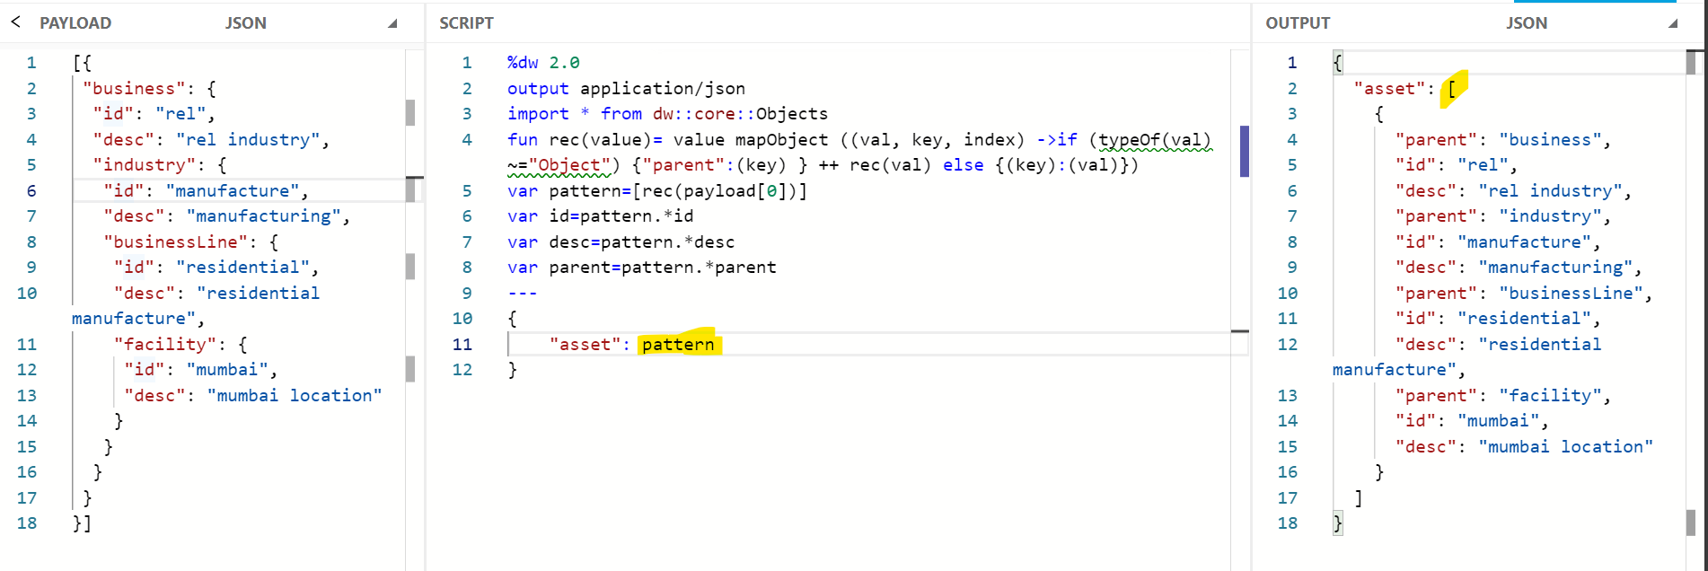**

**divideBy dw:: objects**

**